Stockton Globe Access Guide

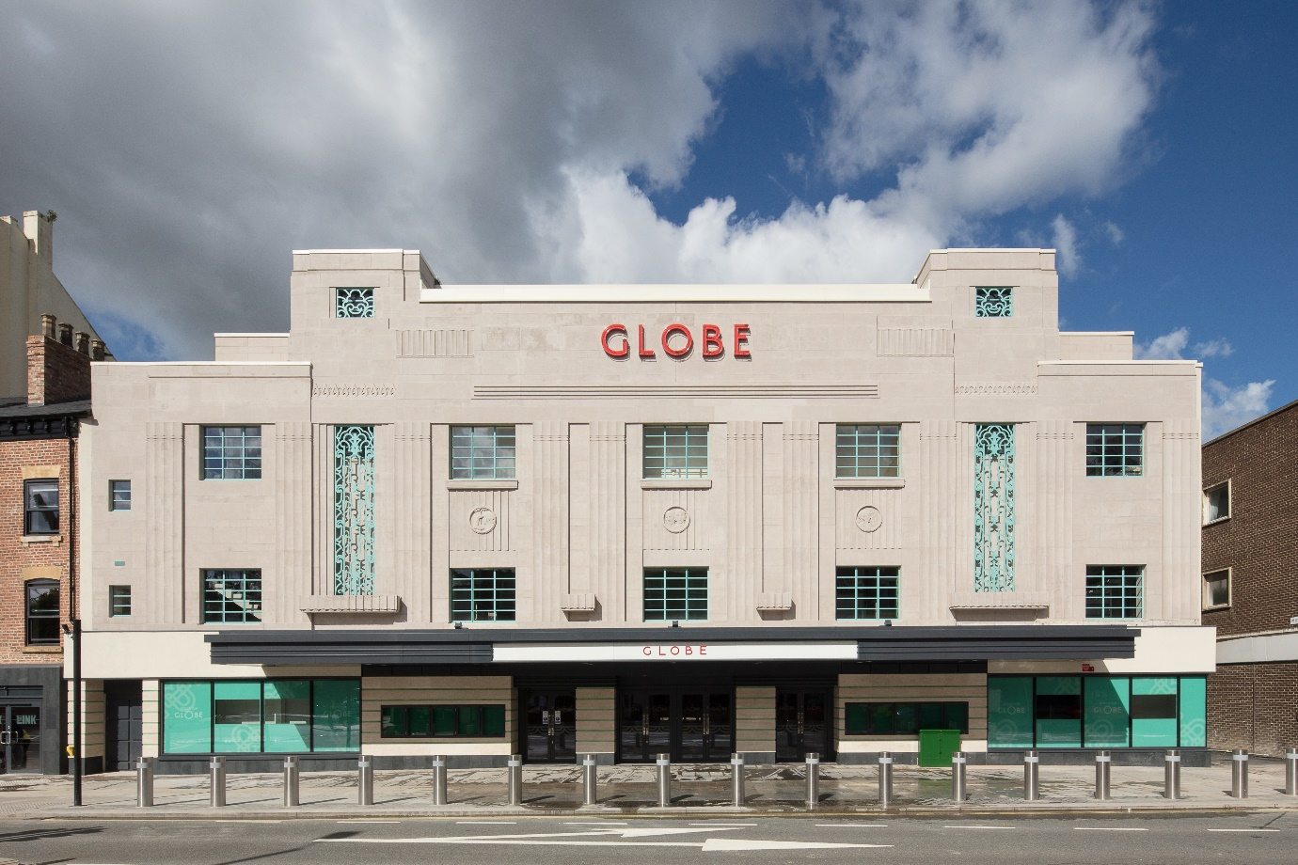

153 High Street
Stockton-On-Tees
TS18 1PL

Contents
Introduction 3
Customer Journey 4
Journey to the Venue 4
Audience Entrances 5
Accessibility for Wheelchair Users and other Patrons requiring Step Free Access 5
Accessibility for Visually Impaired Patrons 6
Accessibility for Patrons who are d/Deaf or Hard of Hearing 7
Toilets 8
Signage and Wayfinding 8
Enhanced Performances 9
Additional Services 9
Best seats/area for… 10
Ticketing & How to Book 12
Key Contact Details 12

Introduction

Following a multimillion-pound refurbishment, Stockton Globe is now bringing the world's biggest names in music and comedy to the North East of England.

A major restoration project, funded by Stockton-on-Tees Borough Council and the Heritage Lottery Fund, saw this beautiful art deco building transformed into an event venue fit for the 21st Century.

The refurbishment included the development of The LINK in the adjacent building. The LINK is a contemporary café bar and 200 capacity venue that hosts up-and-coming regional and national acts.

Situated in the heart of Stockton, the Globe originally opened its doors in 1935 and over the years played host to many international names from The Beatles and The Rolling Stones to Sadler's Wells Ballet and the D'Oyly Carte Opera Company.

Stockton Globe is operated by Ambassador Theatre Group - a world leader in live entertainment - and is the company’s flagship UK music and comedy venue.

Ambassador Theatre Group were founded in the UK in 1992 and have grown to be the world’s number one live theatre company, covering every discipline in the industry: operating venues, ticketing platforms and producing award-winning shows.

Stockton Globe is the largest venue in the Tees Valley with flexible audience capacities. The up to 3000 capacity auditorium features an original, fully restored 1935 art deco interior, coupled with state-of-the-art sound and lighting equipment, which provide an exceptional live experience.

With removable stalls seating, the venue can accommodate both fully seated and partially standing events. With the addition of a full orchestra pit and lift, the auditorium has been designed with flexibility in mind and can accommodate a wide range of live entertainment performances.

This guide focuses on the journeys for customers, staff and visiting production company members, noting the reasonable adjustments made front and back of house.

In no way should this guide be taken as an interpretation of law.

References: Equality Act 2010
The Building Regulations 2010; Approved Document M, Volume 2 – Buildings Other Than Dwellings

Customer Journey

Journey to the Venue

Dropped curb location(s) | Wellington Square car park is a 3-minute walk away and is a level route via Wellington Square and Stockton High Street. The nearest on street parking bays which can be used free of charge with a Blue Badge are located on Church Street.
Pick up/drop off points | Wellington Square car park is a 3-minute walk away and is a level route via Wellington Square and Stockton High Street. The nearest on street parking bays which can be used free of charge with a Blue Badge are located on Church Street.
Public transport routes | Train - If arriving by train, Stockton train station is 0.3 miles away and is walkable in 6 minutes. Thornaby train station is located 1.5 miles from the venue and is a 20-minute walk or a 5-minute drive.  Bus - Stockton Globe is well-situated on the high street for easy access to local bus routes. Bus numbers 7, 7A, 15, 17A, 36, 37, 38, 52 and 58 arrive and depart from stops within a minute walk of the venue along with other services for the wider Teesside area. The X10 bus also departs and arrives hourly from the high street with destinations including Newcastle, Gateshead and Peterlee.  Please find further local information on public transport here: https://connectteesvalley.com/data/busmaps/Stockton_High_Street.pdf
Nearby taxi ranks/suggested taxi firms | There are taxi ranks on High Street, where a number of local taxi companies are available for pre-booked and non-booked journeys.
Location of bollards/posts/potential physical barriers outside building | The entrance to the Globe can be accessed via High Street, there are some physical elements to be aware of; inluding a cross-point, and bollards on the exterior of the Globe pavement – there is plenty of dropped curbs and wide pavements for wheelchair access into venue  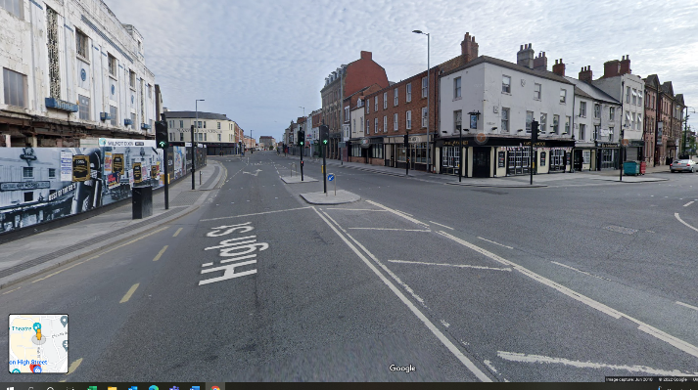
Car Parking facilities/nearest car park & directions to venue from here | Stockton Globe is close to the A19 and A66 and is easily accessible by car. There are several public car parks located within a 10-minute walking distance of the venue including Wellington Square, Riverside, Castlegate and Bishop Street car parks.

Audience Entrances

Step free entrances | Stockton Globe is accessible to all and has step free access to the front entrance and lift access to all levels
Additional entrances – include exact number of steps | N/A – all entrances are step-free
Entrance door types – push/pull, automatic openers, kept open during incoming/outgoing, types of door handle | 3 of our entrance doors are push pull with a handle, which will be held open for customers during an incoming and outgoing. We also have 2 power assisted doors which open automatically at The LINK and main entrance
Auditorium Entrances | Our auditorium entrances are push pull with handles, during incomings and outgoings, we have stewarding staff available to assist you in navigating these entrances.

Accessibility for Wheelchair Users and other Patrons requiring Step Free Access

Auditorium – step free seating and directions to these | There is step free seating in the Stalls. The main foyer is step free, and then there is a passenger lift to the Stalls level.  There is step free seating in the Circle, for our Access & Companion wheelchair seats. All other seats involve at least 3+ steps to be reached.
Auditorium – seats that are accessed by 3 steps or fewer and directions to these | There is step free seating in the Stalls. The main foyer is step free, and then there is a passenger lift to the Stalls level.
Auditorium – wheelchair spaces & additional seating for companion | The wheelchair spaces and companion seats are accessed by the passenger lift from the main foyer up to the Circle level. There is then flat floor from the lift to the wheelchair seats.  The wheelchair seats in The Stalls can be accessed by the passenger lift from the main foyer down to the Stalls level. There is then flat floor from the lift to the wheelchair seats
Sales points – include any points with lowered counters | Both the LINK Bar and the Stalls bar have step free access and have lowered counters.  The 1935 bar has step-free access, but there is no lowered counter.  The Circle bar does not have step-free access.
Step-free access to stage from auditorium | There is step-free access from the stage to the auditorium via the Stage Right via a convertible platform lift.
Passenger Lift | Please note the dimensions of our Passenger Lift:  90cm width, 127cm depth; 630kg weight limit.

Accessibility for Visually Impaired Patrons

Auditorium – recommended seats and directions | We recommend F 13-16 in the Stalls for those with visual impairments.
Guide dogs – possibility of dog sitting available? Water bowls for dogs | We happily accommodate Guide Dogs. Please let the venue know in advance whether you require a dog sitting service, where we can provide water bowls for dogs.
Staff to guide (if applicable) | We have Access Hosts who will help customers by guiding them to their seats, and highlighting nearest bars and toilets
Bar menus – large print/braille/audio versions available (if applicable) | We can have large print bar menus available upon request, and our Access Hosts are able to supply the bar menu in an audio version.
Venue information – audio format/large print | Our venue is a print-free, with no in person box office. This means all our venue information is readily available on the website. If you require information in a different format from what is uploaded, please contact ‘stocktonboxoffice@theambassadors.com’ or contact our Access Booking Line – 0800 912 6971, or on our type talk booking line - 18001 0800 912 6971
Audio Description provisions | When a show has an audio descripted performance, this will be highlighted on the website, as well as across our social media sites.
Touch tours – include information on how to request/book | When we have an Audio Described Performance, please contact ‘stocktonboxoffice@theambassadors.com’ to request of book a Touch Tour.

Accessibility for Patrons who are d/Deaf or Hard of Hearing

If Mobile Connect in place, how to download, use and coverage (is there any outside the auditorium) | Mobile Connect is in place at the Globe. In order to access the system, please make the stewards in the Main Foyer aware, and they will be able to sign-out the required equipment and talk you through how the devices can be used
Where to collect hearing enhancement devices for (if not using their own) | The Main Foyer
Is there a hearing loop at any sales points? | We have Hearing Loops in all Bars; these are portable and therefore can be moved around the venue by staff to areas such as the Main Foyer
Captioning/BSL-Interpreted provisions | When a show has a captioned or BSL-Interpreted performance, this will be highlighted on the website, as well as across our social media sites.

Toilets

Accessible WC(s) – location(s), route(s) from various areas in the auditorium | We have 5 Accessible Toilets, with grab rails on right and left side. They are located  - Rear of Link Bar (Ground Level)  - 1935 Bar (Accessible via Passenger Lift)  - Stalls Bar (Accessible via Passenger Lift)
Nearest changing places facilities (if not in venue) | We do not have a Changing Places facility within the Globe. Our nearest location is:  The Shambles Market Hall, High St, Stockton-on-Tees TS18 1AU - please note access is limited by closing times.
Gents – lowered urinals/grab rails in any | We have lowered urinals in our Lower Circle Toilets, accessible via 5 steps from the Main Foyer
Ladies – any cubicles with grab rails | All Ladies toilets have a minimum of 1 cubicle with grab rails.

Signage and Wayfinding

Is signage consistent throughout building? Does signage include symbols to further aid understanding? | There is signage throughout the Globe, to help way find to Bars, Toilets and Lifts. You will notice some signage is Black and White, these are the signs in the new areas of our building, including The LINK Bar. Other signage is white on wood, as we have some heritage decoration, we have incorporated into. Please see some example images of the signage here:  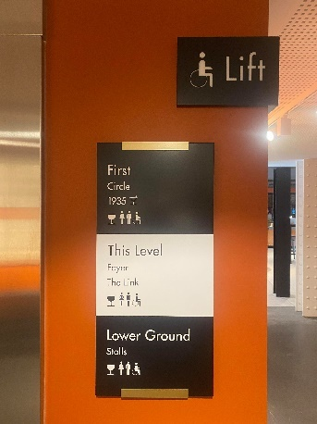  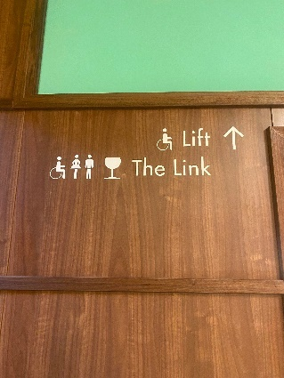

Enhanced Performances

Do you offer Audio Described/Captioned/BSL-Interpreted/Relaxed Performances? | The Globe can facilitate a range of Enhanced performances. If a show is offering an enhanced performance, this will be made clear on the Stockton Globe website.
Link to web page to find out when these will take place | https://www.stocktonglobe.co.uk/
Possibly wish to include service providers and information about these – reassures people that they are receiving a professional service | Our Audio Described Performances are provided by VocalEyes. Please see their full range of services and additional information here:  https://vocaleyes.co.uk/

Additional Services

Pre-show orientation visits | We are more then happy to facilitate pre-show orientation visits. Please contact ‘stocktonboxoffice@theambassadors.com’ for enquires.
Theatre tours | We will have a number of Theatre Tours available on our website. Please find them listed here. If you cannot see any tours listed, this will be due to them be sold-out, so do sign-up to our mailing list for future tour dates.
Creative Learning Workshops – Inclusion in these | Our Creative Learning Officer is Josh Elliot, you can contact him at ‘joshelliott@theambassadors.com’ for enquiries around our Creative Learning Workshops and accessibility
Use of certain effects e.g. smoke/strobe/pyro effects – where to find out if these are in the show for people with sensory sensitivities | If there are certain effects, such as smoke, strobe lighting and pyrotechnics; this will be included on the digital screens at the venue, but please do speak to any member of staff who will be able to advise you in depth on a show by show basis.

Best seats/area for…

Access to accessible toilet facilities | All levels have accessible toilets. The Stalls has 2 located in the rear of the bar, including 1 next to the passenger lift, so we would suggest this is the best area. To avoid using the lift, we have an accessible toilet at the rear of The Link.
Access to changing places facilities | N/A
Access to nearest ladies | All levels have ladies’ toilets. They are located in the bars, we would suggest the rear of both the Stalls and the Circle for best access (apart from Upper Circle – the front of the Upper Circle has the best access).
Access to nearest gents | All levels have gent’s toilets. They are located in the bars, we would suggest the rear of both the Stalls and the Circle for best access (apart from Upper Circle – the front of the Upper Circle has the best access).
Fewest steps | Main Entrance - Step Free access from High Street  The LINK - Step Free Access from High Street  The Stalls Bar - Step Free Access via Lift, or 22 steps from Main Entrance  The Circle Bar - Step Free Access via Lift, or 23 steps from Main Entrance  The 1935 Bar - Step Free Access via Lift, or 19 steps from Main Entrance  The Stalls - Step Free Access via Lift, or 22 steps from Main Entrance  Upper Circle - 34 steps to Upper Circle from Main Entrance, with 16 additional to reach back row  Mid Circle - Step Free Access via Lift or 13 steps from Main Entrance to Mid Circle, with 15 additional to reach back of section  Lower Circle - 4 steps from Main Entrance (The LINK) to Lower Circle, with 6 additional to reach back of section
Better view if Visually Impaired | The recommended seats for Visually Impaired customers are F13, F14, F15 & F16 in the Stalls.
Baby change | We have Baby change units in all of our Accessible Toilets, as well as The Circle Ladies and Stalls Ladies.
Wheelchair users – wheelchair spaces | Our Wheelchair Spaces and companion seats are:  Circle – E11 & E12, E13 & E14, E 24 & E25, E26 & E27.  Stalls – C1,C2 & C3,C4, C25, C26 & C23 &24. G1 & G2, G29 & G3-0, K1&2, K 32&33.  For standing performances, please contact the Access Line regarding the wheelchair platform availability in the Stalls.
Wheelchair users – transfer seats (include information on safe storage of wheelchairs) | Any end of aisle seat in the Stalls can be transferred into, and we can store wheelchairs and mobility aids in the rear of the Stalls Bar.  In the Circle, our transferring seats would be E11 & E12, E13 & E14, E 24 & E25, E26 & E27.

Ticketing & How to Book

Accessible Ticketing Policy Info | The title ‘Access’ refers to everything ATG does to enable anyone who would benefit from additional support because of a disability or health condition to visit our theatres and have an enjoyable visit. We have an Access and Companion rate available on performances, which can be accessed by calling our Booking Line - 0800 912 6971, or on our type talk booking line - 18001 0800 912 6971
Website link | https://www.stocktonglobe.co.uk/
Access Booking Line | Booking Line - 0800 912 6971, or on our type talk booking line - 18001 0800 912 6971

Key Contact Details

Venue Customer Contact for additional support/to offer feedback: stocktonglobeenquiries@theambassadors.com
Venue Address: 153 High Street, Stockton-On-Tees, TS18 1PL
Customer Contact Centre (Phone Bookings): 0800 912 6971
Website Address: https://www.stocktonglobe.co.uk/

