Sunday 18 September 2022
15th Sunday after Pentecost (Ord.25)

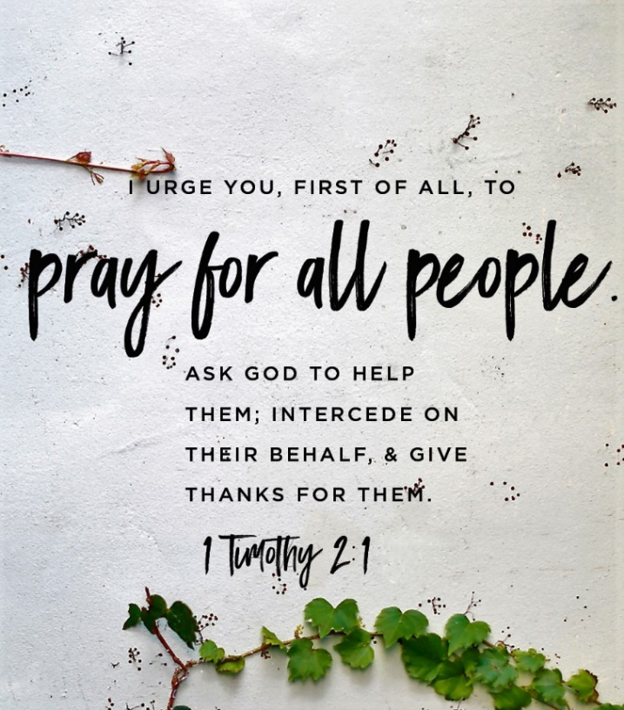

Sentence I urge you, first of all, to pray for all people. Ask God to help them; intercede on their behalf and give thanks for them. Luke 15: 10
Collect God our true wealth, may we be faithful in things both small and great, and serve the needy and the poor, so that finally we can be entrusted with your true riches; through Jesus Christ our Mediator, who is alive and reigns with you, in the unity of the Holy Spirit, one God, one God, now and for ever. Amen.
Readings
Jeremiah 8: 18-9:1 Jeremiah grieves the destruction of his people, who insisted on worshiping idols, but for whom there is now no salvation.
Psalm 79: 1-9 A lament for the land of Israel which has been destroyed by foreign nations, and for the temple which has been desecrated, and a plea for God’s forgiveness, compassion and restoration.

1 Timothy 2: 1-7 Paul calls for believers to pray for all people, including leaders, reminding them of Christ’s pleading for us with God – for which Paul has been called as an apostle to the Gentiles.

Luke 16: 1-13 Jesus’ parable of the shrewd manager who wins social capital and his master’s commendation through the act of radical, inappropriate, forgiveness.

Morning tea after 9:30am service today is in The Gathering Place Please feel free to linger and get to know someone you may not know too well – what an opportunity. Let us walk the talk of welcome.

The 8am service begins on page 404 of ANZPB
The 9:30am service is on the screens

Kay will be on leave the week beginning Monday 26 September and Michael Smart will lead the service on Wednesday 28 September. Kay will be back in the office on Wednesday 5 October.

ONE SUNDAY MORNING SERVICE 9am Sunday 2 October
Led by Rev’d Michael Smart – Preacher: Sarah Murphy
Morning tea will follow the service in The Gathering Place

Keep the Date!
St John’s Plant and Book Stall and Baking Sale
here at church 10am – 12:30pm Saturday 8 October
If you wish to contribute plants, baking and/or books,
or help on a stall, please let Meriel or Sandy know as soon as possible.
Meriel Johansen – merieljohansen@outlook.com
Sandy Jacobs - sancobs@gmail.com
If you have a better name for this event let Meriel and Sandy know!
Clocks go FORWARD ONE HOUR
NEXT Sunday morning 25 September
Confidential Prayer Ministry is available during communion
and after the services by the font at the back of the church.

Please always feel free to speak to Kay if you want prayer,
anointing or a conversation.

Synod 2022: You can find the Bishop Ross’ Charge here and the Eucharist sermon by Helen Robinson, City Missioner-Manutaki, Auckland City Mission
here – highly recommended by Kay, Gill and Alison. Hard copies are available on request from the church office.

PLENTY
How did it happen, God?
How did we come to believe in scarcity?
In “not enough to go around;”
In “you gotta look after yourself”? How did we miss the plenty bursting out around us?

How did we fall for the deception that what we can grasp in our hands
would ever be enough?
How did we grow so blind and so foolish,
that we would allow so much beauty and life,
joy and laughter, sharing and love,
to pass us by unnoticed?

How poor we have become, and how poor we have made others,
simply because we forgot your infinite, overflowing abundance;
because we allowed ourselves to think
that sharing and giving leaves us with less;
because we nurtured appetites that are never satisfied
unless they have far more than is needed,
thinking our gluttony would silence our fear.

Forgive us, and teach us about your generosity again;
remind us that you are able and willing
to do far more than we can imagine;
and open our eyes to the plenty we enjoy,
the plenty we can share,
and all the plentiful goodness in our world
that cannot be owned but can enjoyed by all.
Amen.

Prayer Letterbox The green letterbox at the bottom of the driveway contains paper, pens and envelopes and an invitation to fill out the piece of paper, post it and we will be delighted to pray for them during the coming week. Kay will clear the box regularly and bring the prayers into church.

Water Tank Thanks to your generosity the water tank has arrived and with the help of the builders from the neighbour’s house is safely at the back of the hall. A base will be prepared for it to stand on and once the connections are all set in place we will begin collecting water. Huge thanks to Hannah Brightley and particularly to Dave Davies and Eric Martin for their diligence and perseverance in making this project happen.

Church Gardens Who doesn’t love spring? The church gardens are a feast of colour with all the beautiful flowers, bees, birds and scents. From the abundant pink manuka by the Prayer Letterbox and on up the driveway and not forgetting the newly planted garden bed in front of the church (thanks to Ann Petrich and her sisters) to the Memorial Wall and across the front of the hall. A bonus is we can bird watch from our offices.

Haere i runga i te aroha. Haere i runga i te rangmārie.
Go now to love and serve the Lord. Go in peace.
Amine. Ka haere matou i te runga it te ingoa o te Karaiti.
Kororia ki te Atua.
Amen. We go in the name of Christ.

Parish Contacts

Vicar: Rev’d Kay Brightley 021 275 6763 kdhbrightley@xtra.co.nz

People’s Warden: Gill Barthorpe 0212631220 gillian.barthorpe@aut.ac.nz
Vicar’s Warden: Paul Bargh 021 26 26764 paul.bargh59@gmail.com
Pastoral Care Co-ordinator: Jenny Shaw 021 953 940 jenny@shawdiesels.co.nz
Parish Secretary: Alison Bargh
Church Office: 478-3575 Office hours: 9am - 1pm Tuesday – Friday
Email: admin@stjohns.net.nz Website: www.stjohns.net.nz
On Facebook: St John’s Anglican Church – Campbells Bay

Feedback welcome
If you have feedback on any aspect of parish activities,
please do contact the wardens Gill and Paul – contacts as above

The Anglican Church of St John the Evangelist Campbells Bay
The Diocese of Auckland Registered Charity No. CC31449 GST 110–247-184
St John’s Anglican Church – Westpac Mairangi Bay - 030180 0002723-00

