August 2022
St John’s, Campbells Bay
THE BUZZ

Sustainability Champions Workshop report by Graham and Lorraine Buck
On Saturday 9 July Graham & I attended the Sustainability Champions Workshop 2022 which was held at St Johns Royal Oak. We started off with a welcome from Cathy, the Diocesan Sustainability Coordinator, & a quiz relating to conservation topics.
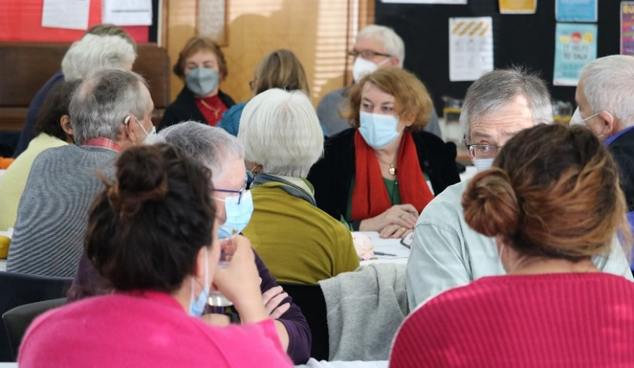
Some interesting facts were shared! We then moved into the church for a Liturgy of Gathering which was very moving, & we laid the samples of harvest from the garden which we had been asked to bring. A representative from Royal Oak then talked to us about how they have set up a Community patch at the back of the church. This consisted of 3 raised beds, which apparently, produce an abundant harvest in summer when they are being attended to. They have had a considerable input from the general community in terms of planting & tending to the crops, & also much interest in the harvesting!
Richard Main, from Diabetes Foundation Aotearoa – Gardens for Health – shared a most insightful presentation on their mission, benefits, & what they do in various communities in terms of education & support of the community gardens that have been set up. It was incredible to see just how passionate these people are about their gardens, & how they are feeding much of their communities. Through their resourcefulness & determination they are growing bananas & pineapples, & there is even a garden getting started with mangoes!! Richard is also very willing to assist with any advice around setting up a community garden in our churches.
Richard Barter from the Auckland Council then talked to us about grants supporting climate action. He shared some tips on applying for grants from the council & some examples of climate action projects that have received funding. Richard is also very happy to assist with applications & advice on projects that could be implemented.
After a delicious lunch kindly prepared by the St Johns parishioners, we heard from the Henderson Parish on their Zero Waste Sunday, & what they have set up to assist with eliminating waste & proper recycling.
Amy Ross from A Rocha Eco Church talked to us about this organisation & how their resources can help with sustainability & climate change initiatives. They are actively caring for God’s earth as an integral part of their mission. This was a very insightful presentation with lots to take away. All in all, it was a most enjoyable day & we came away with a good amount of material that we, as St Johns, need to review & see what we can do to ensure our children & grandchildren can continue to enjoy God’s wonderful creation!! Contributed by Graham and Lorraine Buck
There are resources available by emailing the parish office and indicating the resource you would like to receive: Tips for Sustaining Community Gardens - From Richard Main (richard.m@diabetesfoundationaotearoa.nz) of Gardens4Health / Grants supporting climate action - From Richard Barter (richard@path.net.nz) of Auckland Council / A Rocha Eco Church - Learnings and Tips - From Amy Ross (amyross@arocha.org) of A Rocha Aotearoa NZ
Craig Family Celebrations
In recent weeks Clive and Shann have celebrated their youngest granddaughter Abigail’s baptism here at St John’s and then a week later at Holy Trinity, Devonport the wedding of their oldest grandson Luke to Oriana – congratulations to you all!
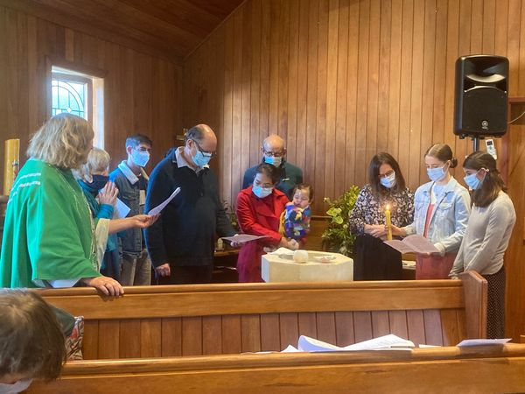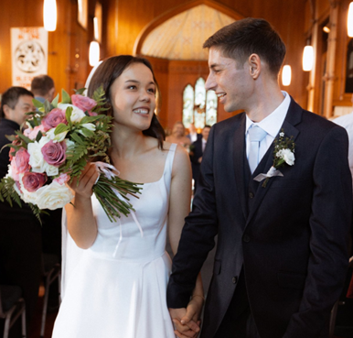
Farewells
Barbara Fraser
With great sadness we farewelled Barbara at a wonderful funeral service recently. Barbara was a true blessing to so many of us and a long-standing member of the parish having started in the Young Mum’s group a few decades ago! Up until a few months ago she was still reading at 9:30am services. Many of you will remember how she cared for her husband Bruce and how she was always honest, kind and interested in listening to you.

Joan Brennan
Joan Brennan died aged 110 and her funeral was here on Friday morning. New Zealand’s oldest woman, she lived in Campbell's Bay for many years and was a parishioner here. She championed organic, home-grown food and had lived independently for all but the last few years. She was a real local identity and involved in our community.
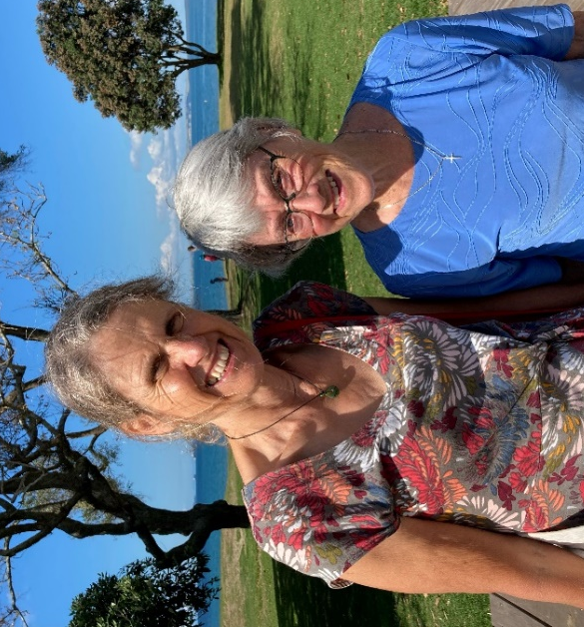
CMS Worker: Janet Garley
Hazel Hipkins caught up with Janet Garley, who we supported as a parish through her work with CMS and their Servants to Asia’s Urban Poor in Phnom Penh. She was based in the slums and as a doctor she worked in a variety of roles; with the government TB programme, and with the CMS women’s health and child health work. Cathy Ross of CMS suggested to this parish that we support Janet by sending out her newsletter to the parish, which Hazel, Shann and Pat Piggott faithfully did for the ten years Janet was in Cambodia. Janet spoke to St John’s at least twice on her various deputation tours.
Yarn Bombing has begun
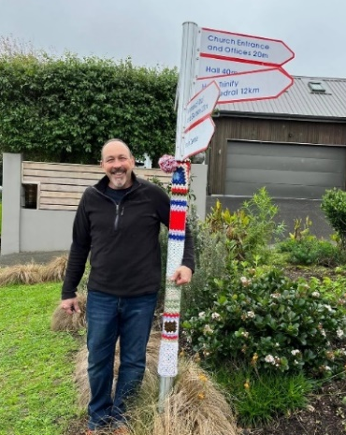
Thank you to the talented knitters and crocheters who have made and donated squares for our yarn bombing project to bring a little whimsy and colour to the church winter garden.
Some bloke ‘bombed’ the photo to accentuate the point!
Thank you to Lionel Redhead for reattaching the drooping sign on our signpost.

Covid and Flu
As flu and covid infections spread wider in our communities, it is prudent to remember a few important things we can all do to protect ourselves and others when here at church.
We continue to ventilate the church – yes, we know it can get cold but please bear with us! If you feel unwell, please stay home. Please wear a mask in church. Use hand sanitiser on entering church and before taking communion.
New in the Library
“Will I be fat in heaven and other curious questions?” Fay Aitken recommended adding this book to the library shelves in the church lounge. Written by Canon J. John and published in 2021 this book recognises the importance of asking questions. We would love a review from someone at a later date.
Something Silly
One Sunday morning the vicar noticed little Johnny was standing staring up at the large plaque that hung in the foyer of the church. The young man of seven had been staring at the plaque for some time, so the vicar walked up and stood beside him and gazing up at the plaque he said quietly, “Good morning, Johnny.” “Good morning vicar,” replied the young man not taking his eyes off the plaque. “What is this?” Johnny asked. “Well Johnny, these are all the people who have died in the service,” replied the pastor. Soberly, they stood together staring up at the large plaque. Little Johnny's voice barely broke the silence when he asked quietly, “Which one sir, the 8:00 or the 9:30?
Something to Ponder
Maybe, all the things we’ve been through exist somewhere inside a melody.
That’s why music is so comforting.
@ Rudy Francisco
Our contact details:

Vicar:

Rev’d Kay Brightley 021 275 6763 kdhbrightley@xtra.co.nz

Parish Secretary: Alison Bargh Church Office: 478-3575
Office hours: 9am - 1pm Tue – Fri – we are currently under traffic light orange

Email: admin@stjohns.net.nz Website: www.stjohns.net.nz

On Facebook: St John’s Anglican Church – Campbells Bay

The Anglican Church of St John the Evangelist Campbells Bay
The Diocese of Auckland Registered Charity No. CC31449 GST 110–247-184
St John’s Anglican Church – Westpac Mairangi Bay - 030180 0002723-00

