Organization Name
>> Employee Accident Report

To be completed by the injured employee.

Employee name: Phone:
Employer: Title:
Date of accident: Time of accident:
Address and location of accident:

Please explain step-by-step how the accident occurred:

Describe the affected body parts:
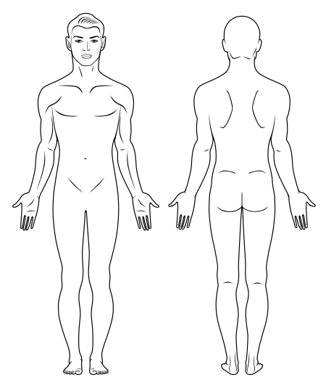
Identify possible causes for the accident and if/how it could have been avoided:

Employee signature: |  | Date:

