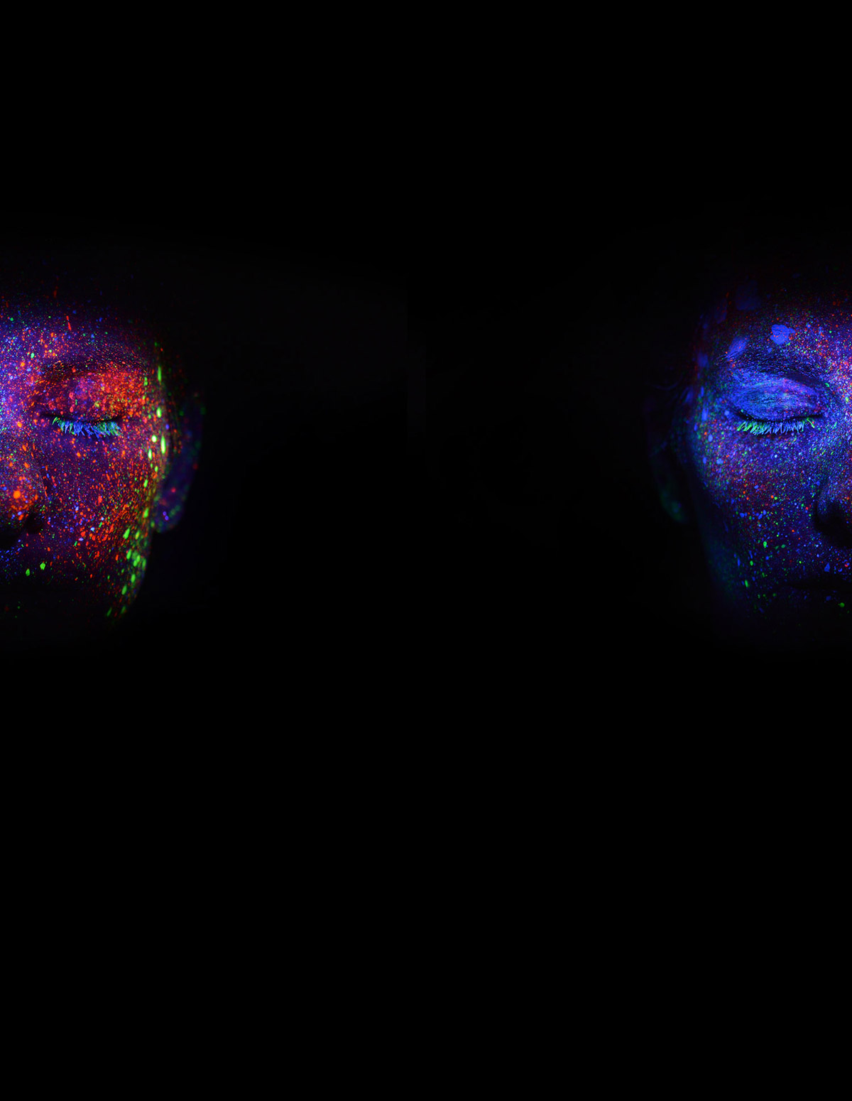

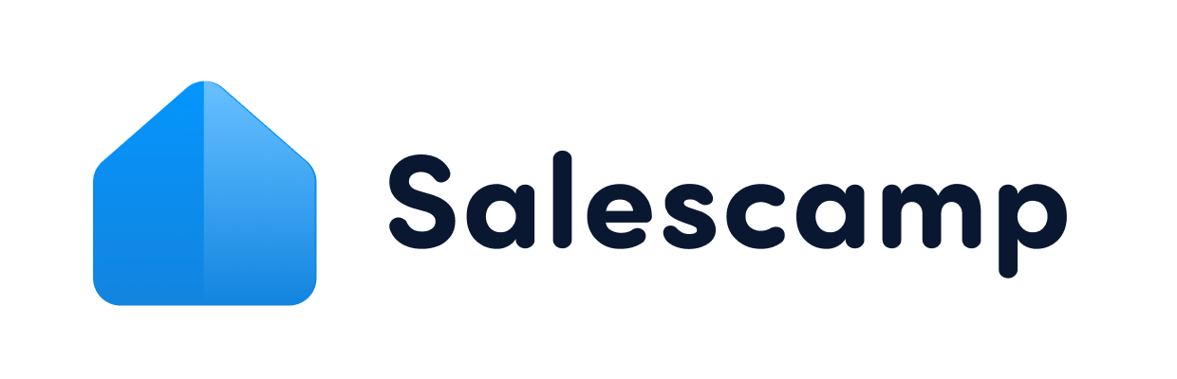

Artificial Intelligence

Services Proposal

for [Client.Company]

This project proposal contains all the information regarding the use and
application of [Sender.Company] artificial intelligence, machine learning,
neural networks, and cognitive science on behalf of [Client.Company].

Prepared for:
[Client.FirstName] [Client.LastName]
[Client.Company]

Prepared by:
[Sender.FirstName] [Sender.LastName]
[Sender.Company]

Cover Letter

Dear [Client.FirstName],
Thanks so much for taking the time to share the details of your research project with us today. I wanted to send over this research proposal as a follow up to our call to further outline how we can use information processing and machine learning to help your project succeed.
As I’m sure you know, computer science and artificial intelligence have changed the way we can collect data for projects like yours. Based on our initial assessment of your current capabilities, we believe that our intelligence systems can provide data and information that will further enhance pattern analysis within your research area.
Please review the enclosed documentation and let us know if you have any questions regarding our process and/or how we might apply machine intelligence to your academic research.

Sincerely,

[Sender.FirstName][Sender.LastName]
[Sender.Company]

About [Sender.Company]

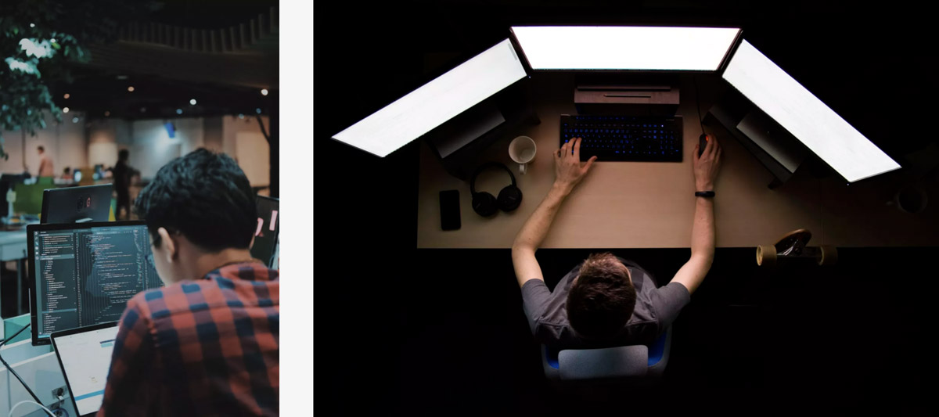

Initially launched as a door-to-door marketing firm, [Sender.Company] made the pivot to AI research and began working with large, academic data sets before big data went mainstream.
Though we largely focus on pattern analysis and problem solving for large brands, we’ve always been passionate about bringing AI into academics. We care about the role that cognitive science and computer science can play in scholarly research areas which have, until recently, been out of reach for most academics.
In recent years, findings from researchers who have partnered with our machine learning algorithms and data science teams have appeared in publications from Academic Press, MIT Press, and Mcgraw-Hill.
Our mission is to help academics discover more about the world through advanced learning processes which are supported by artificial intelligence and modern information theory.

[Sender.Company] Offices

Located in the heart of Silicon Valley, [Sender.Company] calls Sunnyvale, California home. When our team isn’t crunching numbers or tweaking algorithms, you can find us enjoying the beautiful California weather.

Client Testimonials

Testimonial text Testimonial text

Name Name
Company Company

Testimonial text Testimonial text

Name Name
Company Company

Project Summary

The following pages outline the scope of work, the planned services, and the project deliverables – as well as all associated costs.

Proposed Start Date: [Work.StartDate]
Proposed Date of Completion: [Work.CompleteDate]
Total Cost: [Work.Cost]

This research project proposal is based on [Sender.Company]’s conversation with [Client.Company] representatives and [Sender.Company]’s evaluation of the work with its internal technicians and data scientists.

If any aspect of this proposal is unclear, please seek clarification by consulting immediately with your [Sender.Company] representative.

Solutions and Deliverables

[Sender.Company] will use its proprietary artificial intelligence platform and machine learning algorithms to assist [Client.Company] with various academic research including (but not limited to) the following:
- Speech recognition
- Pattern analysis
- Pattern recognition
- Information processing
[Sender.Company] will also assist [Client.Company] in parsing, analyzing, and compiling the collected data into a final report.

Schedule

Based on conversations with [Client.Company], work on this research project should follow the estimated timeline listed below:

Project Milestone | Estimated Completion Date
Project Start | [Work.Start]
Milestone 1 | [Date]
Milestone 2 | [Date]
Project Completion | [Work.CompletionDate]

Terms & Pricing

From conversations with [Client.Company] representatives, we estimate the cost for these services at the following amounts:

Name | Price | Qty | Subtotal
Speech Recognition | $0.00 | 1 | $0.00
Pattern Analysis | $0.00 | 1 | $0.00
Pattern Recognition | $0.00 | 1 | $0.00
Information Processing | $0.00 | 1 | $0.00

Subtotal $0.00
Discount $0.00
Tax $0.00
Total $0.00
Please note that the above-listed prices are only estimates and are subject to change due to the nature of the work, the amount of raw data collected, and the associated network usage required to compile the information.

Signoff & Acceptance

IN WITNESS WHEREOF, each of the Parties has reviewed this project proposal and agreed to the work, terms, and conditions listed herein.
Upon signing, each party will have 48 hours to reconsider and nullify this agreement before payment is transferred and work begins in accordance with the above-listed dates.

[Sender.Company] [Client.Company]

[Sender.Signature] [Client.Signature]

[Sender.Date] [Client.Date]

[Sender.FirstName][Sender.LastName] [Client.FirstName][Client.LastName]

