Website Redesign
Proposal

Prepared for:
[Client.Company]

Prepared by:
[Sender.FirstName] [Sender.LastName]
[Sender.Company]

Cover Letter
Dear [Client.FirstName],
Thank you for considering [Sender.Company] for your website redesign needs. We assure you that we can accomplish this project in a timely manner and within budget. [Sender.Company] has a history of identifying key website redesign needs for clients and accomplishing those objectives.
The following website design proposal lays out the work that will be done and at what cost. If you have questions, please feel free to reach out via email or phone.
Thank you!

[Sender.Signature]
[Sender.FirstName] [Sender.LastName]
[Sender.Company]
[Sender.Email]
[Sender.Phone]

Executive Summary

In order to stay relevant and continue to attract customers, [Client.Company] would like to overhaul its website. In the past [Time Period], [Client.Company] has experienced revenue losses due to decreased online traffic. The company maintains a strong reputation and presence in [Industry] and would like to grow its business again. To accomplish this, [Client.Company] needs a complete website redesign to outpace the competition.

[Sender.Company] boasts a track record of success for clients in achieving increased online traffic and revenue gains after a website redesign.

We are prepared to show [Client.Company] proposed changes and modifications, design elements, solutions to existing problems, and a timeline for the website overhaul by [Overhaul Date].

Assessment

Websites are unique, and [Sender.Company] knows full well that each person or company has specific needs and desires. Our aim is to make your website stronger and more useful for you and your customers. First, we meet and assess what works and what does not with your current website, what you want to keep and what you want to change. Next, we identify problem areas and how to make improvements. After [Client.Company] approves of all changes, [Sender.Company] hits the ground running to ensure timely delivery of your new website.

Process and Timeline

Our top priority is your satisfaction. Therefore, we do all we can to make sure your website redesign is seamless and transparent. Depending on the scope of work, a redesign can take anywhere from several months to a year. While we do all the heavy lifting, your input is an important function in the process. Before any work begins we will establish expectations. Our No. 1 priority is meeting [Client.Company]‘s deadlines with a website redesign you are proud to call your own.

Objective | Timeline
Connecting, planning | Up to two weeks
Client approval of changes | Up to one week
First draft of redesign created | Up to two months
Client approval/changes | Up to two weeks
Implement changes | Up to two weeks
Final draft of redesign, beta testing | Up to three weeks
Client approval and launch | Up to two weeks

Services

When working with [Sender.Company], here’s what you can expect in the redesign process:

Planning Phase

First we connect with the client and analyze the pros and cons of the existing website and plan the next steps. This phase includes:

- Updating the site map
- Reorganizing existing content and identifying where new information will go
- Reviewing competitor websites to compile effective keywords and search-engine optimization (SEO)

Development Phase
Once we are all on the same page, the rebuild begins. This part includes:

- New home and interior pages
- HTML, CSS, JavaScript compliance
- Content Management System (CMS) creation
- CMS configuration
- Migrating existing content to new site
- Optimization for mobile

Testing and Beta Phase

Now that the nuts and bolts of your new website have been created, it’s time to see it in action. This phase includes:

- Code and browser testing
- Analytics setup, through Google or others, to capture site user data
- Putting the site to work to see how it handles video, images, text, and then making necessary adjustments

Launch Phase

We’re almost there. This is the most exciting moment of the website redesign for the client. This phase includes:

- New site host setup
- Domain Name System (DNS) transfer
- Setting up email
- Going live

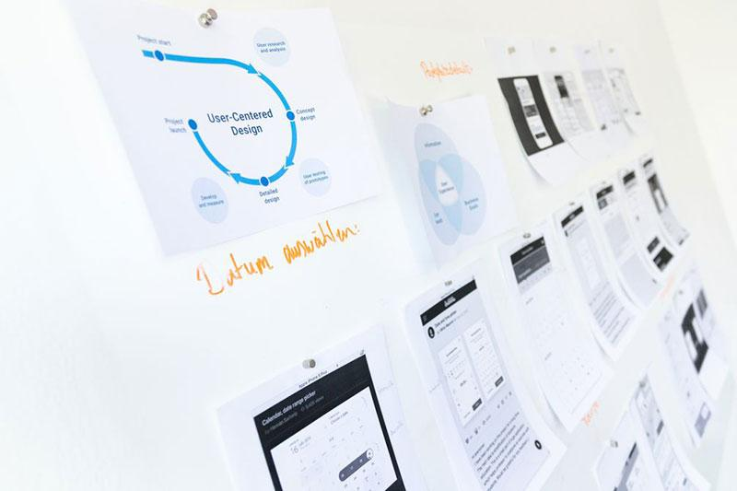
Post-Redesign Services

Once your beautiful new website has launched, [Sender.Company] can provide post-redesign services to help you see the value of your investment while you focus on running your business. We have several options to fit the needs of our clients. Each option costs [Service Cost].

Analytics: We compile usage data and distill it down into simple terms so you
know what’s working and what’s not.

Blogs and Email Marketing: If your company runs blogs and marketing emails,
we can integrate them into your new website and give them the same look.

Offline: We can create a demo of your website’s new functions and give you the
hard copy so you always have something to rely on.

Our Team

[Sender.Company] has been a leader in website design since [Years in Business]. We are a tight-knit group of creative thinkers who understand the impact of a clean, simple, informative, and engaging website. Our unique approach ensures that our clients will not be surprised by the final results because they will have been an integral part of the redesign process, approving all work before it is completed to meet their exact standards. Our goal is simple: creating websites that make an impact.

Portfolio

We pride ourselves on transforming your website into something you can be proud of. Below, you will find the before and after of some of our website redesigns:
Before our web redesign:

[Before.Image]

After our web redesign:

[After.Image]

Pricing

The following is a breakdown of the costs for a website redesign for [Client.Company]:

Name | Price | QTY | Subtotal
Planning | $300.00 | 1 | $300.00
UX/UI | $500.00 | 1 | $500.00
Content Support | $200.00 | 1 | $200.00
Testing/Launching | $1000.00 | 1 | $1000.00
Training Client | $1000.00 | 1 | $1000.00
Programming | $2000.00 | 1 | $2000.00
Support | $300.00 | 1 | $300.00
Post-Redesign Services | $1000.00 | 1 | $1000.00

Subtotal $6300.00
Tax $472.50
Total $6772.50

Billing and Schedule

[Client.Company] agrees to pay 50% of the total upon signing this website redesign proposal and the remainder by [Final Payment Date].

Conditions

Prior to a contractual agreement, this proposal may be amended in consultation with the client, [Client.Company], at the discretion of [Sender.Company].

Acceptance

By signing below, you accept this website redesign proposal. The initial payment, per the aforementioned terms, also enters [Client.Company] into a contractual agreement for services with [Sender.Company].

[Sender.Company] [Client.Company]

[Sender.Signature] [Client.Signature]

[Sender.Date] [Client.Date]

[Sender.FirstName] [Sender.LastName] [Client.FirstName] [Client.LastName]

