Website Redesign Proposal

Prepared for: [Client.Company]

Prepared by: [Sender.FirstName] [Sender.LastName]
[Sender.Company]

Dear [Client.FirstName],

Thank you for considering [Sender.Company] to rebuild your website. We guarantee that we will complete this project on time and within budget. [Sender.Company] has a track record of identifying and achieving important website redesign goals for clients.

The following website design proposal lays out the work that will be done and at what cost. Please contact us by email or phone if you have any questions.

Thank you!

[Sender.FirstName] [Sender.LastName] [Sender.Company]
[Sender.Email] [Sender.Phone]

[Client.Company] would like to revamp its website in order to stay relevant and continue to attract clients. [Client.Company] has faced income losses in the past [Time Period] due to decreased web traffic. The business has a good reputation and presence in [Industry] and would like to expand its operations once more. To do so, [Client.Company] will need a comprehensive website overhaul to keep up with the competition.

[Sender.Company] has a proven track record of increasing online traffic and income for clients after a website overhaul.

We By [Overhaul Date], we are ready to show [Client.Company] recommended adjustments and modifications, design components, answers to current difficulties, and a timeframe for the website overhaul.

Assessment

Websites are one-of-a-kind, and [Sender.Company] understands that each individual or business has distinct wants and aspirations. Our goal is to improve the strength and utility of your website for both you and your clients. First, we meet to determine what works and what doesn't with your present website, as well as what you want to preserve and modify. Then we figure out where the problems are and how to fix them. After [Client.Company] authorises any changes, [Sender.Company] gets right to work on delivering your new website on schedule.

Your satisfaction is our top priority. As a result, we go to great lengths to ensure that your website redesign is seamless and transparent. A redesign can take anything from several months to a year, depending on the breadth of work. While we handle all of the heavy lifting, your input is crucial to the process. We'll set expectations before we start working. Meeting [Client.Companydeadlines ]'s with a website redesign you can be proud of is our top concern.

Objective Timeline
Connecting, planning Up to two weeks
Client approval of changes Up to one week
First draft of redesign created Up to two months
Client approval/changes Up to two weeks
Implement changes Up to two weeks
Final draft of redesign, beta testing Up to three weeks
Client approval and launch Up to two weeks

Here's what to expect during the redesign process while working with [Sender.Company]:

Planning Phase

First, we meet with the client to discuss the benefits and drawbacks of the current website, as well as the next stages. The following items are included in this phase:

- Updating the site map
- Rearranging current content and determining where new information will be placed
- Examining competing websites in order to assemble useful keywords and search engine optimization (SEO)

Development Phase

The rebuild will begin once we are all on the same page. This section contains the following items:

- New home and interior pages
- HTML, CSS, JavaScript compliance
- Content Management System (CMS) creation
- CMS conﬁguration
- Migrating existing content to new site
- Optimization for mobile

It's time to see your new website in action now that the nuts and bolts have been completed. The following items are included in this phase:

- Code and browser testing
- Analytics setup, through Google or others, to capture site user data
- Putting the site to the test to check how it handles video, graphics, and text, and then making any necessary changes.

Launch Phase

We're nearly there. For the client, this is the most exciting part of the website overhaul. The following items are included in this phase:

- New site host setup
- Domain Name System (DNS) transfer
- Setting up email
- Going live

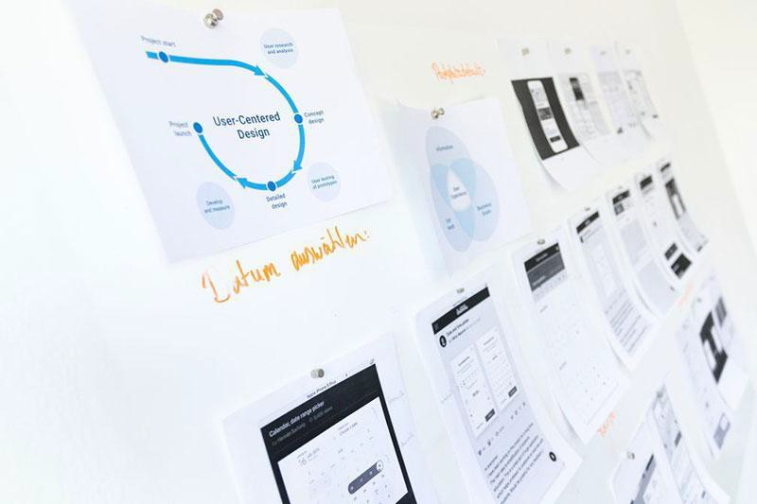
[Sender.Company] can provide post-redesign services to assist you see the return of your investment while you focus on running your business once your gorgeous new website has launched. We offer a variety of options to meet the demands of our customers. [Service Cost] is the price of each choice.

Analytics: We compile use statistics and translate it into plain English so you can see what's working and what isn't.

Blogs and Email Marketing: We can link your company's blogs and marketing emails into your new website and give them the same look.

Oﬄine: We can develop a demo of your website's new features and provide you with a paper copy so you can always rely on it.

Since [Years in Business], [Sender.Company] has been a leader in website design. We're a close-knit group of creative thinkers that recognise the value of a well-designed, easy-to-use, informative, and interesting website. Our innovative method assures that our clients will not be shocked by the final results because they will have been an active participant in the redesign process, authorising all work prior to completion to ensure that it meets their exact specifications. Our mission is straightforward: to create websites that have an impact.

We take satisfaction in creating your website into a work of art that you can be proud of. The before and after images of some of our website redesigns can be found below:

Before our web redesign:

After our web redesign:

The following is a breakdown of the costs for [Client.Companywebsite ]'s redesign :

Name | Price | QTY | Subtotal
Planning | $300.00 | 1 | $300.00
UX/UI | $500.00 | 1 | $500.00
Content Support | $200.00 | 1 | $200.00
Testing/Launching | $1000.00 | 1 | $1000.00
Training Client | $1000.00 | 1 | $1000.00
Programming | $2000.00 | 1 | $2000.00
Support | $300.00 | 1 | $300.00
Post-Redesign Services | $1000.00 | 1 | $1000.00
 |  | Subtotal | $6300.00
 |  | Tax | $472.50
 |  | Total | $6772.50

[Client.Company] agrees to pay half of the total cost when they sign this website redesign proposal, and the rest by the [Final Payment Date].

Conditions

This proposal may be revised in collaboration with the client, [Client.Company], prior to a contractual agreement at the option of [Sender.Company].

Acceptance

You accept this website redesign proposal by signing below. According to the terms of the initial payment, [Client.Company] enters into a contractual arrangement with [Sender.Company] for services.

[Sender.Company] [Client.Company]

[Sender.FirstName] [Sender.LastName] [Client.FirstName] [Client.LastName]

