Ref: SY07

Oceanis 48

Type: Beneteau Oceanis 48
Registered: UK SSR (to transfer to Malta)
Tax Status: VAT Paid
Location: Malta
Price: €290,000

LOA: 14.6M
LWL: 13.86
Beam: 4.74
Draft:2.17M
Light Displacement: 12,594kgs
Deep Ballast weight: 3,550kgs

Construction:

- Built 2016 by Beneteau Yachts (France) Designs by Berret Racoupeau Yacht Design and interior designs by Nauta Design
- Infusion hull built in GRP (Fibreglass), injection moulded deck in glass fibre/balsa sandwich and covered in ‘diamond-point’ non-slip coating.
- Infusion single skin GRP injection inner deck moulding
- Deep cast iron fin keel with stub
- Hung rudder with stainless steel stock
- Teak in cockpit + cockpit seating
- Fully retractable transom, converting into large bathing platform
- ‘Exclusive’ trim package, includes upgraded electronics.

Spars & Rigging:

- Full rig overhaul completed 2021
- 9/10th fractional sloop rig
- Anodized aluminium mast with 2 aft swept spreaders
- Discontinuous stainless steel standing rigging
- Dual adjustable back stays with bottle screws
- In-mast furling
- All running rigging leads aft to cockpit
- Mainsheet mounted on cockpit arch
- Rigid boom vang
- 8 x jammers
- Genoa furling system with drum on deck
- 2 x sheet tracks with travelling cars

Sails:

- Furling Genoa with UV protective strip (original)
- In-mast furling mainsail (original)

Winches:

- 2 x Harken H60.2STC primary sheet winches
- 1 x Harken H46.2 STAECH electric secondary coachroof winch
- 1 x Harken H46.2 secondary coachroof winch

Machinery:

- Yanmar 4JH4TE 80HP diesel engine (serviced June 2021)
- SD60 Saildrive (new 2020)
- 3 blade propellor
- Generator (overhauled 2021)
- Bow Thruster (upgraded version)
- 2 x 200litre fuel tanks (port and stbd aft) with separate filling

Electrics:

- 12 / 220v system including shore supply (both 220v fitted with galvanic isolators)
- 4 x 140Ah Service batteries (new 2021)
- 1 x 110Ah engine battery (new 2022)
- Power distributor
- 2 x 80Ah automatic battery charger
- 12v panel showing fuses, voltmeter, water gauge/warning, fuel gauge/warning
- Victron Battery Monitor
- Victron Inverter
- 12v sockets

Accommodation:

- 6 berths in 3 double cabins
- 2 heads (1 ensuite to master)
- Master cabin forward, twin guest cabins aft
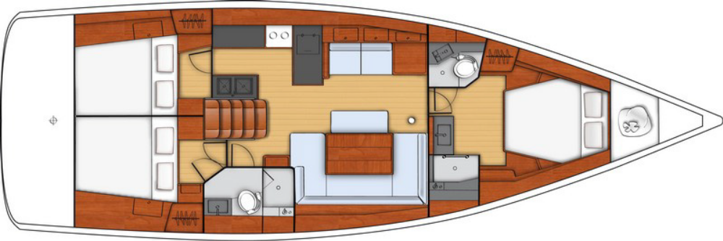

Domestic Equipment:

- Hot/cold pressure water system
- 3 FW tanks (Below fwd bunk 320 litres – below saloon floor 2 x 160 litres)
- 40,000 BTU Dometic Cruiseair air-conditioning throughout (all cabins)
- 2 burner Gas cooker / oven
- 240v induction hob
- 2 x refrigerator (1 top loading freezer, 1 front loading)
- Parquet laminated flooring
- Interior woodwork in Cherry
- Saloon upholstery finished in ‘Commando Natural’
- 2 x panoramic interior windows with concertina blinds
- Mosquito screens on all hatches/ portholes
- Marine toilet with sea smart fresheners
- Holding tank 64L to aft WC
- Various cupboards/drawers for storage
- Seating on pantograph
- LED lighting + reading lights
- Fusion Bluetooth Radio/Stereo
- Internal / external Speakers
- USB sockets
- Mirrors throughout
- Marine mattresses in cabins (drymat fitted under fwd & starboard cabin)
- Electric Drain pump for ice box drain

Navigation Equipment:

- B&G: Helm consoles to port and starboard - 1 T41 Graphic display
- B&G: Sensor (Log, Speedometer, Temperature)
- B&G: Wind Sensor (Windvane, Anenometer)
- B&G Port and Starboard Helm Consoles - Zeus2 7" wide MFD touch screen (GPS/Plotter)
- B&G Autopilot
- Fixed DSC VHF
- AIS (Send/Receive)
- EPIRB
- Radar reflector

Inventory:

- 1500w Electric anchor windlass c/w remote control and chain counter in cockpit
- Anchor with chain + warp
- Ankarolina flat anchor line
- Tender + outboard
- Outboard engine bracket – single
- Full safety equipment including liferaft
- Manual / Auto bilge pumps
- Cockpit shower
- Folding cockpit swimming ladder
- Cockpit table
- Stainless steel pulpit / pushpit
- Adjustable bimini
- Spray hood
- Full cockpit covers including table + wheels
- Self bailing chain locker with clench bolt
- Stainless steel bow fitting with dual rollers
- Jackstays
- Various engine spares
- Crockery, cutlery, glassware
- Sundry deck ware
- Fenders / moorings etc

Brokers’ Comments:

With its attractive sleek silhouette and a deck plan optimized for long cruises, the Oceanis 48 is perfectly proportioned. Important options in terms of space organization and ergonomics distinguish her from others. She urges you to set off on long cruises and experience very comfortable stopovers. The mainsail arch and centered mast makes her very well balanced and her hull offers great stability and comfort at all speeds. The Oceanis 48 is a distillation of innovative developments making her safe, fast and incredibly comfortable, inside and out.

This particular Beneteau Oceanis 48 is being proudly presented for sale; coming very well equipped with air-conditioning, generator and more! The current owner has spared no expense in ensuring this yacht is being sold with peace of mind, having completed a major overhaul (including rig) in 2021. Contact us now to get onboard this superlative yacht!

Disclaimer:
the above details are given in good faith, however shall not form part of any contract or agreement, unless otherwise concluded.

