Ref: SY01

First 25.7
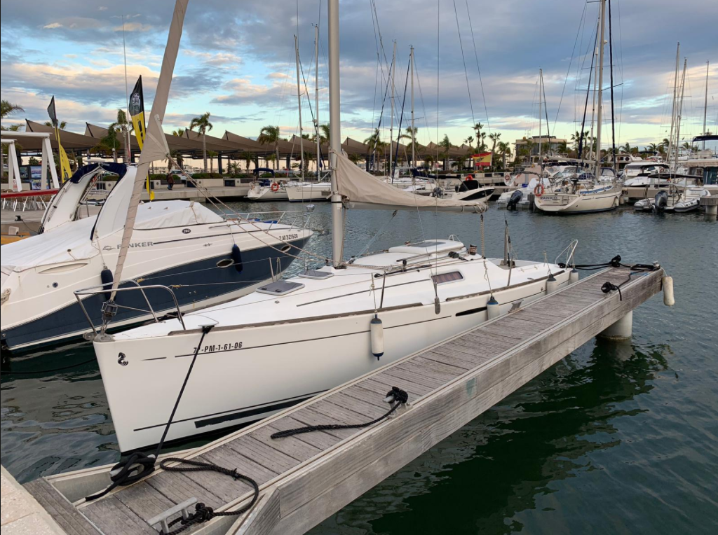

Type: Beneteau First 25.7
Registered: Malta
Tax Status: VAT Paid
Location: Malta
Price: €30,000

LOA: 7.50M
Beam: 2.75M
Draft: 0.85 / 1.85M

Displacement: 2150KGS

Construction:

- Beneteau First 25.7, built by Beneteau Yachts (France) in 2005 and designs by well reputed Groupe Finot.
- Monolithic hull design in polyester, deck in balsa type fibreglass. Deck is finished with
‘Picot’ non-slip surface.
- Retractable cast iron keel – pivoted and adjusted via a manual system at saloon table
- Twin retractable / adjustable rudders attached at transom.
- Teak cockpit seating
- Tiller steering system
- Seacocks upgraded to bronze type

Spars & Rigging:

- 9/10th Fractional sloop with 1x19 stainless steel shrouds.
- Adjustable single backstay with tackle
- Lazy Bag & Lazy Jack system
- Complete running rigging (replaced as needed)

Sails:

- Fully battened mainsail
- Furling Genoa

Winches:

- 2 x Harken ST16 winches mounted on coachroof

Machinery:

- Yanmar 14HP diesel engine (original, always serviced)
- Shaft drive

Electrics:

- 12 / 220v system including shore supply
- 1 x BOSCH 105Ah domestic battery
- 1 x BOSCH 72Ah engine starter battery
- WAECO PerfectCharge IU1512 automatic battery charger
- 12v socket at chart table

Accommodation:

- 4 berths in 1 double cabin + saloon berths

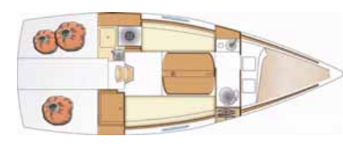

Domestic Equipment:

- Pressure water system
- Salt water foot pump at galley
- Polyester sink
- ENO 1 burner gas cooker
- LPG Gas system
- Upgraded LED Lighting
- Leather upholstery (great condition)
- Jabsco Manual Toilet
- Folding saloon table
- Pioneer Bluetooth stereo / radio
- Internal / external waterproof speakers
- Sliding entry doors into fwd cabin
- ‘Pop on’ fabric blinds for portholes/hatches

Navigation Equipment:

- Raymarine ST1000+ Autopilot c/w handheld remote rod
- Raymarine ST40 Bidata
- Raymarine DSC VHF
- Raymarine windex at mast top
- Radar Reflector
- Plastimo steering compass
- Inclinometer at chart table

Safety Equipment:

- Foghorn
- Fire extinguishers
- Manual Bilge pumps

Inventory:

- Spade 5KG anchor
- 20m of chain + 10m warp ?
- Mooring cleats
- 6 x spinlock clutches
- Bimini on arch
- Lewmar deck hatches
- Sundry deck ware / fenders etc

Brokers Comments:

This is a fantastic opportunity for either the keen sailor, or for someone ready to take on the wonderful world of race sailing. This little pocket rocket is an incredible sailor, whilst offering the comforts of a what feels like a larger boat. The owner has always maintained the yacht including the engine / electrics / hull and sails. It is also worth noting the low engine hours!

This yacht is a real gem at a great price, what more do you want?!

Disclaimer:
the above details are given in good faith, however shall not form part of any contract or agreement, unless otherwise concluded.

