CYCLADES 43.3

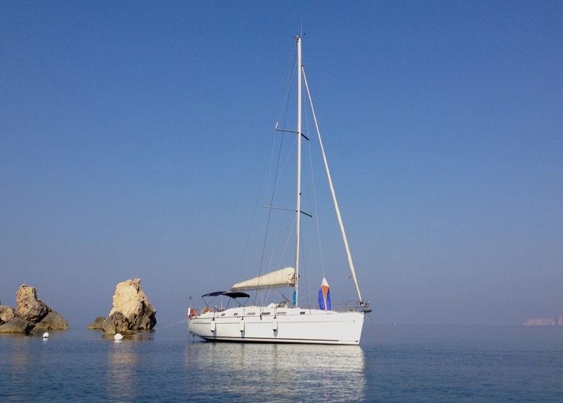

Model: Beneteau 43.3 Cyclades
Flag: Malta
Year Built: 2005 launched 2006
Tax Status: VAT not paid
Price: EUR89,000
Location: Malta

LOA: 13.26 M
Beam: 4.43 M
Draft: 2.00 M
Displacement: 8980kgs
Construction:

- Built 2005 by Chantiers Beneteau (France) in GRP hull and deck.
- Designs by Berret-Racoupeau
- Fin bulb keel with spade rudder
- Twin helm with teak seating

Spars and Rigging:

- 9/10th masthead sloop rig with furling headsail
- Sparcraft mast & boom in anodized alu with twin aft swept spreaders
- All controls lead aft to cockpit
- Lewmar deck vent hatches
- Lazy Bag & Lazy Jack

Sails:

- Semi-battened Mainsail (original)
- Furling Genoa (original)
Winches:

- 2 x Harken ST44 primary winches
- 2 x Harken ST40 secondary winches

Electrics:

- 12v / 220v including shore power mains
- 2 x 140Ah Varta service batteries
- 1 x 80Ah engine battery
- 1 x 120Ah bow thruster battery (new 2020)
- Victron Battery charger

Machinery:

- 1 x 54 HP Yanmar diesel engine with Shaft drive

Thrusters:

- BCS 100kgf tunnel Bowthruster

Accommodation:

- 8 berths in 3 double cabins & convertible saloon
- 3 heads c/w toilet, washbasin & shower partition
- Fully equipped galley to port
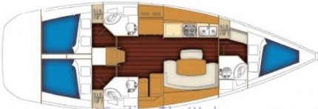

Domestic Equipment:

- 12/220v circuit including shore supply
- 2-burner ENO gas cooker, grill & oven
- 12v top-loading fridge/freezer compartment
- Hot/Cold pressure water system
- Double stainless steel sink
- Radio CD player / Stereo MP3 / USB
- Hot/cold deck shower
- AKURA Flatscreen TV
- 12v fans throughout
- Leather upholstery
- Manual flush toilets
- Fuel Capacity: 400 ltrs
- Water Capacity: 980 ltrs
- Holding Tanks: Yes

Navigation Equipment:

- RAYMARINE E80 GPS/plotter
- RAYMARINE ST60001 Autopilot
- RAYMARINE ST60+ Tridata (wind/speed/depth)
- RAYMARINE ST60 wind instrument
- ICOM VHF

Safety Equipment:

- Liferaft
- Life Jackets
- Fire extinguishers
- First Aid kit
- Safety Flares kit
- Horseshoe buoy
- GME EPIRB
- Repair kits
- Fog horn

Inventory:

- Electric anchor windlass
- Main anchor with 50Mchain and bow roller
- BiminiS/S bathing ladder
- MAGMA BBQ
- Cockpit table & wheel covers
- Cockpit cushions

Brokers Comments:

The Cyclades is a real cruising yacht where convenience is everywhere, double helm position to improve comfort when sailing and moving around the boat; a cockpit designed so that all manoeuvres are simple, genoa winches near the helm, instrument supports and all running rigging leading back to the cockpit. The Cyclades 43.3 is certain to give you moments of pure pleasure.

This particular Cyclades 43.3 is coming suitably equipped for coastal / offshore cruising; and is being presented for sale in great condition, having been fully serviced (including engine and hull).

Disclaimer:
the above details are given in good faith, however shall not form part of any contract or agreement, unless otherwise concluded.

