Women with Disabilities Australia

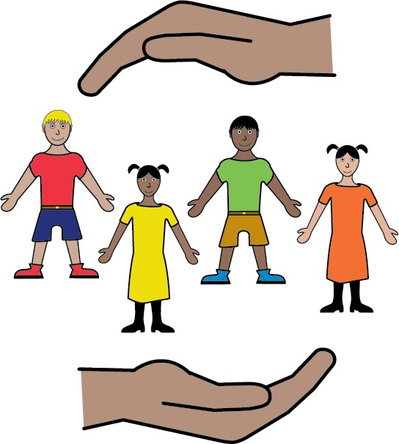

Child Protection

Child Protection Part 1
Are my children safe at home?

This book asks us:

Are my children safe at home? This is called Child Protection.
Some people call it The Department.

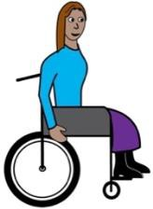

We wrote this book for women and girls with disability.

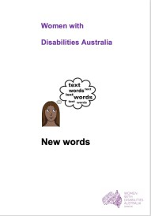
Read more about disability in our book New Words.

We are Women with Disabilities Australia.

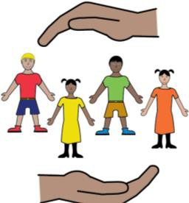
What is Child Protection?

Child Protection helps children to be safe. It is run by the government.

The staff see how you look after your children. They also talk to:
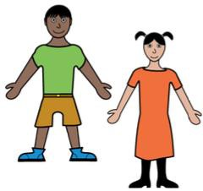
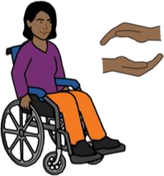
- day care centre staff

- school staff

- other family.

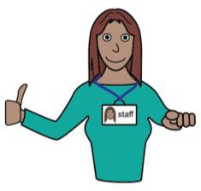
Child Protection may say everything is OK.
Like:

- there is food your child can eat

- your child has a safe place to sleep.

That is good.

But:

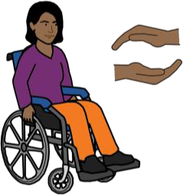
Sometimes Child Protection may say:

- your child is not in a safe home

- you are not caring for your child in a safe way.

Like:

- there is no food to eat

- someone in your home hurts your child.

This is not good.

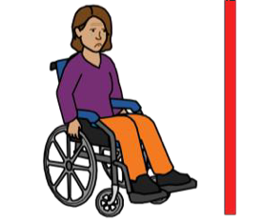
Child Protection says your child cannot live with you.

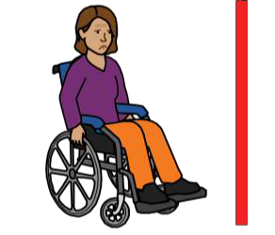
Your child cannot live with you

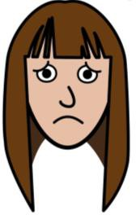
You may feel very upset. Your child may be very upset.

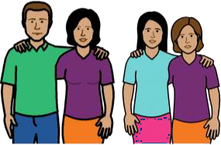
Talk to someone you trust.

Like:

- a family member

- a friend.

You can also call:

- Lifeline 13 11 14

- Beyond Blue 1300 22 46 36

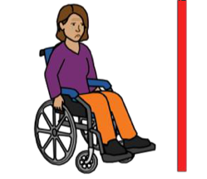
Your child cannot live with you. What next?

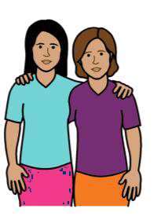
Your child may stay with a member of your family. Like:

- your mother

- your aunt

- your sister.

or

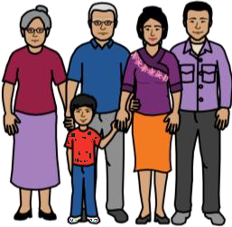
Your child may stay with a foster family.

A foster family is a family you do not know.

The government has checked this family.

Your child will be safe with the foster family.

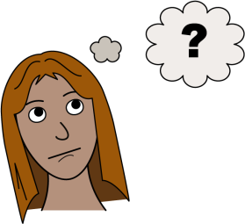

What do you do now?

You cannot see your child.

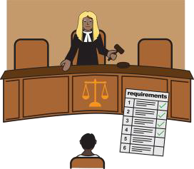

You will need to go to Court.

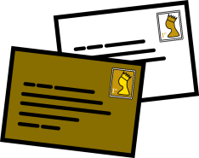

You will get a letter to tell you when this is.
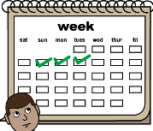
It will be about 3 days before you go to Court.

Before you go to Court

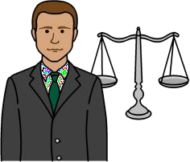

Talk to a lawyer.

Find a lawyer.

Call: 1800 050 321

or go to:

www.familyrelationships.gov.au/legal-advice

Intellectual Disability Rights Service (IDRS)
IDRS can help you find a lawyer. You need to have an intellectual disability to get help from IDRS.
Call: 02 9265 6300

Website: www.idrs.org.au

Get ready for Court

Read Part Three of this book:

“I want my children back.”

“I need to go to Court.”

There is information about:

- some more things to do before you go to Court

- the day of Court

- who will be in the Court room?

- in the Court room.

There is information about your child. Like:

- when can I see my child?

- how do I see my child? This is called ‘Contact’

- during Contact

- ideas to say goodbye.

To find out more

Talk to some-one you trust.

Like:

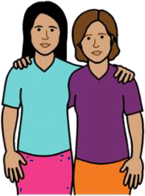

- a friend

- a family member

- your lawyer

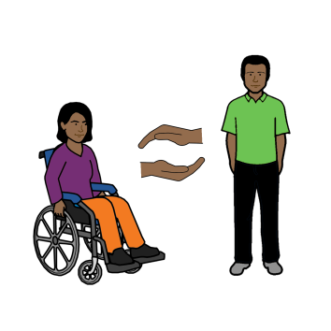

- a disability advocate.

Go to:
https://disabilityadvocacyfinder.dss.gov.au/disability/ndap

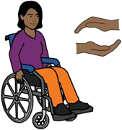
Child Protection Part 2

I want to see my children. What the Court says.

This book is about when you see your children. This is called Contact.
It is a part of Child Protection.

We wrote this book for women and girls with disability.

Read more about disability in our book New Words.

We are Women with Disabilities Australia.

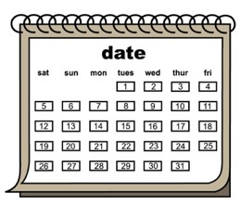

When can I see my child?

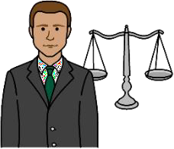
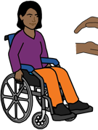
Before you go into Court, tell your lawyer:
- where you want to see your child

- when you want to see your child.

Like every 2 days at home.

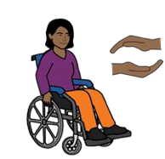
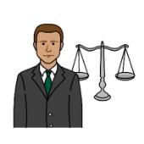
Your lawyer will talk to you about what the Court might say is OK. Like 2 afternoons a week in a Child Protection room.

Your lawyer will tell the court.

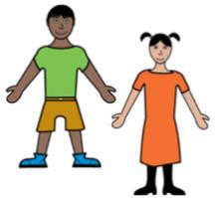
The judge listens to all the lawyers.

The judge will decide how many times a week you can see your child. This is called Contact.

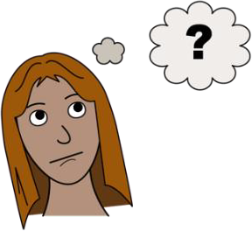

How does Contact work?

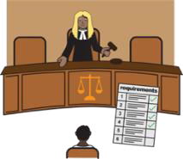
You have your paper from the judge. This is called a Court Order. It tells everyone the rules about your Contact.

Like you can see your child on Tuesday and Thursday

- for 2 hours

- in a Child Protection room at their office

- with a Child Protection staff person with you.

Make the times to see your Child.

A person from Child Protection will help set up your visits. This is your Case Worker.

A different Child Protection staff member may be there when you see your child.
This person is called a Contact supervisor.

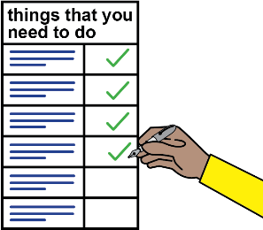
Get ready for Contact

Go to all the visits with your child.

Tell your case worker if you cannot go.

Before the visit check that you know:
- where you need to go

and

- how to get there. Like by:

  - bus
  - train
  - car.

and

- take a snack. Like fruit or nuts

- take a drink. Like water or juice

This is for you and your child.

Take something to do with your child. Like:

  - a toy your child likes

  - a book your child likes.

When you have Contact

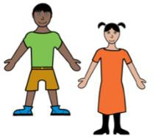
It is your job to look after your child.

Your child may ask when they can come home. Tell your child
- you love them

- you will see them soon.

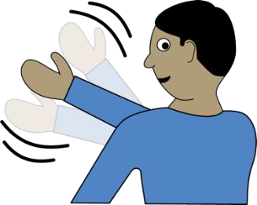
Ideas to say good-bye

It is hard to say goodbye.

Get some ideas from people you trust.

Like:

- a family member

- a friend.

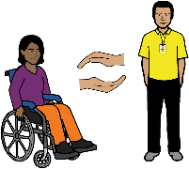

- an advocate.

You can also call:

- Lifeline 13 11 14

- Beyond Blue 1300 22 46 36

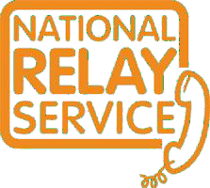
You can use the National Relay Service

when you call a service

Call: 1800 555 677

TTY: 133 677

Ask for: 1800 737 732

Need a translator?

Call: 131 450

Ask for: 1800 737 732

Child Protection Part 3
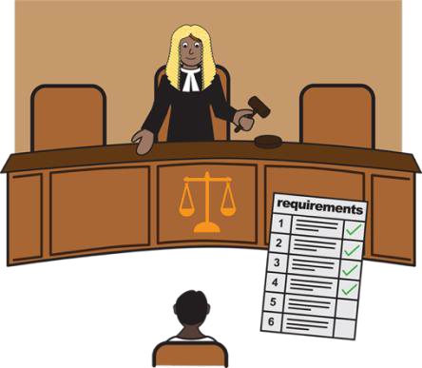

I want my children back. I need to go to Court.

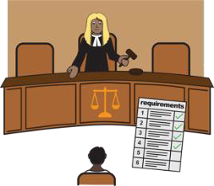

This book is about how you get to see your children again. It about when you go to Court.
It is a part of Child Protection.
Some people call this The Department.

We wrote this book for women and girls with disability.

Read more about disability in our book New Words.

We are Women with Disabilities Australia.

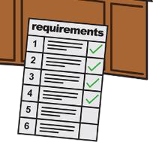
Things to do before you
go to Court

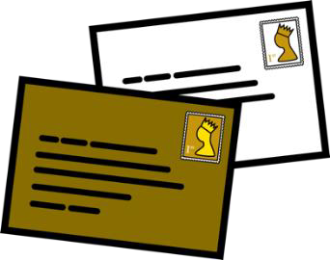
You will get a letter about Court. It will tell you:

- what day you need to be there

- what time you need to be there

- what Court you need to go to.

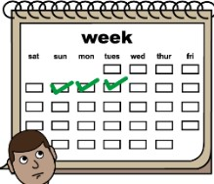

Your Court date will be about 3 days away.

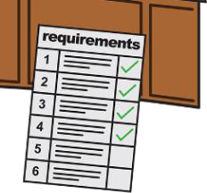

There are some things you need to do.

1. Talk to a lawyer.

Find a lawyer.

Call: 1800 050 321

or go to:

www.familyrelationships.gov.au/legal-advice

Intellectual Disability Rights Service (IDRS)

IDRS can help you find a lawyer. You need to have an intellectual disability to get help from IDRS.
Call: 02 9265 6300

Website: www.idrs.org.au

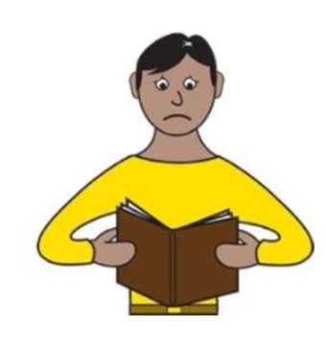

2. Read the report about your child.

Child Protection will write a report. It will say:

- why they took your child away

- what you need to do to make your home safe.

Like:

  - help for you to be a good mum

  - to move away from someone who hurts your child.

The report may be very long. It is called a First Bundle.

The report is very important. You will get the report:
- the day before or

- on the day you need to go to Court.

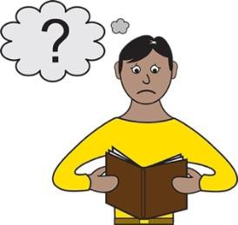

You need to read

- the report

- any other papers.

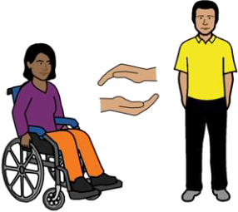

Someone can help you read them.

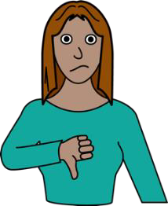
You may think some things you read are:

- not fair

or

- wrong.

Put an X next to these bits.

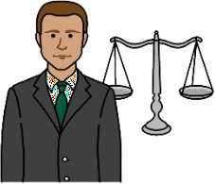

Give all the reports to your lawyer.

Show your lawyer the bits you have marked. The lawyer may ask you what it needs to say.

- Get ready for the day at Court

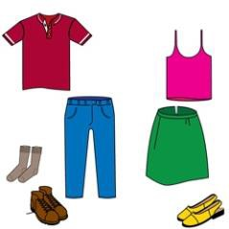

Think about what you will wear to Court. Check that your clothes are clean.

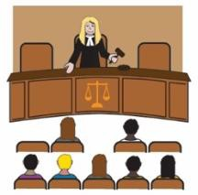
You need to take some things to Court. We wrote a list for you.
Get all the things on the list.

The list is on pages 40 to 44

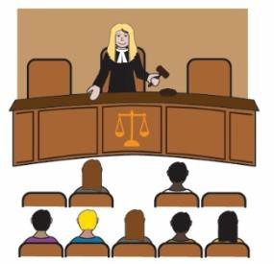
You can have someone to be there for you in Court. Think about this now.
It can be:

- a friend

- a family member

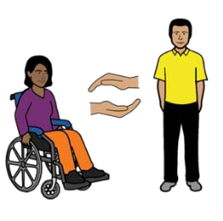

- an advocate

- your lawyer.

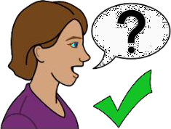
Ask the person before you go to Court. Can the person be there on that day?
Can the person be with you in the waiting area?
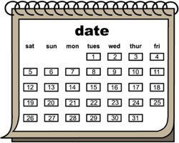

The day of Court

Put on your clean clothes. Check that your clothes look neat.

You may need to wait a long time. Take some food. Take a drink.

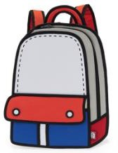

Put the papers from the list in your bag.

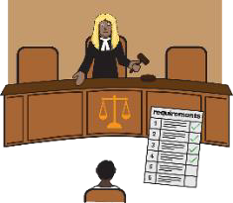

At the Court House

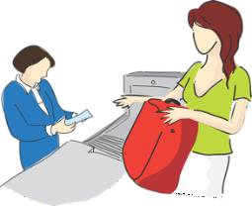
You will need to go through a security check. It is like at the airport.

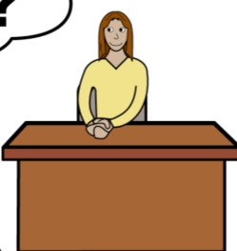

Go to the front desk. Tell them your name.

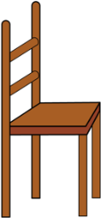

The staff will tell you where to sit. It will be outside the Court rooms.

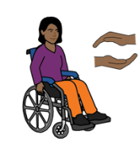

You may talk to your lawyer.

The lawyer will find a private room to do this.

Do not put headphones on in the waiting area. You will not hear your name called.

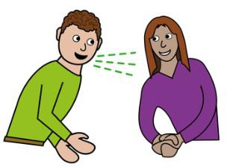
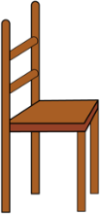
Listen for your name.

Listen for the Court room you need to go to. It will be on the loudspeaker.
The judge is ready for you.

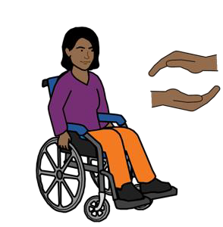
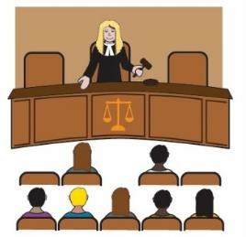
34

Who will go into the Court room?

- you

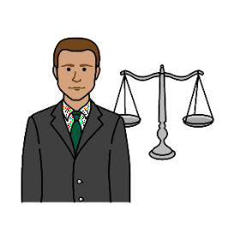
- your lawyer

- a lawyer for your child

- maybe a lawyer for the other parent

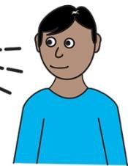

- maybe the other parent.

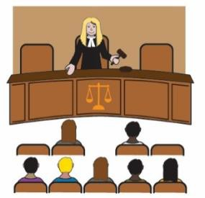

In the Court room

A judge sits at the front of the Court. The judge faces you.
They sit behind a long desk.

Listen to the judge.

The judge is the boss of the Court room.

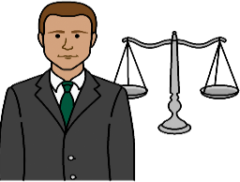
Only the lawyers talk in the Court room. Your lawyer speaks for you.

But

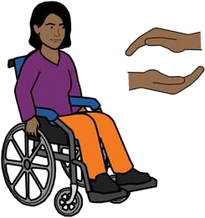

You can speak too.

Talk to your lawyer about this.

The lawyers and judge use lots of big words.

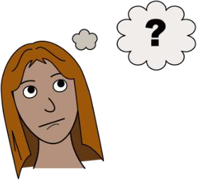

It can be hard to understand.

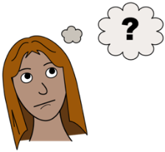

You may not understand everything said in Court. That is ok.

Try to write down what you do not understand.

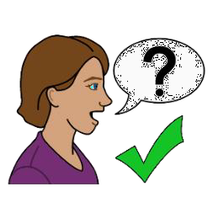

Ask your lawyer about it after.

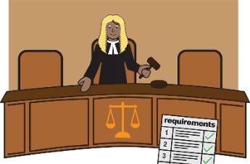
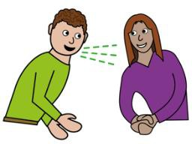
The judge must listen to:

- your lawyer

- the lawyer for your child

- the lawyer for Child Protection

- the lawyer for the other parent.

The judge will:

- ask the lawyers about where your child can live now

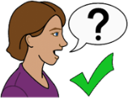
and

- decide where your child lives now.

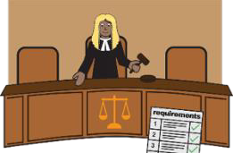

The judge may need more information.

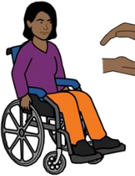
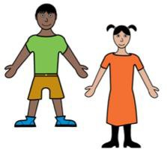
You may not take your child home on the day.

You will need to go back to Court.

The judge will tell you:

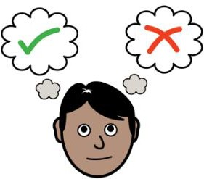

- who will make the decisions about your child during the Court case.

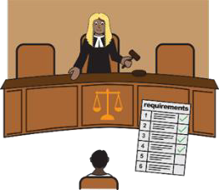
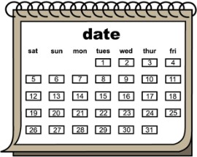
- when you need to go back to Court.

The judge will also tell you:

- how many times you can see your child

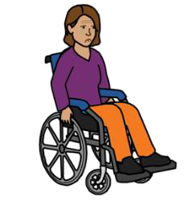

- who has to be there. Like someone from

Child Protection. This is called Contact.

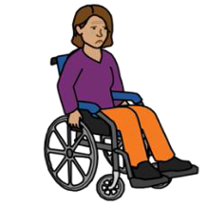
Read about Contact in the Book:

“I want to see my children. What the Court says.”

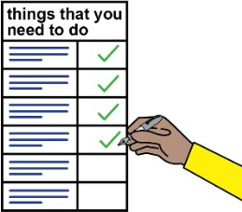
My list of things for Court

Tick the purple box when the job is done

Court date

- My Court date is

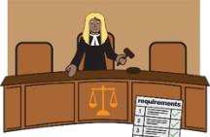

2. The Court address is ____

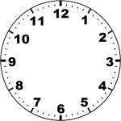
- Be there are at _

People I need to talk to before Court

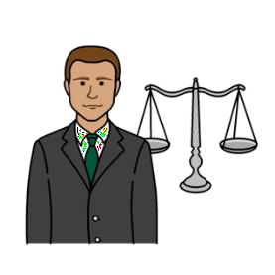

- Find a lawyer. Go back to page 9

- Do I need someone to be with me on the day?

Yes No

Who?

will meet me at the Court

will come with me from home.

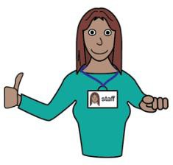
- Do I need support staff? Like help to toilet.

Yes No

Who? ____

will meet me at the Court

will come with me from home.

Things to find now.

I must take these things to Court.

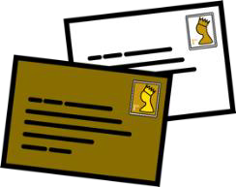
- Court Attendance Notice or
Letter about my Court date

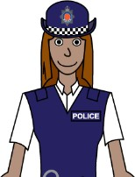

- My police statement

- Notepad and pen

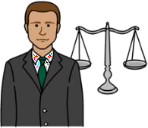

- Other things the lawyer wants.

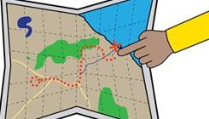

My plan to get to Court

- I will go to Court by .

- I need to catch the at .

- I need to leave home at .

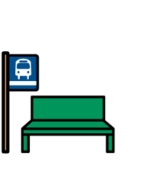

- I will get off the at .

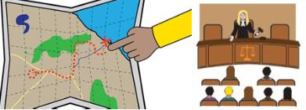
- I know how to get to Court from the stop.

Other things I need to do

- Choose the clothes I will wear.

- Pack any pills I take in the daytime.

- Pack a snack. Pack a drink.

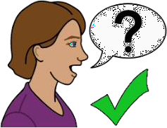

To find out more

Talk to someone you trust.

Like:

- a family member

- a friend.

- an advocate.

- your lawyer

You can use the National Relay Service

when you call a service

Call: 1800 555 677

TTY: 133 677

Need a translator?

Call: 131 450

Thank you

Who wrote this book?

Women with Disabilities Australia wrote this book in 2019-2020. This book is for general education and information only.

Copyright

© Copyright

Women with Disabilities Australia (WWDA) Inc. 2020.

All intellectual property rights, including copyright and patents, in this book is owned and licensed by Women with Disabilities Australia Inc.

Thank you for the money to write this book.

The National Disability Insurance Scheme gave Women with Disabilities Australia some money to help build this website.

The images used in this book

Easy on the I Images © 2019 Leeds and York Partnership NHS Foundation Trust. Used with permission. www.easyonthei.nhs.uk

The Picture Communication Symbols © 2019 by Mayer Johnson LLC a Tobii Dynavox company. Used with permission. www.tobiidynavox.com

Logos. Used with permission.

