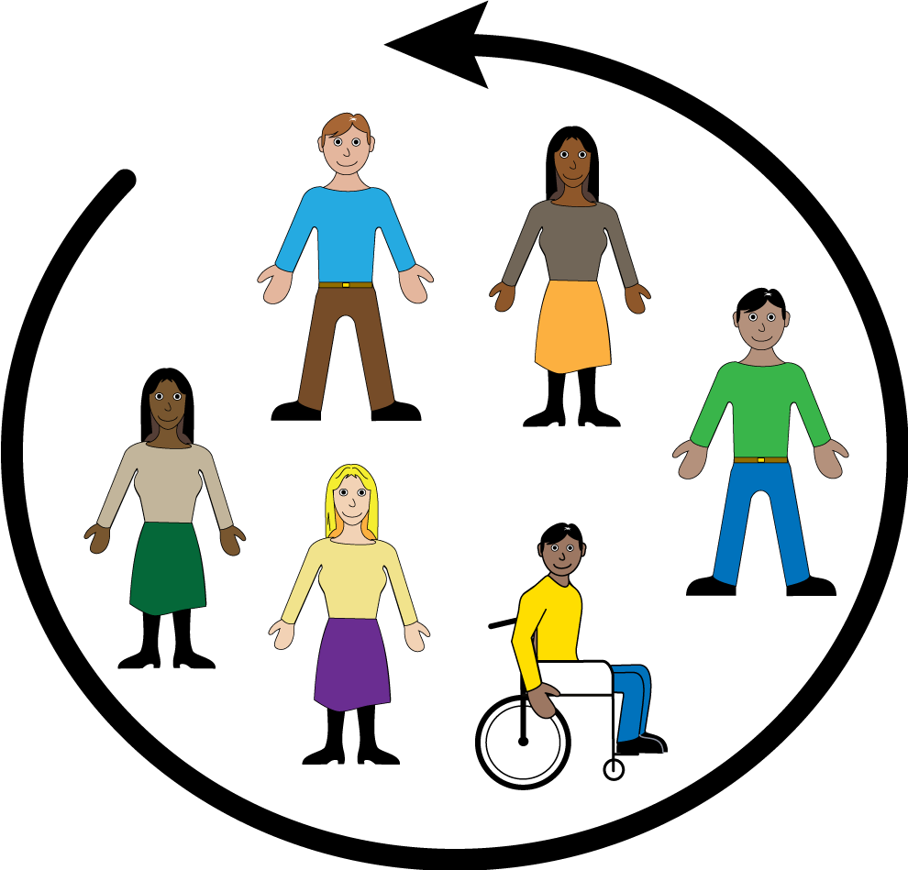
Kirriji-jji kuntta Disabilities Australia

Book 3
Ngarunyu-murra kapi jukula part
Anyul ngini kirriji-jji kuntta Disabilities Australia.
Anyul ngini pakinjarl WWDA alaparra anyal wangkan

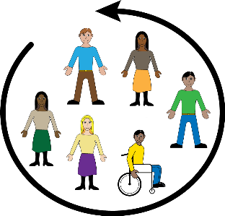
Book 3
Ngala book ngini kirriji-kki kapi partarta-kka appa ajjul kuntta Disabilities mirlamirla-jirra disability-kki kanyyu book-kana apparr-kka

Ngala book ngini kirriji-kki kapi partarta-kka appa ajjul kuntta disability.

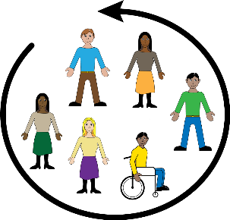
Participation
Ngala ngini jukunjuku karnttu ngala-kana

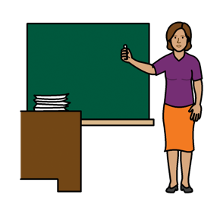

- Angi nyanjiki kapi apijiki scholl-kka

- Angi pukunjinjiki

- Angi appijiki events-kka

Kapi

- Angi vote jinjiki elections-kana

Alaparra angi right kuntta

Kirriji Kapi partouta-kka appajul kuntta disability-jji kuntta right kapi help-kka jukunjuku-part

      - Information-kki kapi jartu ngarra ngala ngini
- Easy apparr-kka
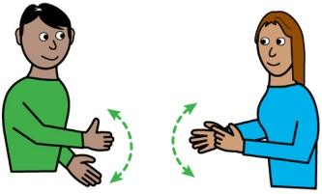
- Kumpu pakinjiki
- Kapi signs-kki

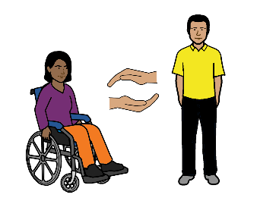

      - a support worker to help.

Ngala Australian Government must support wakapi kurunta kirriji-jji appa ajjul kuntta disabilities

Like
- Kirriji-jji kuntta Disabilities Australia

- Kirriji-jji kuntta Disabilities Victoria

- Kirriji-jji kuntta Disabilities ACT

- Kirriji-jji kuntta Disabilities WA

Ngala Australian government ngini

- Nyunjuku information kirriji-kki kapi partarta-kka disability jangu kapi jukunjuku part

- Nyunjuku Wangari-kki kirriji-kki kapi partarta-kka appa ajjul kuntta disability jukunjuku part kapi leaders

- Nyunjuku information-kka United Nations-kki kirriji-kki kapi partarta-kka appa ajjut kuntta disability.

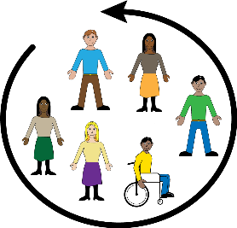
Ngala international kapi rules wangkan kirriji-kki kapi partarta-kka appa ajjul kuntta disability kunula right kapi jukula part like:

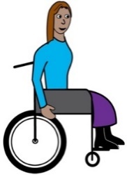
- UN Convention ngala Rights ngini karrinyi-ngini disability jangu

- International Covenant ngala Economic Social kapi Cultural Rights-kki

Ngala Australian Government-jji Kuntta appa ajjul pakinyi pappers kapi ngala rules. Ngala Australian Government-jji ngirrjanjiki ngayitinya rules

Kamanta

Nyayiji pakinyi ngala book
Kirriji-jji kuntta Disabilities Australia-jja pakinyi ngala book 2019
Ngala book ngini General education-kki kapi information-kki

Copyright
© Copyright
Copyright © Copyright kirriji-jji kuntta Disabilities Australia WWDS Inc 2019

Wakapi intellectual anyinyiginyi rights including Copyright kapi patents karnttu book-kana arjurnunginyi kapi licenced kirriji-ngarra appa ajjul kuntta Disabilities Australian Inc.

Kamanta ngala Wangari-kki
Ngala National Disability Insurance Scheme-jji nyunyu Wangari kirriji-kki Disability jangu Australia website

Ngala images ngini karnttu fact sheet-kina
Easy jana images© 2018 leeds kapi York mappu NHS Foundation, kapi trust-kki ala permission-jangu www.easyonthei.nhs.uk

