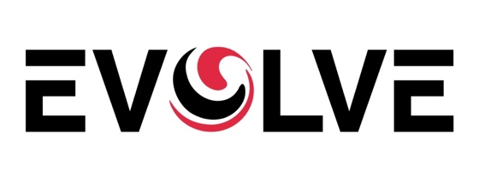
Admission Statement on COVID-19
You are seeking admission to our facility during a very uncertain time as we, along with the rest of the world, respond to COVID-19. As many news sources have noted, nursing homes are on the front lines of this pandemic. COVID-19 is highly contagious, and the frail elderly and immunocompromised residents that we serve are the most at risk.
Our goal is to be as open and transparent as possible about the dangers of COVID-19. We understand that these risks may factor into your decision to become a resident at our facility.
We have adopted a number of measures designed to protect our residents and staff. These include a no visitor policy, enhanced health screening of residents and staff, and other measures informed by guidance from federal agencies, such as the Centers for Disease Control (CDC).
Unfortunately, despite our efforts, like so many other nursing care communities, we too have had some of our residents and staff members test positive for COVID-19. While this is not unexpected, it still saddens us, and our hearts go out to those affected. We have notified our local and state departments of health and will continue to work with them to monitor our active cases. [Insert information on any additional steps that you will be implementing and believe are important to share.]
Rest assured, if we need to contact a family member with updates about a specific resident, we will reach out directly. But, also, please note that out of respect to our residents and their families and, in accordance with privacy laws, we will not be sharing any details regarding the health care of any of our residents publicly (unless we are required to do so by law).
We know that this crisis is particularly challenging for our residents and their families, and we empathize with your feelings of separation and vulnerability. We are doing what we can to ease these feelings, and our staff has been performing heroically. While many people are staying home during this crisis, they show up every day to do the essential work of caring for our vulnerable residents with dedication and purpose for the greater good. If you have any concerns, please let them know.
[Optional (include or remove signature line at your preference)]

Resident Representative
DISCLAIMER (REMOVE BEFORE USING)
This document is intended to be informational only and is not intended to be nor is it legal advice. EVOLVE Legal Solutions LLC (EVOLVE) disclaims any and all liability related to or arising from the information contained in this publication. This document is provided “as is” without any express or implied warranty. EVOLVE makes no guarantee that this document will meet your requirements or be of use to you for any specific purpose or application.

