

**Mechanical automat chip operated-refund (column-model)**

**datasheet (version 2020-04)**

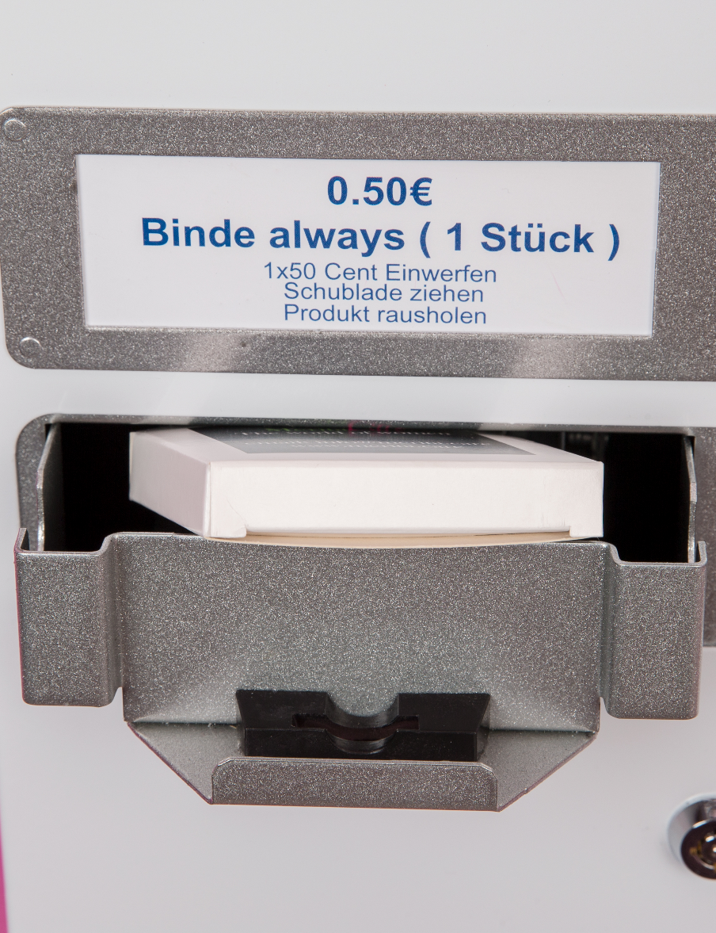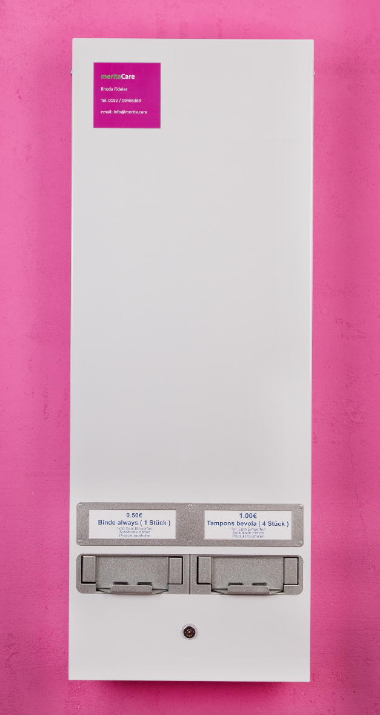

[**www.merita.care**](http://www.merita.care) **/** [**info@merita.care**](mailto:info@merita.care) **/ Tel. +49 0152 09465369 0946536909465369**



**Description**

This 2 column machine is a robust, space saving unit offering maximum product capacity with the option to dispense 2 different products.

The design of the drawers is made in such a way that the machine is suitable for the use of chips. The chip is dispensed out again after being used.

Ideal for any indoor location – we do not recommend installing the machine outdoors.

**Technical Data**

* weight: 13 kg
* payment system: chip operated
* functions completely mechanically (by pulling drawer)
* 2 product columns (capacity: 2 x 40 packages)
* requires neither battery nor electrical power supply
* lockable

[**www.merita.care**](http://www.merita.care) **/** [**info@merita.care**](mailto:info@merita.care) **/ Tel. +49 152 09465369 0946536909465369**

[**www.merita.care**](http://www.merita.care) **/** [**info@merita.care**](mailto:info@merita.care) **/ Tel. 0152 / 09465369 0946536909465369**