Mechanical automat coin operated (column-model)
datasheet (version 2020-04)
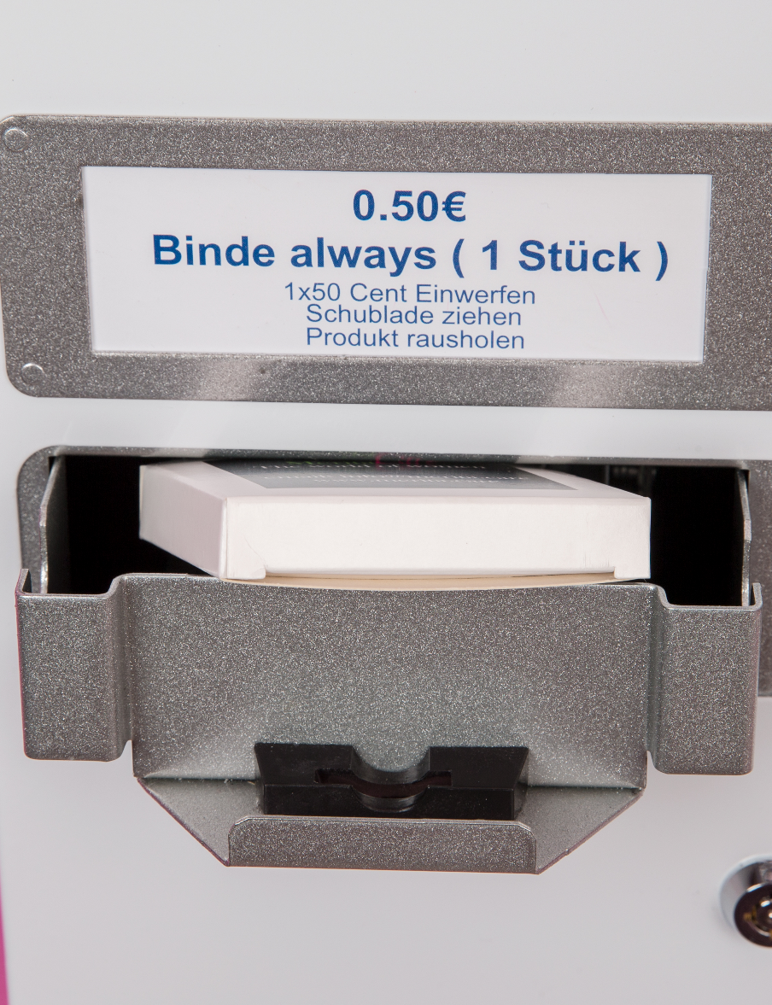
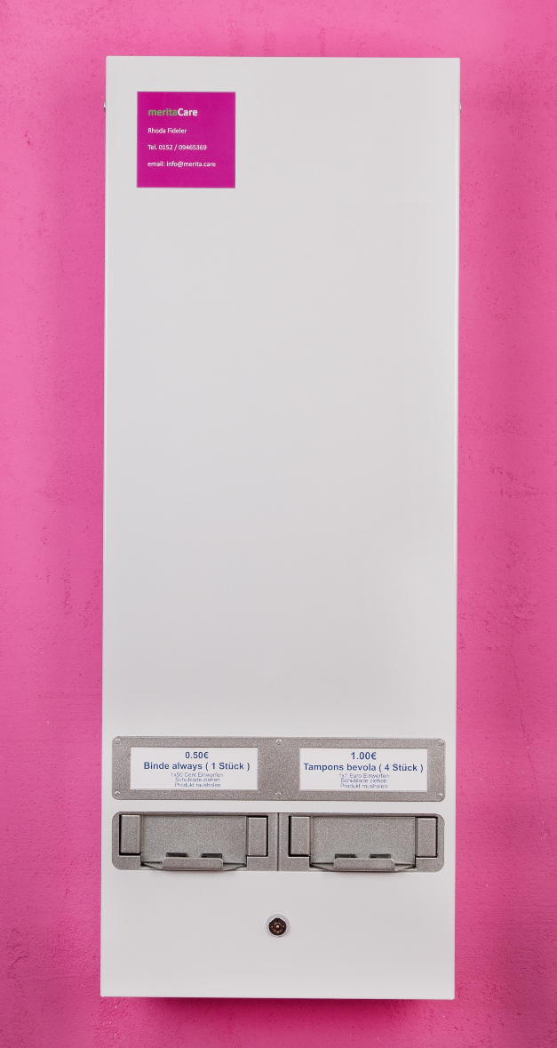

www.merita.care / info@merita.care / Tel. +49 152 09465369 0946536909465369
Technical Data
- weight: 13 kg
- dimensions: height 90cm x width 33 cm x depth 14cm
- payment system: coin operated
- functions completely mechanically (by pulling drawer)
- 2 product columns (capacity: 2 x 40 packages)
- requires neither battery nor electrical power supply
- lockable
- does not give change

Description
This 2 column machine is a robust, space saving unit offering maximum product capacity with the option to dispense 2 different pack sizes at 2 different vend prices.
The design of the drawers is made in such a way that the machine is suitable for the coins to be used.
example:
- left product column: suitable for 50cent-coine
- right product column: suitable for 1€-coin
(other price versions are available on demand)
Ideal for any indoor location – we do not recommend installing the machine outdoors.

www.merita.care / info@merita.care / Tel. +49 152 09465369 0946536909465369
www.merita.care / info@merita.care / Tel. 0152 / 09465369 0946536909465369

