Battery operated coin automat (rectangle model)
data sheet (version 2020-04)

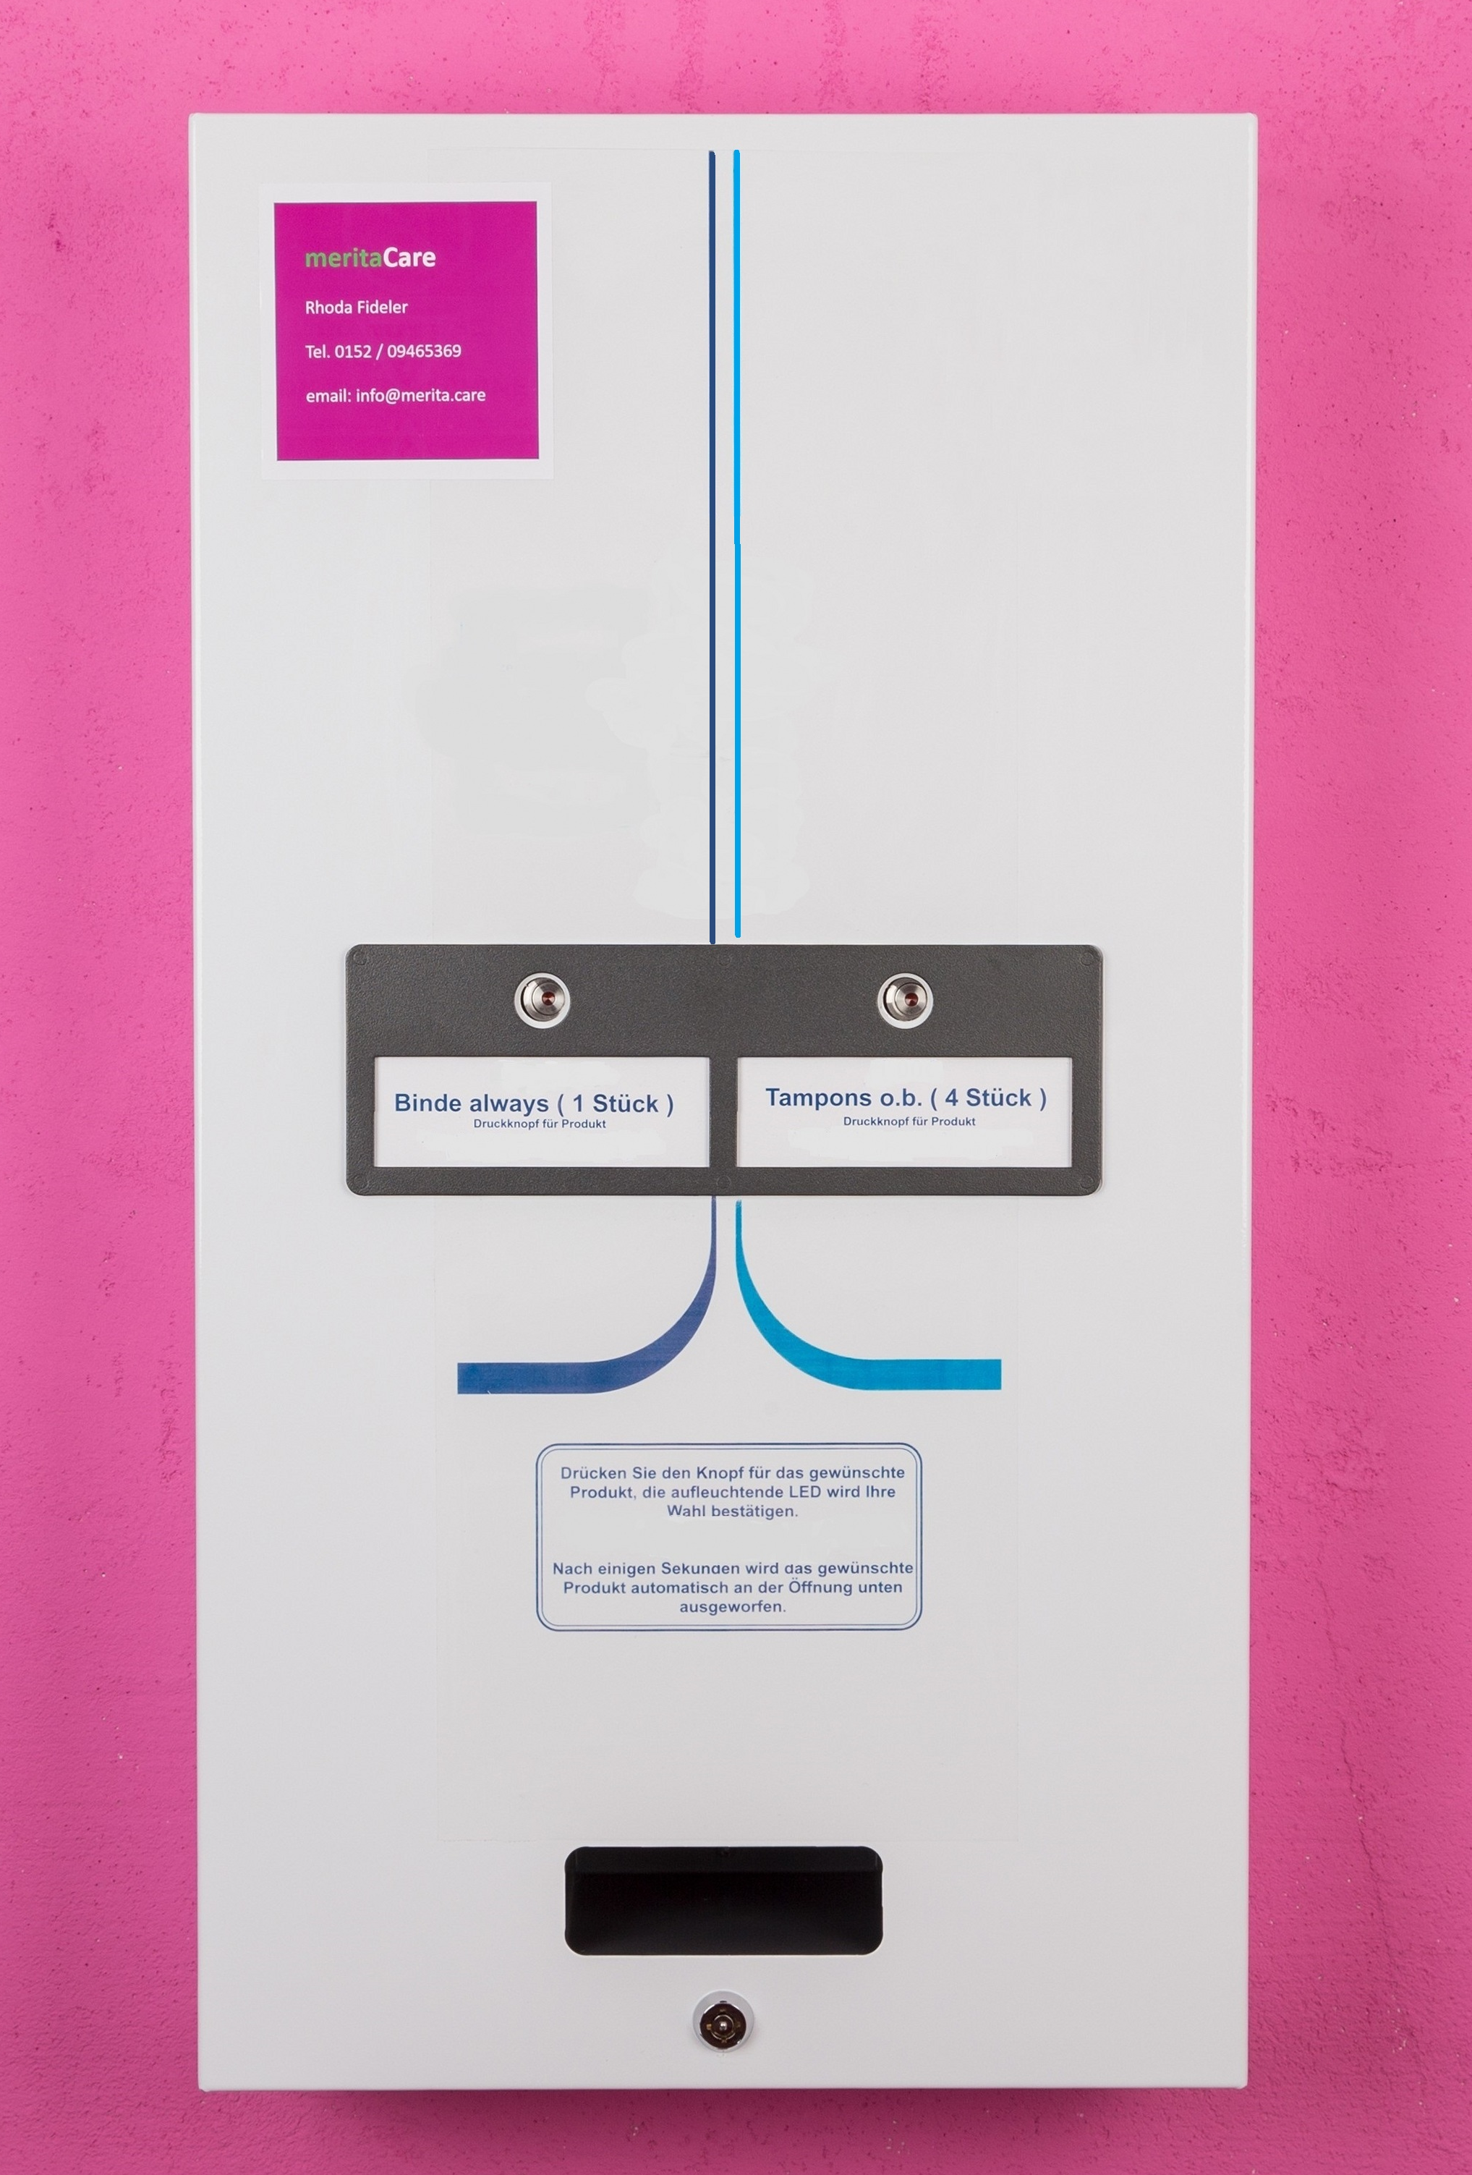

www.merita.care / info@merita.care / Tel. +49 152 09465369 0946536909465369

www.merita.care / info@merita.care / Tel. 0152 / 09465369 0946536909465369
Description

This battery operated 2 Column Electronic machine is a compact, space saving unit offering maximum product capacity with the option to dispense 2 different products at 2 different vend prices.

The price setting can easily be adjusted. The electronic coin acceptor has been pre-programmed to accept the following coinage:
10ct / 20ct /50ct / 1€ / 2€ (for other currency-versions please ask)

The maximum vend price setting is 9,90 €. All foreign and fake coins are automatically rejected. The machine does not give change.

The machine has been designed to offer maximum product capacity and incorporates 2 internal columns, that can easily be re-stocked in minutes.

Ideal for any indoor location – we do not recommend installing the machine outdoors.
The machine is lockable.

www.merita.care / info@merita.care / Tel. +49 152 09465369 0946536909465369
Technical Data
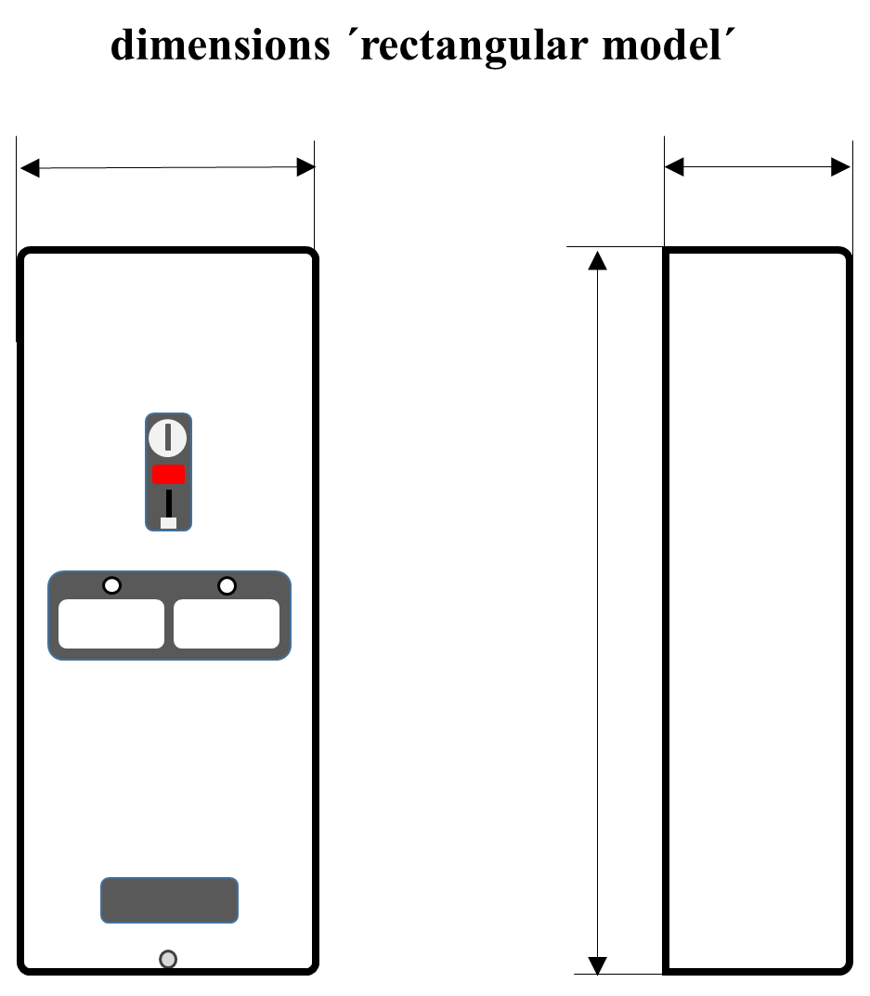

- weight: 13kg
- The machine is being delivered with a 15-V-battery pack, consisting of 10 x 1,5 V-batteries (AA-cells)
- Pre-programmed electronic coin validator 10ct/20ct/50ct/1€/2€ coins
- Payment system: coin operated
- Compact control board with easy access for changing price settings
- Dispensing motors fitted with Sold Out switches
- Vending pack capacity: 25 pieces per product column

www.merita.care / info@merita.care / Tel. +49 152 09465369 0946536909465369
www.merita.care / info@merita.care / Tel. +49 / 152 09465369 0946536909465369

