

**Mechanical automat (window-model)**

**data sheet (version 2020-04)**

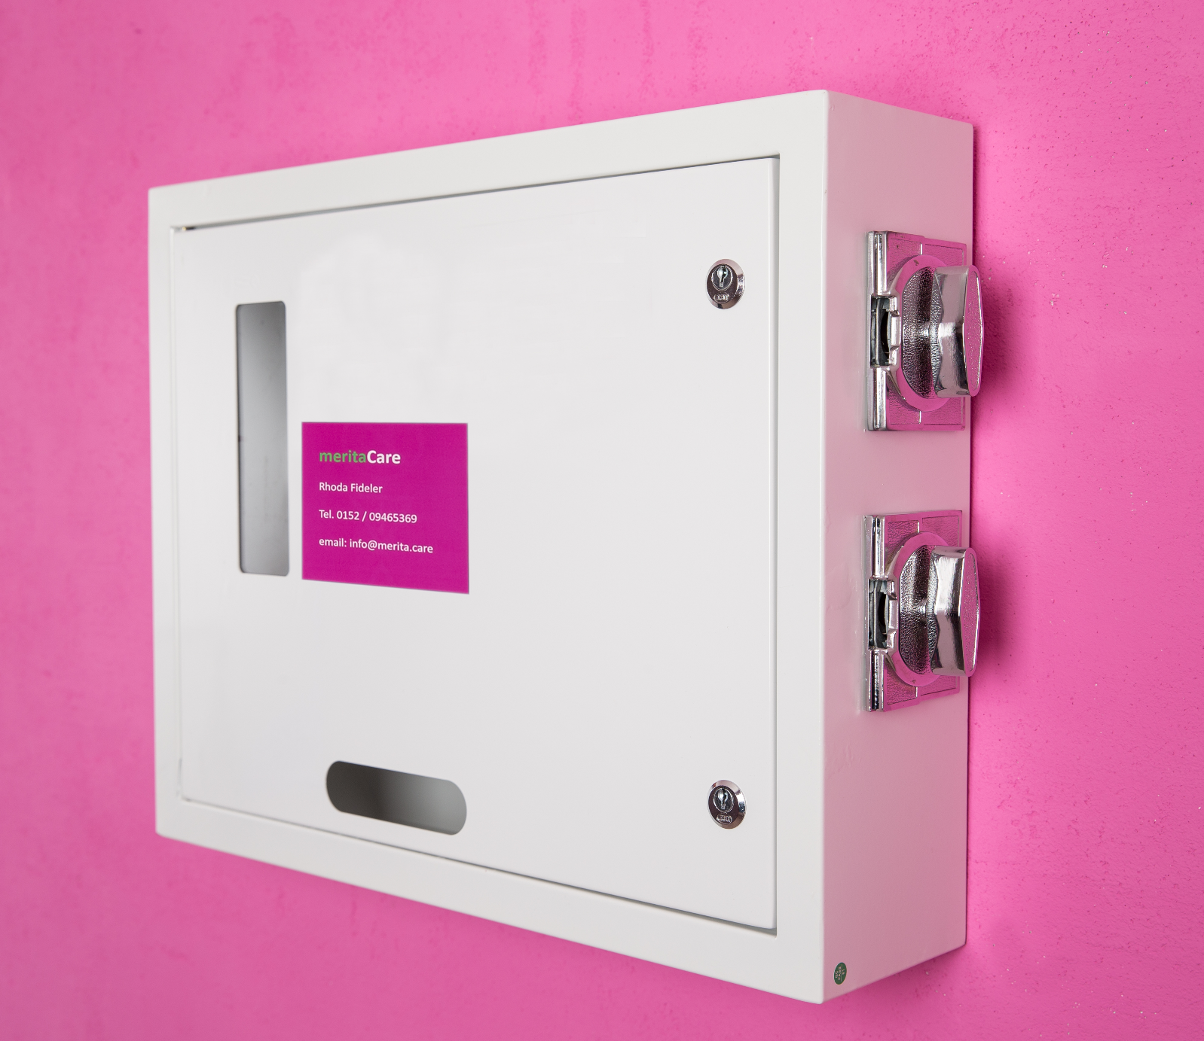

[**www.merita.care**](http://www.merita.care) **/** [**info@merita.care**](mailto:info@merita.care) **/ Tel. +49 152 / 09465369 0946536909465369**

**Description**

This mechanical automat is a robust and compact unit offering maximum product capacity with the option to dispense 2 different products at 2 different prices.

The machine is made according to the following price setting:

- upper product compartment: suitable for 50 cent-coin

- lower product compartment: suitable for 1€-coin

Ideal for any indoor location – we do not recommend installing the machine outdoors.

**Technical Data**

* weight: 10 kg
* dimensions: height 42cm x width 52 cm x depth 12cm
* payment system: coin operated
* functions completely mechanically (by turning knob)
* 2 product spiral rows (capacity: 2 x 15 packages)
* requires neither battery nor electrical power supply
* lockable
* does not give change

[**www.merita.care**](http://www.merita.care) **/** [**info@merita.care**](mailto:info@merita.care) **/ Tel. 0152 / 09465369 0946536909465369**