Cape Verde

Institutional Partner | National Institute of Public Health of Cape Verde, Brazilian Association of Field Epidemiology Professionals
Project dates | April 1, 2022 to March 31, 2023
Project Title | Improving data quality through field epidemiology

Project Objectives | Project Outcomes and Impact
- Train 17 field epidemiology professionals at the frontline level to generate and analyze quality data  - Creation of a website for the Public Health Bulletin  - Preparation and periodic publication of the Public Health Bulletin | - Health professionals trained in field epidemiology  - Public Health Bulletin website created and available for public access  - Public health bulletin published at the end of March 2023

Project Sustainability
Website prepared and hosted within the INSP web page; Professionals qualified in training work in the country's health services; Bulletin governance policy approved by health authorities in Cape Verde.

Project Outputs
- Cape Verde Public Health Bulletin web page https://bsp.insp.gov.cv/  - Notebook of articles from the 1st Scientific Meeting of Epidemiologists from Campo Verde | Minister of Health presides over the opening of the 1st Scientific Meeting on Epidemiology of Campo Verde and welcomes the completion of the 4th training group Link
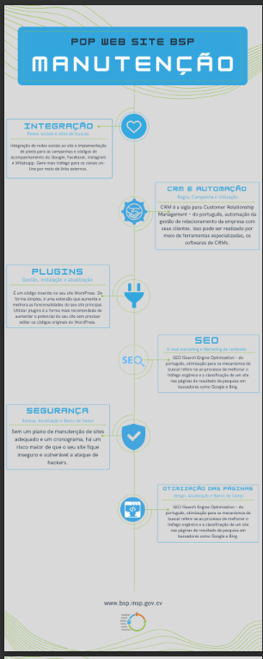
Standard Operating Procedure for the Maintenance of the Cape Verde Public Health Bulletin Website

