Burkina Faso
Institutional Partner | Ministry of territorial administration, decentralization and security represented by the General Directorate for the modernization of the civil status (DGMEC)
Project dates | April 1, 2022 – March 31, 2023
Project Title | Implementing CRVS Systems Improvement Framework in Burkina Faso

Project Objectives | Project Outcomes and Impact
The overall objective of this project was to map civil registration processes, to identity gaps, bottlenecks and challenges that exist, in order to inform the development of a comprehensive new CRVS law in Burkina Faso. The specific objectives were:  - To rain of key CRVS stakeholders on the mapping process.  - To conduct stakeholders’ analysis and mapping.  - To document and map the current (as-is) processes of registration of top priority vital events and production of vital statistics.  - To conduct field visits to assess the feasibility of implementing re-design ideas for new business processing maps.  - To revise the current strategic and action plans considering the desired processes and conclusions of previous legal reviews | - Key CRVS stakeholders were trained on mapping process using Bizagi software.  - Stakeholders’ analysis report developed. This report gives detailed information on all the players involved in the CRVS system in Burkina Faso (including roles, responsibilities, activities, areas of interventions, target audiences, budgets, intervention period, etc.).  - CRVS Systems Improvement Framework Implementation Report disseminated. The CRVS process mapping clarifies how things work on the ground and in reality, to suggest desired CRVS processes improvement and the review of CRVS law.  - Strategic and Action plans were revised considering the desired processes and the conclusions of legal review.

Project Sustainability
In the CRVS Systems Improvement Framework Implementation Report, bottlenecks to improve the CRVS system were identified. The root causes of these bottlenecks have been highlighted and, in view of them, short-term (quick wins), medium and long-term improvement solutions have been proposed. The improvement solutions proposed in the report can be consulted at each revision of the strategic and action plans.

Project Outputs
- CRVS stakeholders trained on mapping  - Stakeholders’ analysis report | - CRVS System Improvement Framework report  - CRVS Strategic and Action plan
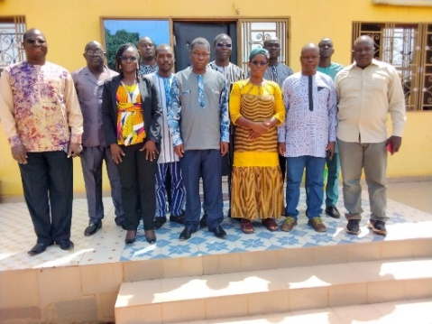
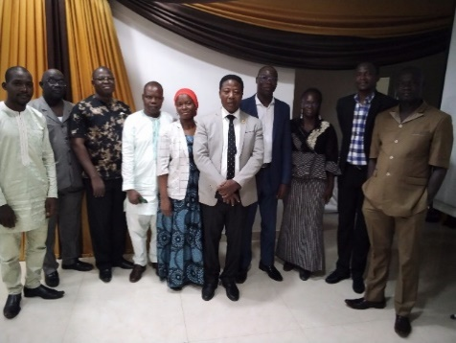

Participants during the Bizagi Training
Participants during the Desired Processes Workshop

