Paraguay
Institutional Partner | General Directorate of Health Surveillance, Ministry of Health and Social Welfare
Project dates | August 1, 2021 – December 31, 2022
Project Title | Development of the burden of disease in Paraguay

Project Objectives | Project Outcomes and Impact
- Implement a disease burden report showing not only the main causes of premature death, but also, the main causes of diseases and disability. This report helps determine planning to address the health priorities in Paraguay | - The results of the burden of disease reporting integrated into national health insurance priorities and plans  - Developed a prioritized list of insurable conditions based on the main conditions/diseases

Project Sustainability
- The information produced will be used for the strategic management of programs, and for determining health priorities. In addition, the project promotes improvements in information systems, specifically in morbidity registries, focusing on data quality. Finally, the terms "disease burden and WARNING" will be introduced into the usual public health practice, thus allowing a methodological complement in the knowledge of the country's health situation

Project Outputs
- Final report presented during the XIII National Epidemiology Exhibition | - Project press release from the General Directorate of Health Surveillance

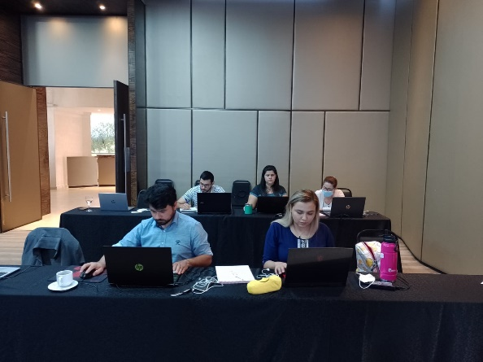
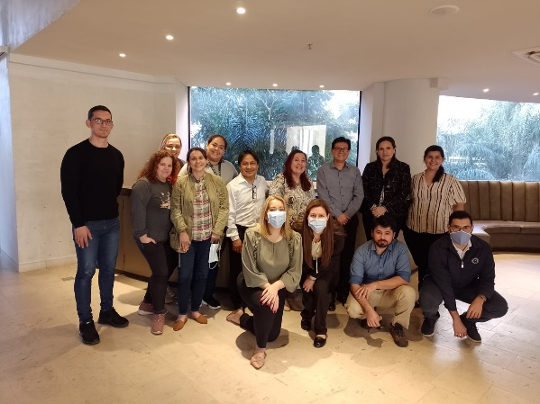

Multidisciplinary face-to-face workshop on the construction of disease burden indicators attended by 15 participants from the various government directorates

