Paraguay
Institutional Partner | General Directorate of Health Surveillance, Ministry of Health and Social Welfare
Project dates | March 1, 2021 - December 31, 2022
Project Title | Health Information Dashboards for Decision Makers

Project Objectives | Project Outcomes and Impact
- Design dashboard for indicator monitoring.  - Develop indicators for NCD monitoring.  - Lead Technical Assistance workshops to train participants on dashboard development and monitoring. | - Seven NCD dashboards developed for the identification and maintenance of digital solution tools.  - System changes implemented to operating procedures, new laws, new policies, new ministerial circulars, new business units, and revised procedures.

Project Sustainability
- The Ministry of Health created policies and documents instituting the use of dashboards and their data.
- Programs that participated in this project have dashboard information that is systematically updated on a monthly, quarterly, and annual basis according to the availability of the data which allows them to make decisions in a timely and effective manner for the change in prevention and logistics strategies.

Project Outputs
- Operations manual and monitoring procedures of the indicators developed. | - Staff trained in maintaining the Digital Solutions.
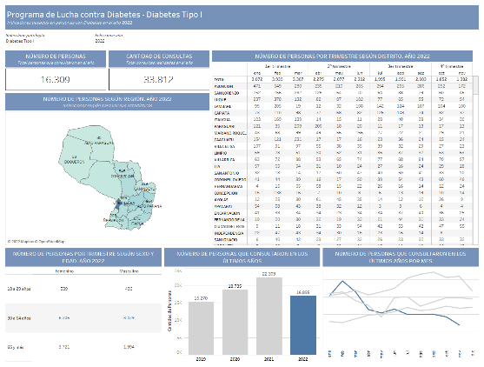
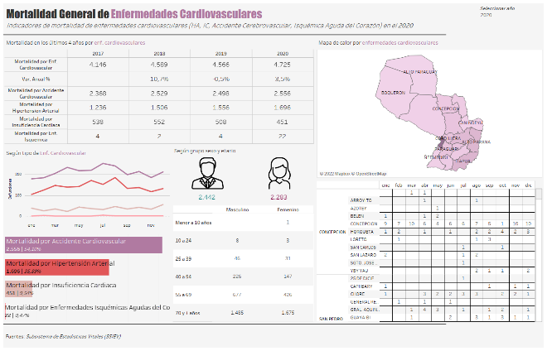
Dashboard – Diabetes Control Program
Dashboard – Cardiovascular Prevention Program

