Malawi
Institutional Partner | National Registration Bureau - Malawi
Project dates | August 2020 – December 2021
Project Title | Transition of Equipment from the Electronic Village Registration Project to High-Burden Health Facilities Using the Integrated Maternity Electronic Birth Registration System
Project Objectives | Project Outcomes and Impact
- Upgrade the integrated maternity (MeBRS) system at four health facilities previously equipped through D4H support  - Install network, power supply, and the MeBRS system in eight new health facilities and operationalize the system through training of health workers  - Train NRB technical staff to provide maintenance and support of the integrated system in both software and hardware, to ensure sustainability  - Present the fully functional sites to CDC and EGPAF to ensure future maintenance support to NRB | - Upgrades to the previously installed system at four health facilities alongside technical reconnaissance and power and network installation at eight newly selected facilities ensured that all 12 of the targeted health facilities across Lilongwe district are now equipped with the upgraded integrated MeBRS software and the accompanying power and network infrastructure.  - Maintenance, provision of supplies, distribution of birth certificate forms, and training of health workers took place at each site  - Complementary to the main project objectives, modified the birth registration system to print adhesive labels that to be attached to the NR8 form, eliminating the need to hand-write them.  - An Optical Character Recognition system was built mid-way through the project to assist with recovering data that were lost due to hard-disk failure in other health facilities. This enabled the “lost” data to be entered into the system, further enhancing data completeness.  - An SMS sync feature was also developed to serve as a secondary means of data synchronization and alleviate network connectivity challenges. This will ensure continuous transmission of data from health center to district server.  - Resulted in a significant increase in birth registration rates from 3.1% to 91% across the 12 health facilities. All 12 health facilities are all reporting birth registration rates above 80% as compared to only 5% at project onset.

Project Sustainability
- Technical training and capacity building was carried out for NRB team members to equip them with the knowledge and skills to assist with any technical challenges that the system may encounter in the future.
- Standard Operating Practices (SoPs) have been developed as part of the handover to NRB and local CDC partner, EGPAF, who will now support and maintain the sites.
- Due to the success of the integrated MeBRS model in increasing birth registration rates, the NRB plans to update the official business process for birth registration and scale the system to additional health facilities.
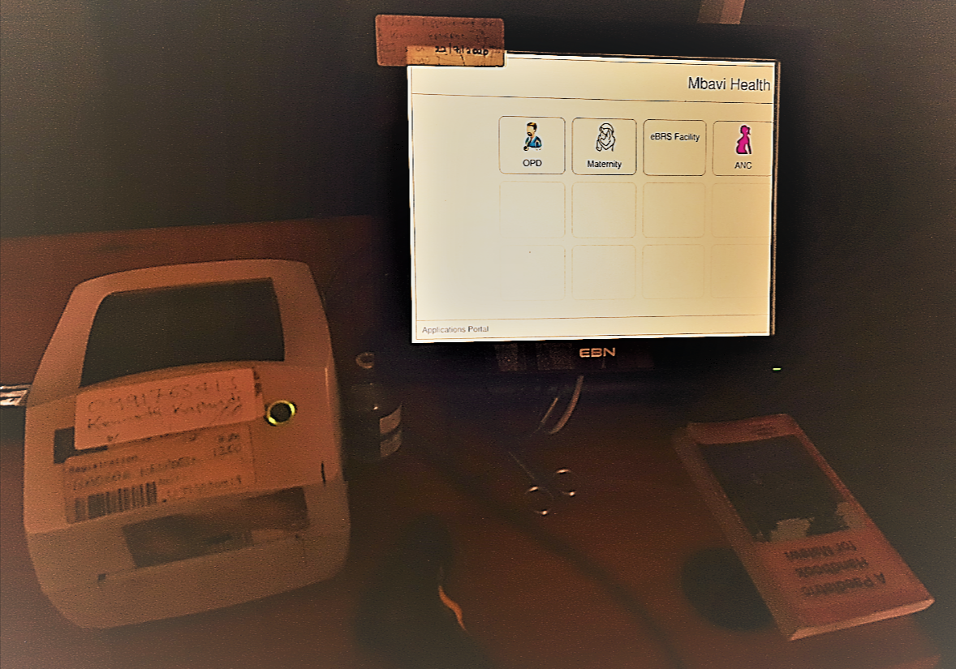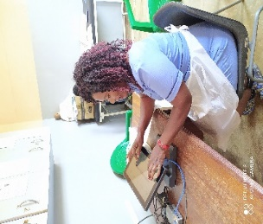
“Increased registration coverage data…has indicated that the integrated model adopted along the way should be sustained and replicated in other health facilities…”
Moses Chiwoni, Deputy Director, NRB
Image 1: The MeBRS at Mbavi Health Center, Malawi
Image 2: Nurse Entering Data Using the MeBRS System

