Kenya
Institutional Partner | Ministry of Health (Kenya)
Project dates | May 1, 2020 – December 31, 2021
Project Title | Improving Information on Causes of Death in Communities in Kenya
Project Objectives | Project Outcomes and Impact
- Streamline and standardize resources for verbal autopsy (VA) implementation in Kenya  - Disseminate resources for relevant stakeholders across the country  - Make resources easily available for anyone pursuing VA implementation in Kenya | - Developed and launched the Kenya Verbal Autopsy (KeVA) Resource/Management Hub, an online platform that serves as a national repository of data for the collection and analysis of information related to cause of deaths.  - The KeVA Hub will serve as a tool for policymakers, government institutions, organizations, and other relevant stakeholders in the promotion and scale-up of VA implementation in Kenya by providing users with valuable VA resources and materials, as well as a platform to share VA data and insights.  - Drafted and published a set of guidelines and SOPs for VA implementation in Kenya that includes KeVA training materials.  - Developed additional guidelines for VA implementation, covering topics ranging from VA scale-up and institutionalization to mortality surveillance VA data visualizations.
Project Sustainability
- The KeVa hub shares in-demand resources related to the standardization, scale-up and institutionalization of the national CRVS system.
- The KeVA Hub was specifically designed to require minimal maintenance costs, ensuring its continued use as a cost-effective VA database management system.
- Engagement with relevant in-country partners has generated momentum and yielded additional contributions in the form of technical and financial support.

Project Outputs
- The Kenya Verbal Autopsy Resource Hub
“This grant provided an avenue for showcasing how VA implementation can improve mortality and cause of death statistics [in Kenya]”

Samuel Cheburet, Kenya Ministry of Heath
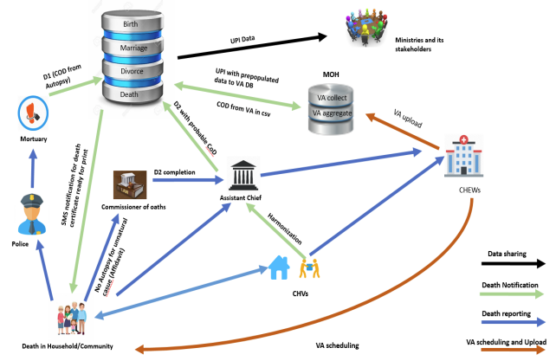
Figure representing Integration of VA within Kenya’s CRVS system

