Brazil
Institutional Partner | Secretariats of Health in Goiania, alongside the Office of the Governor in Rio Grande do Norte
Project dates | December 1, 2020 – November 15, 2021
Project Title | Linking Health and Non-Health Data Sources for Informed Public Health Policy- and Decision-Making

Project Objectives | Project Outcomes and Impact
- Support evidence-based policies on Violence Against Women (VAW) through the linkage of health and non-health data sources  - Generate a methodology for priority health issues through data linkage  - Build institutional capacity within regional health sectors | - Developed, implemented, and disseminated a methodology for record linkage using 13 health and non-health data sources, including the Mortality Information System (SIM), Brazil’s Statistics Office (IBGE), public records from the Public Prosecutors Office, the Police Department, and records from other municipal departments. Use of the methodology will expose the scope and parameters of GBV and provide public health officials with the guidelines necessary to improve public policies in GBV prevention.  - Disseminated policy recommendations to improve women’s protective services based on the results of the analysis.  - Generated guidelines and SOPs for use of the methodology and data sharing practices among national and regional health and non-health government stakeholders.  - Authored a comprehensive data analysis report on the risk of mortality in GBV that has been shared with the mayors of Goiania and Natal. This report will be used to create new intersectoral policies.  - Designed a STATA course based on the linkage methodology that will be used as an analytical tool for violence notifications in real time in Goiania’s Health Secretariat Office, thereby contributing to the strengthening of the public health sector’s technical capacity.

Project Sustainability
- Through the usage and promotion of the record linkage methodology, a culture of data usage is being entrenched within the health departments of Natal and Goiania, enabling policymakers to formulate policies based on high-quality data analysis.
- As a result of institutional collaborations, the Observatory of Gender Violence was formed within the Secretariat of Policies of Women. This group will work alongside regional public health systems to implement intersectoral strategies to address GBV.

Project Outputs
Visualization Panel in Tableau: An Analysis of the Linkage of the Databases of Goiânia | Integration of Different Databases to Promote Health Public Policies and Evidence-Based Decision Making Processes
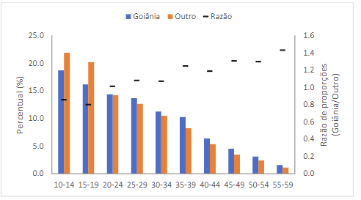
“…This project has an extremely important role as the evidence can be used as a basis for the adoption of public policies to combat violence against women…”
Durval Pedroso, Health Secretary of Goiania

Relative distribution of notifications according to age group and place of
residence of the victim. Goiânia, 2021.

