Paraguay
Institutional Partner | General Directorate of Health Surveillance, Ministry of Public Health and Social Welfare
Project dates | November 16, 2020 – May 16, 2021
Project Title | Optimize a COVID-19 Dashboard to Inform Decision-Making During the Pandemic Response

Project Objectives | Project Outcomes and Impact
- Enhance existing dashboards to include COVID-19 case incidence, mortality indicators and hospitalization rates.  - Train Ministry of Public Health personnel in preparing and using dashboards for planning, managing and monitoring public health initiatives. | - Developed enhanced COVID-19 dashboards for the early detection and surveillance of COVID-19 community transmission, providing up to date information to governmental leaders, the public and the media on a weekly basis.  - The Ministry of Public Health and Emergency Operations Center uses data reports for response planning and for weekly conferences to the general public on the COVID-19 situation and response.  - The enhanced COVID-19 indicators allow Ministry of Public Health personnel to prioritize health interventions, and the dashboard guides decision-making and created transparent accountability mechanisms.  - Developed Risk Maps over 14-day intervals to guide national and district level decision-making by providing recommended public health and social measures for each level of community transmission.  - Governments and municipalities established measures of social distancing from greater to lesser severity based on the information generated by risk maps. The risk maps informed national decrees in March and May to shape social distancing restrictions around varying levels of transmission.  - The General Directorates of Health Surveillance and Statistics visited local health departments to train local personnel in data generation and integration, as well as excess mortality measurements and the construction of health indicators for monitoring and evaluation.

Project Sustainability
- Using data reports and dashboards in the situation room discussions and in meetings with the Presidential Cabinet to inform national decision-making will continue after the pandemic.
- Trained Ministry of Health personnel in generating enhanced dashboard features to meet other public health needs moving forward.
- Championed collaboration and data sharing among Directorates of the Ministry of Health, including the General Directorate of Statistics and the General Directorate of Health Surveillance for the preparation of excess mortality estimates.
Project Outputs
- COVID-19 Risk Maps in Paraguay | - COVID-19 Indicators | - Epidemiological Situation Room
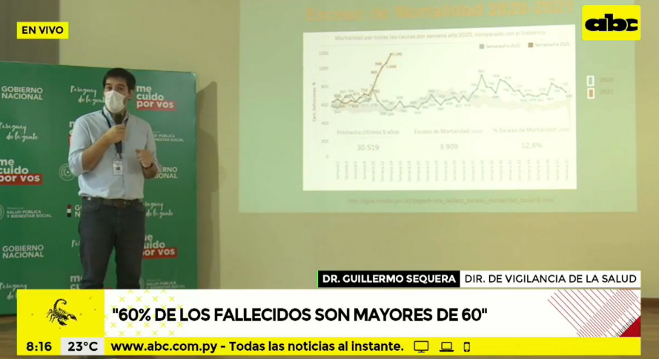

This project provided the government, the general population and the media with a source of accurate, objective, agile and coordinated information, adapted to the country's context and the evolution and impact of the pandemic.

- Dra. Agueda Cabello
Director of Research, Training and Development
General Directorate of Health Surveillance

Fig. 1: Director of Health Surveillance discusses excess mortality on national TV

