Ecuador
Institutional Partner | National Institute of Statistics and Census (INEC)
Project dates | October 1, 2020 – April 1, 2021
Project Title | Analysis and Presentation of Vital Statistics During the COVID-19 Response in Ecuador

Project Objectives | Project Outcomes and Impact
- Build a dashboard for Civil Registration and Vital Statistics data, including key COVID-19 indicators such as excess mortality.  - Develop a module to facilitate Iris-assisted coding of deaths reported through the civil registration data system (REVIT). | - Developed a comprehensive dashboard capturing mortality data from 1990 – 2020, which allows users to isolate fluctuations in excess mortality throughout time.  - Configured a database to merge input from the Civil Registry and the Ministry of Health and updated the Ecuador Iris Dictionary, resulting in 90% coding accuracy, a 15% increase from the original dictionary’s automated coding capacity.  - Implemented Iris to increase the speed of cause of death coding from the REVIT databases.  - Iris-assisted coding enabled INEC to assemble a 2020 mortality database within two months, making the basic cause of death for all deaths in 2020 available to the Ministry of Health in the midst of the COVID-19 pandemic. For the first time in Ecuador’s history, the counting of the previous year’s deaths was accelerated by five months.  - This database was used by Ecuador’s Emergency Operations Committee to better monitor locations with increasing COVID-19 deaths, allowing for more direct and targeted interventions.  - Automated the integration of records from the Civil Registry Mortality Database (REVIT) with the Vital Statistics Integrated System (SIES), reducing integration time from days to 5 minutes.  - Analyzed excess mortality in Ecuador at the national and provincial level.

Project Sustainability
- Trained INEC personnel to maintain and update the dashboard by capturing additional indicators, such as hospital bed occupancy.
- Iris-assisted coding allows INEC to now code 100,000 causes of death within 24 hours, a task that would have previously required months of manual coding. Automating the cause of death coding from REVIT databases through Iris reduces the administrative burden for INEC analysts, creating additional time for data analysis beyond data collection and processing.
- GGP support made it possible to access mortality data analyses in unparalleled times compared to previous years by reducing the time dedicated to manual cause of death coding, allowing INEC teams to dedicate the bulk of their time to quality analyses.
Project Outputs
- Dashboard on COVID-19 Mortality in Ecuador | - Figures for births, fetal deaths and overall deaths (2020)
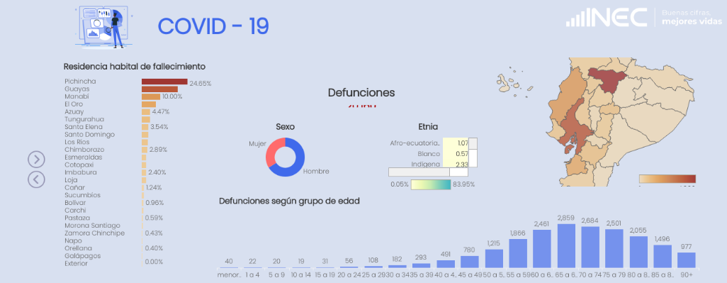

Due to COVID-19, the IRIS software was used earlier than anticipated… The databases were processed using IRIS, [making] it possible to publish the General Death annual review ahead of time.

- Soledad Carrera, Director of Sociodemographic Statistics, INEC
Fig. 1: COVID-19 Mortality Dashboard for Ecuador

