Peru
Institutional Partner | National Center for Epidemiology, Prevention and Control of Diseases – Ministry of Health
Project dates | July 1, 2019 – January 1, 2021
Project Title | Development of Subnational Burden of Disease Studies

Project Objectives | Project Outcomes and Impact
- Estimate the burden of disease for each region of Peru in order to tailor the coverage of the Essential Health Insurance Plan to meet regional demands.  - Train regional epidemiologists in burden of disease methodology.  - Guide regional epidemiologists in developing burden of disease studies.  - Assemble list of insurable health conditions so they reflect regional fluctuations in burden of disease. | - Led three workshops for 31 epidemiologists representing each region of Peru on how to carry out burden of disease studies.  - Workshop I: Methodological Introduction to Disease Burden (Press Release).  - Workshop II: Review of disease incidence and prevalence data for estimating years of life lost to disability.  - Workshop III: Review of mortality data for estimating years of life lost to premature death.  - Developed an application to calculate healthy years of life lost to disease or disability.  - By importing mortality data generated annually by the Ministry of Health, the disease burden for each region is automatically updated.  - Published the results of the first ever subnational burden of disease study conducted in Peru. Through regional breakdowns of population mortality and morbidity trends, local decision makers will gain a better understanding of the leading causes of premature disability and death within their populations, thereby informing health planning and health resource priorities at the regional level (Press Release).

Project Sustainability
- This work was carried out through a transfer of burden of disease methodology to regional epidemiological teams, ultimately equipping each region with the knowledge and experience to carry out similar studies in subsequent years.
- Developed a guidance document for conducting national burden of disease studies.
- Easy-to-use applications were developed for regional epidemiologists to update burden of disease estimates in the future.
- The Essential Health Insurance Plan of Peru will undergo review as decision makers adapt the plan to meet regional trends reflective of the results found in the subnational burden of disease study.
Project Outputs
- Guidance Document for National Burden of Disease Analyses | - Subnational Burden of Disease Studies
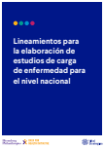
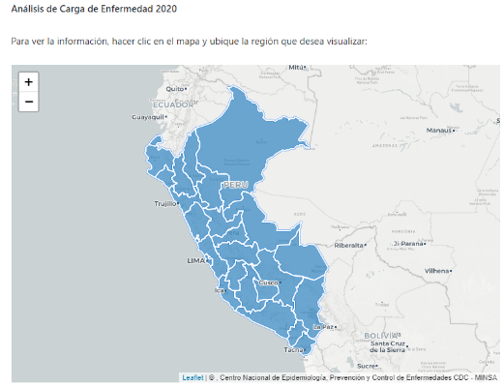

This research seeks to identify priorities for both health intervention and prevention… serving as an important input for the essential health insurance plan.

- Luis Suárez Ognio, MD
Vice Minister of Public Health, Peru
Quoted in Ministry of Health Press Release

Guidance Document
Subnational Burden of Disease Study

