Ghana
Institutional Partner | Ghana Health Service and US Centers for Disease Control and Prevention (CDC)
Project dates | July 31, 2019 – January 31, 2021
Project Title | Ghana Weekly Epidemiological Report App Development and Launch

Project Objectives | Project Outcomes and Impact
- Create an application to host the Ghana Weekly Epidemiological Report (GWER), increasing the scientific journal’s readership by housing all of its content within a single platform that is readily accessible by physicians, epidemiologists and other health professionals. | - Developed a web application to integrate the GWER onto an interactive media platform.  - The platform allows users to download GWER journals to be read offline at a later date, as well as the ability to subscribe to the journal and receive timely notifications of recent uploads.

Project Sustainability
- The GWER App is linked to the Continued Professional Development platform, managed by the Ghana College of Physicians. Users of this application will have access to the Weekly Epidemiological Review as well as the Continued Professional Development platform, and vice versa, providing a constant influx of readers.
Project Outputs
- GWER App

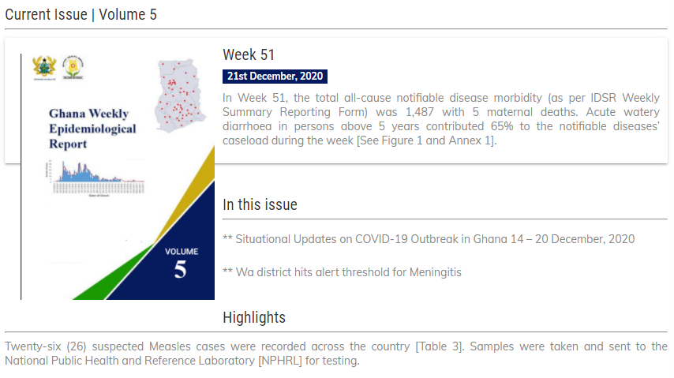

The Ghana Weekly Epidemiological Report… publishes reports of public health interest and importance to the Ghana Health Service and Veterinary Health Service constituents, thereby informing its readership of the developments in the health sector in Ghana. The App notifies readers of updates and new issues.”

- Ken Ofosu-Barko, MD
Editor-in-Chief, GWER

Ghana Weekly Epidemiological Report available for download on GWER app platform

