Ecuador
Institutional Partner | National Institute of Statistics and Census (INEC)
Project dates | July 1, 2019 – September 30, 2020
Project Title | Implementation of Automated Mortality Coding Using Iris and Training to Physicians in Standard Death Certification Practices

Project Objectives | Project Outcomes and Impact
- Implement Iris software to automate the coding of cause-of-death information on death certificates into International Classification of Diseases categories.  - Develop an Iris dictionary contextualized to medical terminology in Ecuador.  - Evaluate the quality of Iris-assisted coding.  - Institutionalize the Medical Certification of Cause of Death (MCCD) form and protocol across private and public health facilities by conducting in-person trainings. | - Implemented the Iris software.  - In an assessment of data coded in 2019 following the implementation of Iris-assisted coding, 78% of causes were correctly coded by the automated system, meeting international standards. Further, there was 99% concordance between manual and Iris coding.  - Developed a comprehensive Iris dictionary adapted to Ecuador’s mortality data, enabling Iris to be implemented for automated coding of cause of death.  - Leveraged Iris capabilities to accelerate the production of mortality data from 2019, and in the COVID-19 response.  - Completed 30 trainings with 731 physicians on the proper completion of MCCD.  - The formative work completed by the team enabled INEC to quickly code cause for deaths that occurred in 2020 and benchmark excess mortality in the context of COVID-19. This information was regularly shared with the national emergency response coordinating body, along with other key health indicators, to inform public health and social measures.

Project Sustainability
- Mortality coders at INEC received the necessary trainings and coaching institutionalization to adapt Iris agency-wide.
- The Iris software alleviates the impact of staff reductions at INEC by processing the bulk of mortality certificates without requiring manual coding.
- The team is adapting the MCCD training materials that were developed for this project to virtual trainings that can be carried out throughout private and public health facilities remotely.
Project Outputs
- Dynamic Mortality Reports
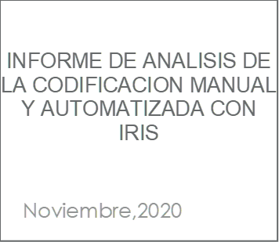

We conclude that the Iris software, accompanied by a good dictionary, will always produce the best [results]… and the more current the dictionary is, the better the results will be.”
- INEC
Internal Report, Analysis of Manual Coding and Automated Iris Coding (see right)

Home Page for Dynamic Mortality Reports

