Ghana
Institutional Partners | Births and Deaths Registry, Ghana Health Service
Project dates | July 15, 2019 – January 1, 2021
Project Title | Electronic Notification for Increased Death Registration

Project Objectives | Project Outcomes and Impact
- Establish a system for the direct notification of community deaths from the Ghana Health Service (GHS) to the Births and Death Registry (BDR) to increase current levels of death registration.  - Increase the percentage of community deaths notified and registered by 70%.  - Train personnel within GHS to implement and maintain the direct notification system. | - Established an electronic notification system operating between GHS and BDR, enabling electronic data sharing between the two agencies.  - Designed a web application for BDR to securely receive records of births and deaths from GHS, prompting BDR to register the reported deaths.  - Developed a tool for BDR to generate reports comparing all registered events against the record of notifications from GHS.  - Trained regional and district-level staff on how to operate and maintain the electronic notification system.  - Successfully communicated 217 community deaths via the electronic notification system within the first 5 months of implementation.  - Adapted the death notification tool to an application available for download on tablets distributed among field notifiers.  - Trained field staff on how to notify community deaths through the electronic notification system using tablets.

Project Sustainability
- Established a basic, functioning system for the direct notification of community deaths that can be built upon via future collaborations between GHS and BDR.
- E-notification from GHS to BDR to be incorporated within the Standard Operating Procedures for birth and death registration in Ghana.
- Strengthened working relationships between the Ghana Health Service and the Births and Death Registry.
Project Outputs
- Births and Deaths Electronic Notification System
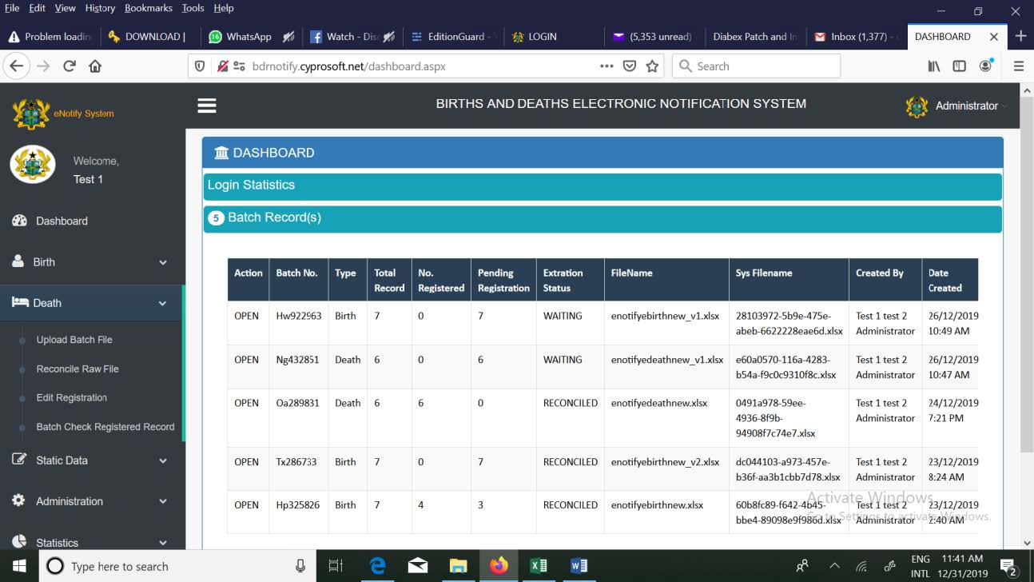

The activities supported by this grant continue to foster data sharing collaborations between partner institutions for improving CRVS in the country.

- Dominic Anaseba
Focal Point for Ghana E-notification Project

Dashboard for Electronic Notification System

