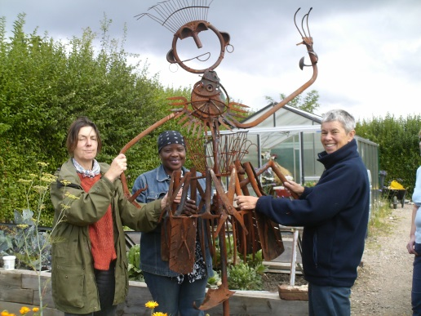

**What can you offer?**

* Join us for occasional work days on our allotment sites in Burngreave
* Help us run stalls at local festivals
* Organise a fundraising activity
* Make a one-off donation
* Set up a regular standing order donation

**What can we offer?**

* Keep you up to date with project developments via our newsletters
* Invite you to our annual Open day and periodic activity days
* Provide leaflets, display boards, photo-album and DVD footage showcasing our work to promote it more widely.
* Send you a bookmark or card handmade from flowers grown on site to remind you of the work you are supporting – albeit from afar!

**Want to get involved?**

If you would like to be involved please complete the form below and return by post or email to: **SAGE Greenfingers, 30 Minna Road, Sheffield, S3 9AZ** or **enquires@sagesheffield.org.uk**

Tel 0114 273 7718

[www.sagesheffield.org.uk](http://www.sagesheffield.org.uk)

Registered Charity No. 1114743. Company No.5698287

**I would like to become a Friend of SAGE Greenfingers.**

Name:……………………………………………………………………………………………………………………..……….

Email: ………….…………………………………………………………………………………………………………………

Postal address: …………………………………………………………………………………………………………………

………………………………………………………………………………………………………………………………………

Pease circle and indicate which of the following you would like to offer:

**Help on activity days Help run stall Volunteer**

**Fundraise Make Gift aid donation (we’ll send you a form)**

**Other (please specify and we’ll be in touch):……………………………………………………………………**

**Our 'Friends of SAGE' initiative offers you lots of different ways to get involved.**

***SAGE Greenfingers is a charity that supports adults with mental health needs via gardening and arts activities***.