Process for renewing the membership for 2019/2010-Parents
Step 1:
Enter the Swim Central System via: https://swimcentral.swimming.org.au
Step 2:
Enter your login details
Step 3: (If you’re a 18 & Over Swimmer with full membership rights skip to Step 6)
- Open your parent account interface
- Click on Family Setup

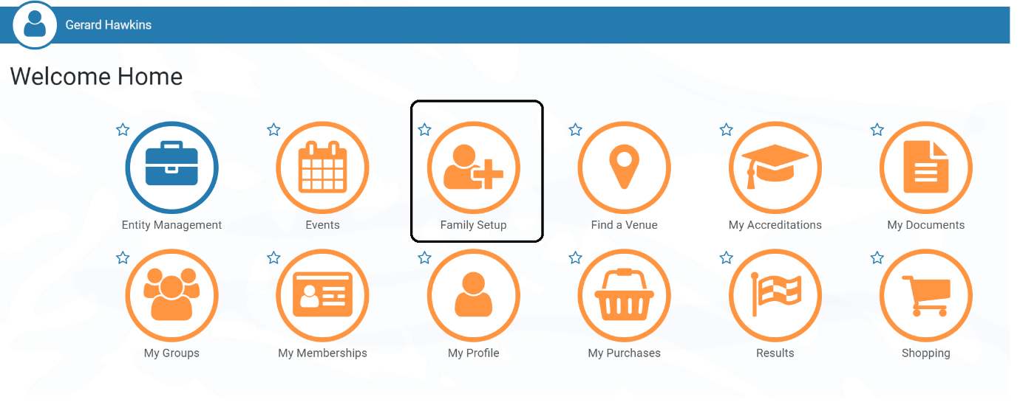

Step 4:
Click on the child symbol to the left of main icon
- This starts the “impersonation” of your child
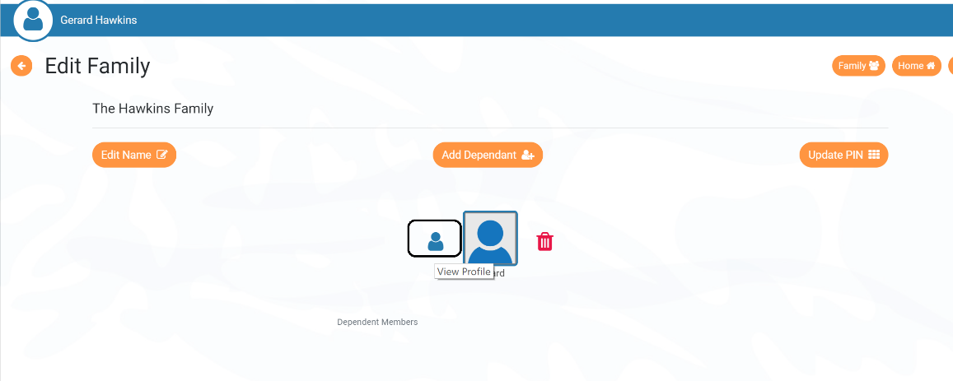
Step 5:
Click on the top right symbol to enter back to your child’s home page
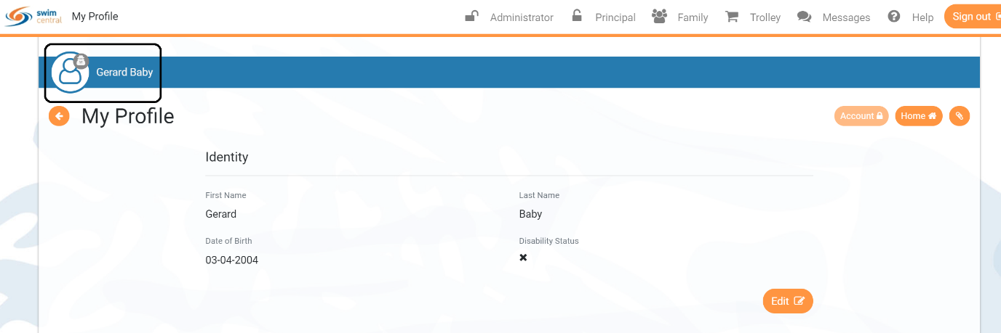

Step 6:
Click on Shopping
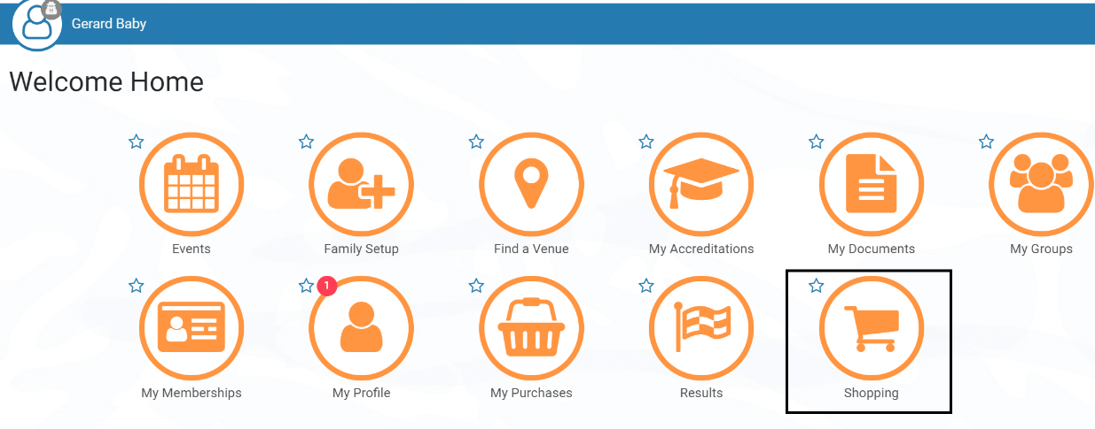
Step 7:
Search “Melbourne University”
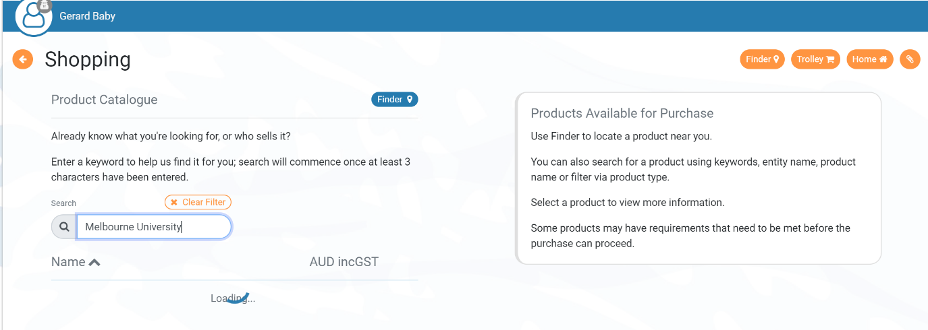
Step 8:
Find the relevant product (All products will automatically screened based on age and membership status)
- Click “add to trolley”

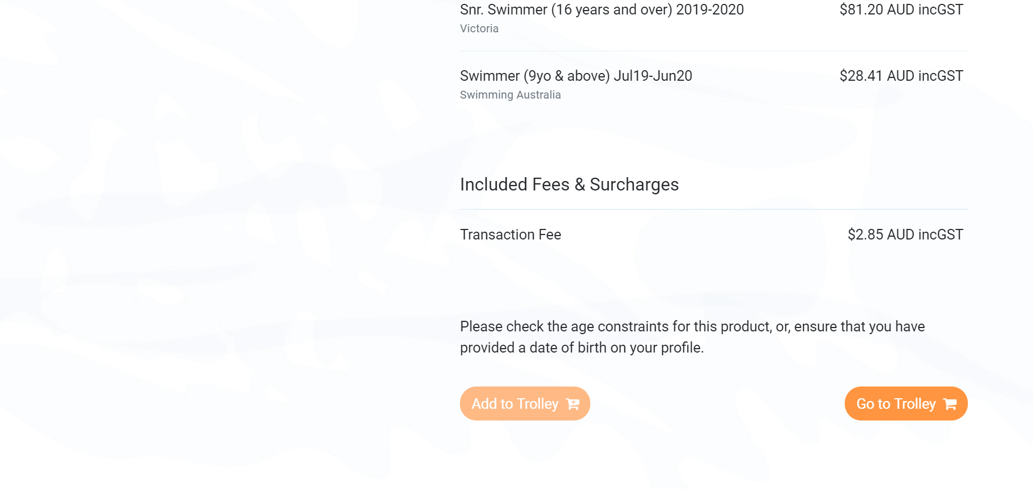
Step 9:
Repeat Steps 3-8 for any additional children
Step 10:
Click on the “Trolley” icon
Selected products will be present in the cart.
