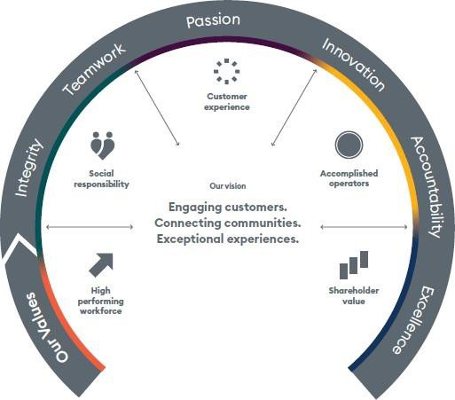

Our Vision defines our purpose. Our five pillars guide our strategic direction. Within each pillar are strategies to deliver our goals and realise our vision. These strategies drive our existing business and underpin any acquisitions. Our Values influence the right behaviours when making decisions to achieve our Vision

Position Title: Marketing Executive

Location: Gold Coast

Department: Business Development & Marketing

Reports to: Marketing Manager

Reporting to this position: Nil

Job Role Requirements
Job Role Requirements
The Marketing Executive is responsible for the implementation of the marketing strategy and social/digital media management for all QAL ports.
Job Role Requirements

Objective 1: Marketing Coordination
- Execute cooperative marketing campaigns with airlines, tourism stakeholders, marketing agencies, event managers, online travel agents, airport representatives and various other parties.
- Manage and produce annual brand campaigns in local catchment areas where Queensland Airports Limited (QAL) ports operate, creating further awareness of Gold Coast, Townsville, Mount Isa and Longreach Airports and their unique selling points and outbound connectivity.
- Interpret marketing proposals, read media activity plans to assess their value for money and liaise with creative and advertising agencies.
- Provide marketing support to Commercial department for retail and car park, managing a marketing calendar and activities in the terminal throughout the year.
- Coordinate merchandising requirements for Queensland Airports Limited Group marketing activities.
- Prepare copy and content for QAL group collateral, including e-marketing activities.

Objective 2: Digital Media Management
- Ability to update content management system (CMS) development, deployment, and maintenance.
- Content updates for QAL ports websites, to ensure information is kept up to date and opportunities are effectively leveraged.
- Specialise in digital content and e-marketing distribution through the businesses Marketing and Sales Clouds.
- Manage and execute the social media strategy for the business ongoing liaison with airline digital marketing teams to promote relevant airlines sales through the QAL digital media channels, with the goal of increasing bookings for airline partners.
- Generating and posting content to the QAL Group social pages. Moderating and responding to comments and messages for all QAL ports in the social space.

Objective 3: Research and Reporting
- Generate monthly Social Media Reports for the Board and Executive Teams.
- Provide accurate marketing and industry intelligence updates for monthly reports.
- Ensure all QAL marketing related finance and administration requirements are up to date.
- Provide reports and results showing the ROI at the completion of each campaign.
- Data Custodian for Gold Coast, Townsville, Mount Isa and Longreach Airport Marketing and ensure SharePoint is structured appropriately.

Objective 4: Project Participation / Innovation / Continuous Improvement
- Build strong working relationships with internal and external stakeholders
- Effort is made to continuously maintain and improve the quality of WH&S procedures and tools for the site

Objective 5: Workplace Health and Safety, Environmental
- Take reasonable care for your health and safety
- Take reasonable care for the health and safety of others including the implementation of risk control measures within your control to prevent injuries or illnesses
- Comply with any reasonable instruction in relation to WHS by the Company
- Co-operate with any reasonable policies and procedures of the QAL and associated entities including the reporting of hazards or incidents via the QAL reporting process
- All compliance requirements (e.g. legislative, policies, procedures) adhered to
- Other responsibilities as outlined in the QAL WHS management system
- Adhere to the locations Environmental Management System (EMS) as relevant to your work activities
- Attend EMS related training
- Adhere to relevant aviation safety and security requirements
Individual Behaviour Expectations

QAL employees expected to demonstrate behaviour which is aligned to our core values:

Teamwork
  - Together we succeed
  - Everyone is a customer
  - We are inclusive and support each other

Innovation
  - We think differently
  - We are creative
  - We share our experience to build new ideas

Accountability
  - We take responsibility for our actions
  - We all lead by example
  - Safety and social responsibility are priorities

Integrity
  - We value honesty, respect and fairness
  - We do what we say
  - We act in the best interests

Passion
  - We are enthusiastic
  - We care about what we deliver
  - We take pride in our work

Excellence
  - We have high performance standards
  - We add value and deliver quality
  - We embrace change and deliver outcomes
Key Stakeholders

Internal: Management and staff at all levels within the QAL Group.

External: Airlines, tourism organisations and operators, advertising and creative agencies, sponsorship partners, website host(s) and digital media agencies.

Key Capabilities Required to Perform Role

Educational Qualifications:
- Bachelor degree in Tourism and/or Marketing/Communications.

Professional Experience:
- Minimum 3 years work experience in a marketing role.
- Experience within the tourism industry/ aviation and hospitality.

Specific Job Knowledge, Skills and Abilities:
- Proven experience in digital/visual media design.
- Proven experience in managing front end of consumer websites or corporate and CMS platform
- Proven experience in managing social media accounts.
- Proven experience in copy writing.
- Advanced computer skills – particularly in Microsoft Office including PowerPoint and Adobe Creative Suite including Indesign, Illustrator and Photoshop.
- Previous use of marketing automation platform, for example Salesforce

Physical Demands:
- Must be able to perform required physical and psychological demands of the role.

ACKNOWLEDGMENT

I acknowledge that I have read and understood the key result areas described in this Role Description and agree to carry out my duties and responsibilities to the best of my ability. I also understand that at times I may be required to undertake other duties relevant to the position that are not listed in this statement. I acknowledge my employer’s right to alter this Role Description from time to time in accordance with company requirements.

Name Date

Signature

