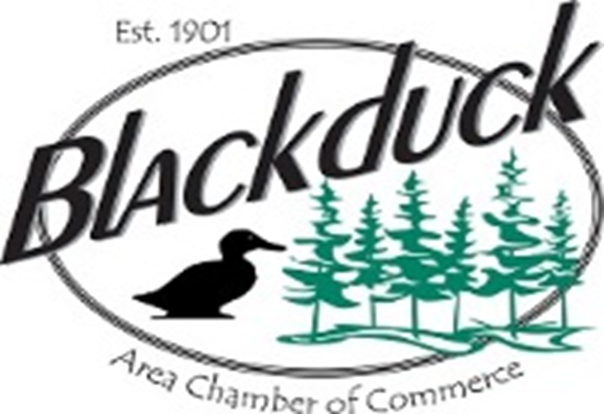

2020 CHAMBER EVENTS!
SAVE THESE DATES IN YOUR CALENDAR!

Chamber Appreciation Dinner | February 24, 2020
Chamber Bingo @ The Pond | March 22, 2020
Backwoods Bash Boil Fundraiser | Late April, 2020 (date TBD)
Adopt a Highway Clean-up | May 2020 (date TBD)
City-Wide Garage Sale | May 16, 2020
Chamber Bingo @ The Pond | June 14, 2020
37th Annual Blackduck Woodcarvers Festival | July 25, 2020
Blackduck Backwoods Bash | August 14-15, 2020

The Blackduck Area Chamber of Commerce Visitors Center is open beginning Memorial Weekend and is staffed
Friday – Monday in the summer months through Labor Day Weekend.

Please visit www.blackduckmn.com/business
for more information updated through the year.
Email city@paulbunyan.net to get your event on the Chamber page!

