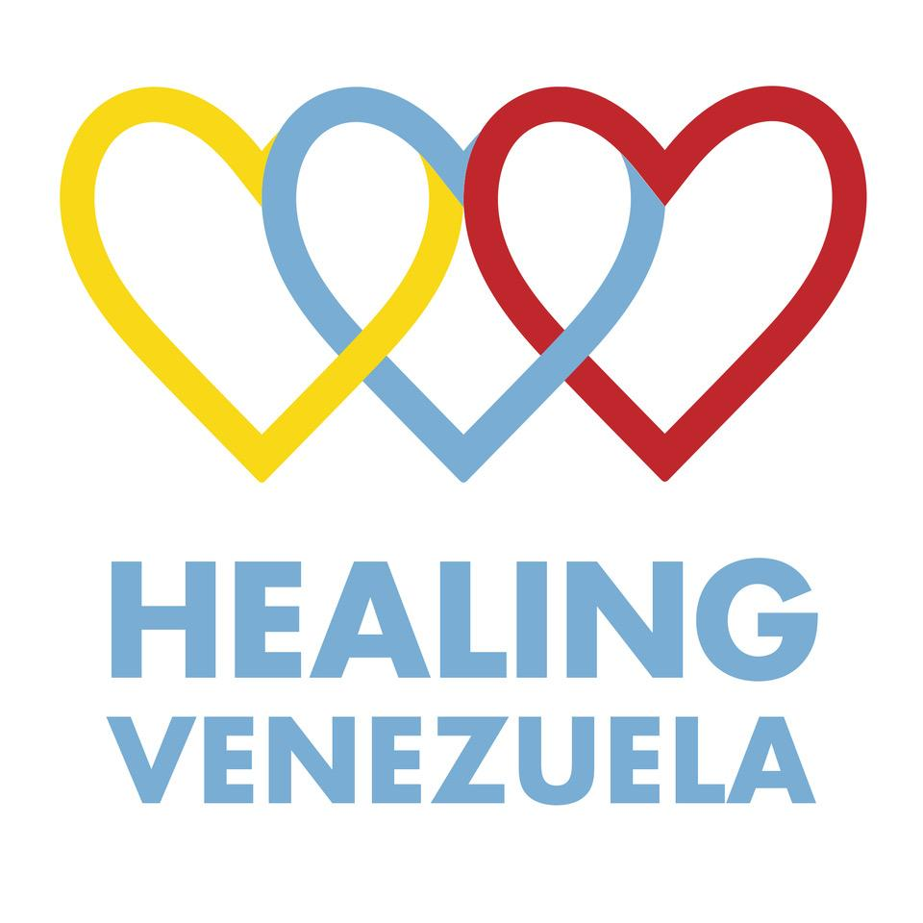

Form to Request Medical Supplies

About Us

Healing Venezuela is charity registered in England and Wales No. 11700709 based in London to relieve and to preserve the health of the patients of hospitals and other health-related institutions in Venezuela by
- PROVIDING OR ASSISTING IN THE PROVISION OF HEALTH-RELATED SUPPLIES;
- PROVIDING SUPPORT IN THE IMPROVEMENT OF MENTAL HEALTH AND
- ENABLING THE EXCHANGE OF MEDICAL EXPERTISE, AND ADVICE TO VENEZUELAN DOCTORS AND HOSPITALS

Our values are:
Gratitude: any donation, small or large, matters and is valuable to us.
Respect: at Healing Venezuela we have no political or religious affiliation, we respect all the creeds and political affiliations and we expect the same from others.
Transparency: a transparent management of the resources of our organisation is a Paramount value at Healing Venezuela.
Collaboration: at Healing Venezuela we believe that working with other organisations with the same objective we can optimise the efficiency of our work
Community: we believe in creating a community of both Venezuelans and British citizens to support patients in Venezuela

Objective of the document

To provide guidelines to collect medical supplies on behalf of Healing Venezuela. If you wish to request medical supplies on behalf of Healing Venezuela, please let us know by sending an email at info@healingvenezuela.co.uk and we will arrange a collection. In Annex I there is a list of medical supplies we accept.

(Date and location)

Dear Sir/Madam,
I’m a volunteer for Healing Venezuela, a UK registered charity based in London. We send medical supplies to Venezuela, a once thriving country now on the brink of a humanitarian crisis.
We are a non-political, non-religious organisation that relies only on private donors. We are 100% run by volunteers.
We are requesting support from surgeries, hospital, hospices and care homes to donate medical items which can still be used, but that you don’t need anymore. Healing Venezuela will collect them.
If you can support us, please see in Annex 1 items that we accept and that don’t. On behalf of Healing Venezuela, thank you so much for your support,

Kind Regards,

Annexe 1

Items accepted by Healing Venezuela

✓ Adhesive tapes
✓ Airways/Tracheostomy Tubes
✓ Aprons
✓ Baby Scales
✓ Bandages (all types)
✓ Bed Linen
✓ Blood Glucose Test Meters (if Strips are available)
✓ Baby Food Formulas or BNF’s (up to 1 Year)
✓ Baby Food Formula or BNF’s for Children (up to 1 Year)
✓ Blood Pressure Monitors
✓ Catheters (Long/ Short Term)
✓ Emollient Creams
✓ Delivery Forceps
✓ Small Devices (All must be complete and in working order)
✓ Dressings
✓ Face Masks
✓ Gallipots
✓ Gauze
✓ Giving sets & cannulae
✓ Gloves (sterile and non-sterile)
✓ Kidney Dishes
✓ Lab Items (Slides, Bottles)
✓ Lancets
✓ Maternity/ Sanitary Pads
✓ Measuring Cups / Spoons
✓ Microscopes
✓ MIM’s (up to 1 Year old)
✓ Naso-Gastric Tubes
✓ Nebulisers
✓ Neck Collars / Wrist Braces
✓ Needles (including Butterfly/ Venflow)
✓ Plasters (all types)
✓ Saline for Irrigation only
✓ Scissors
✓ Shampoo
✓ Sharps/ Yellow Bins
✓ Small Surgical Instruments (Forceps, tweezers, Vaginal Speculum etc.)
✓ Soap and Alcohol Hand Rub
✓ Spatulae
✓ Sphygmomanometers (not mercury)
✓ Stethoscopes/ Patella Hammers
✓ Sutures (all types)
✓ Swabs
✓ Syringes
✓ Test Strips (Colourimetric Blood and Urine)
✓ Theatre Drapes
✓ Thermometers (not mercury)
✓ Toothbrushes & Toothpaste
✓ Tourniquets
✓ Uniforms
✓ Wipes (Anti-bacterial and Alcohol Injection)

Items NOT accepted by Healing Venezuela
× NO PATIENT RETURNED MEDICINES
× NO Artificial Limbs
× NO Bladder Washout
× NO Callipers
× NO Colostomy Items/ Stoma Bags
× NO Crutches
× NO Enteral Feeding Sets or Syringes
× NO Incomplete Equipment

NO Insulin Pen or Needles
× NO Leg braces
× NO MERCURY items
× NO Specialised Appliances
× NO Syringe Drivers
× NO Ward/ Theatre Furniture
× NO Water or Saline for Injection

