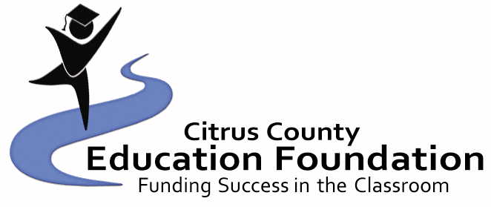
$1,000 Barbara J. Lewis Memorial Scholarship Application
Spring 2023 Due Date: April 17, 2023
(Applicant must be a graduating senior from the CHS)
(Application MUST be typed or computer-generated)

Last Name: First Name: Middle Initial:

Address:

City/Zip Code: Telephone Number:

High School: GPA:

Date of Birth: Social Security Number:

Parent(s)/Guardian(s) Name:

Parent(s)/Guardian(s) Occupation(s):

Place(s) of Employment:

Do you live with your parent(s)/guardian(s)? How many children in your family?

Ages of each child:

Please list school activities, honors, hobbies, clubs/organizations, talents and community activities. Also, include information about leadership roles you may have had. (You may use additional sheets):

Does attending college depend on outside help?

Name of School/College you plan to attend:

School/College Major:

Attach an essay explaining why you are seeking this scholarship, why you want to attend college and your goals for the future. (300 words or less.)

Student’s Signature:

Parent(s)/Guardian(s) Signature:

The application, essay, letters of reference and transcript must be returned to the Citrus County Education Foundation’s Scholarship Committee, Attention: Tiffani King, PO Box 2004, Inverness, FL 34451. Applications MUST be received NO LATER than April 17th, 2023. If you have any questions, please call Tiffani King at (352) 726-1931 x4369.

$1,000 Barbara Lewis Memorial Scholarship Application
Spring 2023

Procedures:

- All applications must be typed or computer-generated and complete.

- All applications must be returned to the:

Citrus County Education Foundation Scholarship Committee
Attention: Tiffani King
PO Box 2004, Inverness, FL 34451

Applications MUST be received NO LATER than April 17th, 2023.

3. The recipient will be announced at the Citrus High School’s academic awards program.

- The monetary award will be forwarded to the selected post-secondary institution upon documentation (student ID and proof of registered classes) obtained by the student from the school that the recipient is currently enrolled in.

Criteria Checklist:

_____1. The applicant must be a Citrus County resident of at least one year.

_____2. The applicant must be a graduating senior at Citrus High School.

_____3. Grades: The transcript of the applicant must be submitted. The transcript must include the current GPA and SAT/ACT scores. Students should have taken academically rigorous courses, and must have earned at least a 2.5 GPA.

_____4. Leadership Activities: Students must also demonstrate leadership in extracurricular activities.

_____5. Community Involvement: List all contributions to the community and/or work and/or volunteer experience. Evidence of involvement in community activities may help to document a student's leadership skills.

_____6. It is preferred that the applicant have Executive Internship/ Peer Counselor experience.

_____7. References:
a. Two (2) letters of reference are required.
b. References may come from a teacher, advisor, guidance counselor, school administrator, employer, clergy, a person with whom the student has done volunteer or community work, or any other adult who is aware of the student's leadership skills.

_____8. Essay (300 words or less): Each applicant must write an essay explaining why the student is seeking this scholarship, why the student wants to attend college and the student’s goals for the future.

