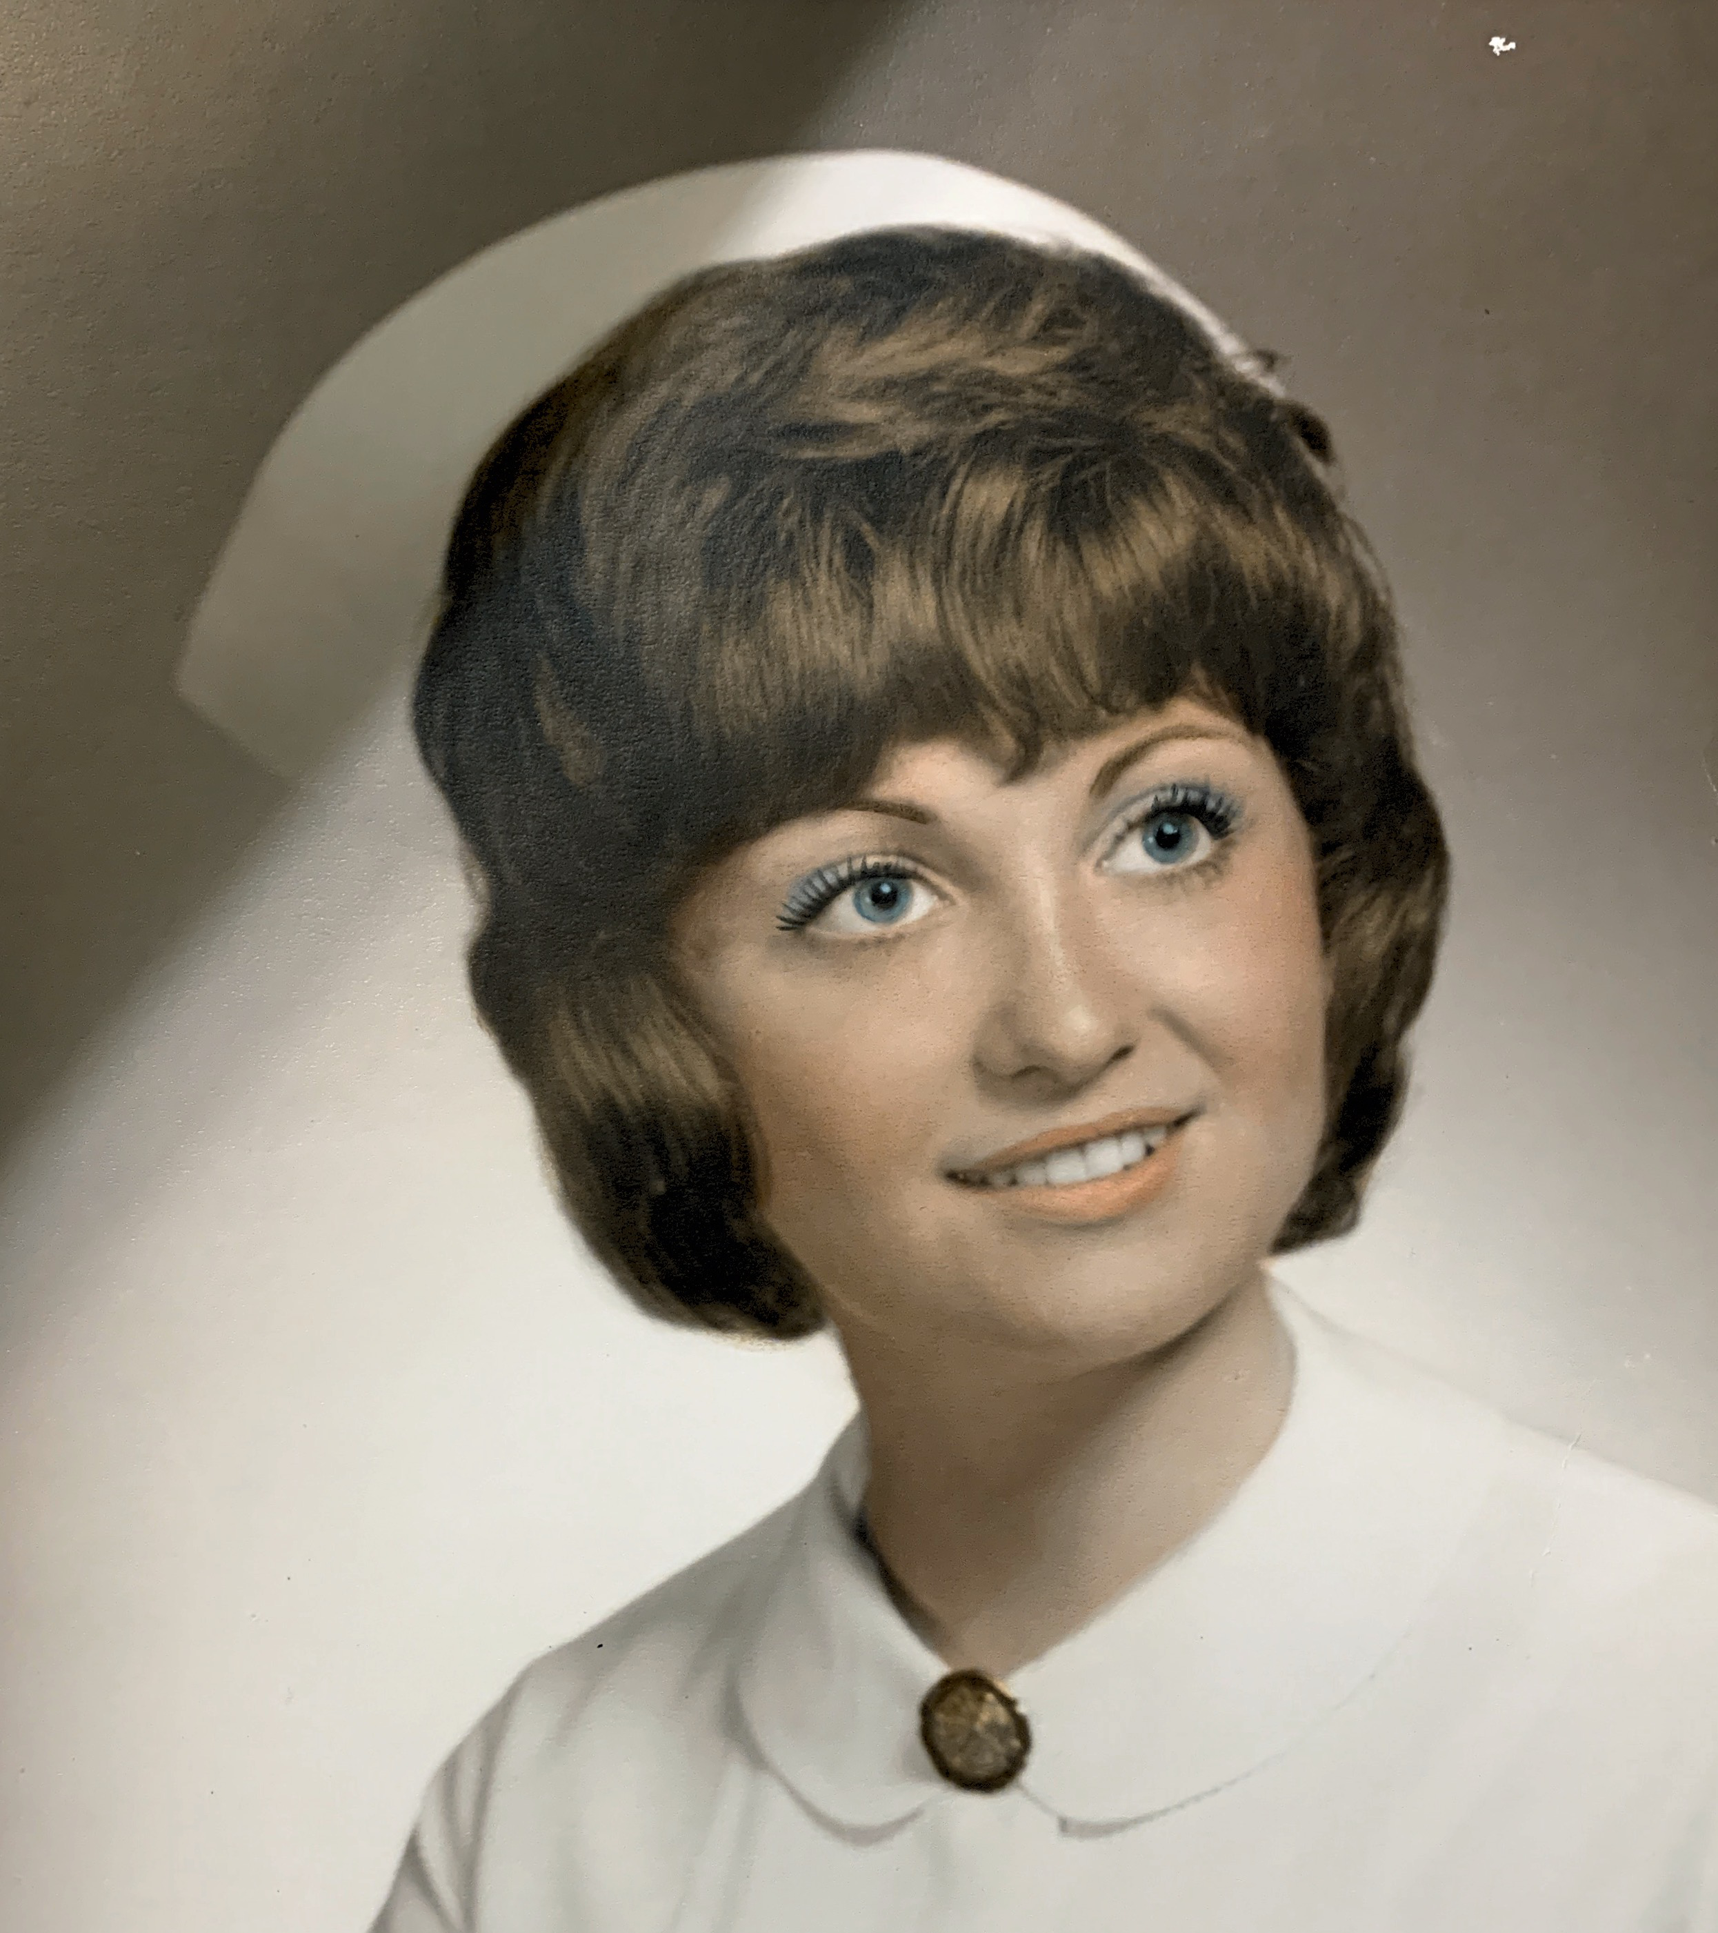

Barbara Fallon Memorial Nursing Scholarship Application
Spring 2023
(Application MUST be typed or computer generated)

Last Name: First Name: Middle Initial:

Address:

City/Zip Code: Phone Number:

High School:

Date of Birth:

Parent(s)/Guardian(s) Name:

Parent(s)/Guardian(s) Occupation(s):

Place(s) of Employment:

Do you live with your parent(s)/guardian(s)? How many children in your family?

Ages of each child:

Please list school activities, honors, hobbies, clubs/organizations, talents and community activities. Also, include information about leadership roles you may have had (additional sheets may be used):

Does attending college depend on outside help?

Name of School/College you plan to attend:

School/College Major or Field of Study:

Attach an essay explaining your goals pertaining to the nursing profession and why you are in need of this scholarship.

Please note: Academic information will automatically be pulled for each applicant.
The application, essay, and reference letter MUST be returned to the Citrus County Education Foundation’s Scholarship Committee, Attention: Tiffani King, PO Box 2004, Inverness, FL 34451 NO LATER than April 7th, 2023. If you have any questions, please call Tiffani King at (352) 726-1931 x4369.

Barbara Fallon Memorial Nursing Scholarship

Procedures:

- All applications must be typed or computer-generated and complete.

- Applications MUST be received NO LATER than April 7th, 2023. All applications must be returned to:
Citrus County Education Foundation Scholarship Committee
Attention: Tiffani King
PO Box 2004, Inverness, FL 34451

- Recipients will be announced at the high school academic awards programs.

- The number of recipients and the monetary amount awarded will be based on number of applicants.

- The monetary award will be forwarded to the selected post-secondary institution upon documentation (student ID and proof of registered classes) obtained by the student or from the school that the recipient is currently enrolled in.

Criteria Checklist:

_____1. The applicant must be a Citrus County resident of at least one year.

_____2. The applicant must be seeking a career in the nursing profession.

_____3. The applicant must be a graduating senior or currently enrolled in college or nursing program.

_____4. The applicant’s transcript will automatically be pulled. All of the transcript’s academic information will be taken into consideration.

_____5. It is preferred that the applicant demonstrate leadership in extracurricular activities and contribute to the community and/or work and/or have volunteer experience.

_____6. One (1) reference letter is required:
- Reference may come from a teacher, coach, advisor, school counselor, school administrator, employer, clergy, a person with whom the student has done volunteer or community work, or any other adult who is aware of the student's goals and skills.
- Reference may NOT be a family member.

_____7. Essay: Each applicant must write an essay explaining your goals pertaining to the nursing profession and why you are in need of this scholarship.

