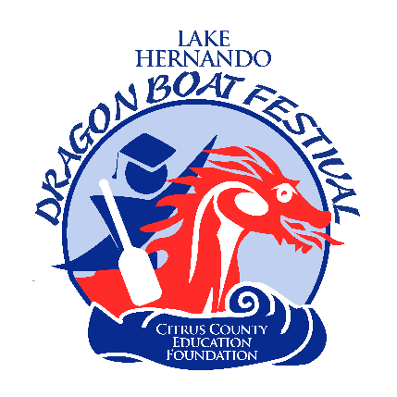

The Citrus County Education Foundation’s Lake Hernando Dragon Boat Festival will take place on Saturday, November 5th, 2022. Now known as “The Beast of the Southeast”, this event has become one of the largest International Dragon Boat Festivals in the Southeast, bringing teams and spectators in from all around the world! Over 5,000 participants and spectators attended this event in previous years and it continues to grow. The Arts & Craft and Commercial Village are adjacent to the Team Village making it convenient for team members and spectators to look and buy!

CCEF’s Lake Hernando Dragon Boat Festival is an invitational event. Due to the number of entry requests, the festival committee reserves the right to rule on any entries, and accept only those which we feel will offer the best variety for the festival. **All pricing is for vendor spaces of 12 feet in length; Electricity is not available at this location. If you require electricity you will be responsible for providing your own generators. Generators are permitted if they are quiet.

Space #’s are NOT guaranteed.

Commercial Vendor Fee: $125

Non-Profit Vendor Fee: $75
- Crafters Vendor Fee: $75 (YOUR ART OR CRAFT MUST BE CLEARLY HOMEMADE, manufactured, kit-made. Resale items will not be permitted. If the festival committee determines that your product does not meet requirements, you will be asked to leave the festival without a refund).

At least one photo of the complete setup is required.

Mail applications to: Citrus County Education Foundation
P.O. Box 2004
Inverness, FL 34451
Please contact the Citrus County Education Foundation if you have any questions or concerns:
Ted King, Event Chair
tedkingisking@gmail.com
Phone: (352)726-1931 x4369
Shaunda Burdette, Executive Director
burdettes@citrusschools.org
Phone: (352)726-1931 x2240

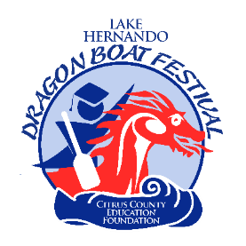
Lake Hernando Dragon Boat Festival
2022 Contract Information

- You will be furnished with a 12’ x 12’ space. The cost for a commercial booth is $125, non-profit is $75 and craft booths are $75. Electricity is not available.
- The date is November 5th, 2022. Hours of operation are Saturday, 8 am – 5 pm
- The festival will be held at Lake Hernando (Hernando Beach Park): 3699 E. Orange Drive, Hernando, FL. 34442.
- You must furnish your own booth materials; tables, tents, etc. It must be neat, clean, and attractive.
- Booth space numbers are not guaranteed to any exhibitor from year to year. Once spaces have been assigned, there will be no moving of vendors to another space during the festival unless done so by the Festival Chairman or Festival Director.
- You can drive into the festival area to load and unload only. Someone will be available to help you locate your space. You can set up your booth on Friday, November 4th between 4:00 pm and 7:00 pm or on Saturday, November 5th prior to 7:30 am. It is strongly encouraged that the setup is completed on Friday. Security will be in place starting Friday evening and throughout the night. NO VEHICLES will be allowed to enter the festival area after 7:30 am and before 5:00 pm on Saturday. All cars and trailers MUST be out of the festival area by 7:30 am on Saturday. Parking is available nearby.
- No refunds will be made for cancellations or due to inclement weather. No sharing of spaces.
- Vendors MUST keep their area clean. TRASH must be taken to the dumpsters throughout the day as well as at the end of each day. You MUST leave your area as clean as it was when you arrived. Failure to do so will result in not being permitted to enter the event again in future years. Please remember, we are utilizing a public park area and private property. Therefore, the area MUST be clean.
- Vendors will be responsible for compliance with the Florida State Sales Tax Regulations in effect during the period of the festival.
- We are not responsible for accidents, thefts, or loss of property. Exhibitors will be responsible for all accidents at your own booth.
- There will be security patrolling the festival area from 8:00 am through 5:00 pm.

- Problems of any kind should be taken to the Festival Director or Festival Chairman. If you do not comply with the contract rules, you will be asked to leave with no refund.

Lake Hernando Dragon Boat Festival
Contract
November 5th, 2022

Business: Name:

Address: ____________________________ City: ____________________________ State: __________

Zip: Phone: Email:

License Plate # Type/Color of Vehicle:

Did you participate last year? Yes No
** Please attach a list of items that you plan on selling at this event.

Price range of items to be sold: $ ___________________________

Size of set-up: ft. x ft.

Number of spaces needed: _______________

GENERAL RELEASE:
The undersigned does hereby discharge and release the Citrus County Education Foundation, Citrus County BOCC, and all other sponsoring organizations from any and all manner of actions, suit, damages, or claims whatsoever arising from any loss or damage to the property of the undersigned while in possession of supervision of the CCEF’s Lake Hernando Dragon Boat Race and Festival rules as set above. I understand that my fee shall not be refunded if all or part of the festival is canceled, including but not limited to, inclement weather or acts of nature.
I HAVE READ ALL THE RULES AND AGREE TO ABIDE BY THEM WITH NO EXCEPTIONS.

Please note: If you have any questions, please call (352)726-1931 x4369 before signing and mailing your contract.
** By signing below, I have read and understand all instructions provided with this contract.

Signature: ________________________________________________ Date: _____________________

Please make checks payable to CCEF and mail to:
Citrus County Education Foundation
P.O. Box 2004
Inverness, FL 34451 Received: ______________

