Lake Hernando Dragon Boat Festival
“Beast of the Southeast”
Sponsorship

Sponsorship of the 2022 Lake Hernando Dragon Boat Festival is a great way to show a large audience your company’s dedication to education and your community. It is an incredible way to partner with the Citrus County Education Foundation (CCEF) to help support programs that impact over 16,000 students and teachers in Citrus County. This international event is now the largest of its kind in the southeast, with over 85 teams and over 5,000 attendees including racers, spectators, and volunteers.
The Dragon Boat Festival benefits the Citrus County Education Foundation, the only 501(c)(3) non-profit organization whose sole mission is to support public education, prekindergarten through 12th grade. Funds raised help support programs such as; Foundation 4 Success classroom mini-grants, First Library early literacy program, scholarships for high school seniors, classroom technology enhancements, Supplies 4 Success free teacher store, the Citrus County Regional Science & Engineering Fair, Math Field Day, student art festivals; and investments in numerous other programs supporting our students.
This year’s event will be held on Saturday, November 5th, 2022, and we are asking for your support. Please review the attached sponsorship opportunities. We greatly appreciate your support of our children knowing that the impact on students and teachers of Citrus County comes from the generosity of donors like you.
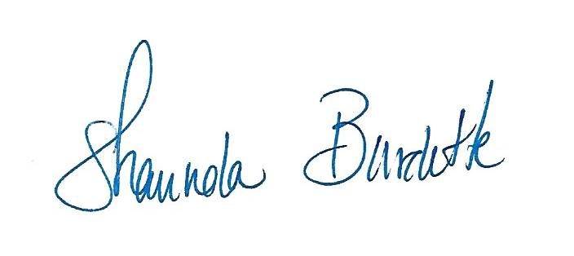
Sincerely,

Shaunda Burdette, Executive Director Ted King, Event Chair
Citrus County Education Foundation Citrus County Education Foundation
burdettes@citrusschools.org theodore.king@duke-energy.com

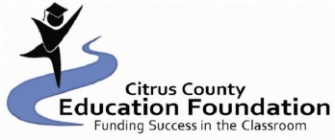
Sponsorships

Flagship Sponsor $5,000
- Print and broadcast advertising (flyers, posters, radio ads, etc.)
- All CCEF marketing and social media outlets regarding Dragon Boat.
- Logo on festival T-shirts
- Festival banner and program
- Prominently displayed link to your website on the Hernando Dragon Boat Festival page
- Broadcast advertisements on Race Day
- One complimentary vendor space
- One complimentary Dragon Boat team entry fee

Gold Sponsor $2,500
- Company name/logo displayed on the Lake Hernando Dragon Boat Festival page
- Marketing on CCEF’s social media outlets.
- Logo on festival T-shirts
- One Complimentary vendor space
- Festival banner
- Broadcast advertisements on Race Day

Silver Sponsor $1,000
- Company name/logo displayed on the Lake Hernando Dragon Boat Festival page
- Marketing on CCEF’s social media outlets
- Logo on festival T-shirts
- One Complimentary vendor space
- Festival banner
- Broadcast advertisements on Race Day

Bronze Sponsor $500
- Name on festival banner
- Marketing on CCEF’s social media outlets
- One complimentary vendor space
- Logo on festival T-shirts

Friends of Dragons Sponsor $150
- Name on festival banner
- Marketing on CCEF’s social media outlets

Lake Hernando
Dragon Boat Festival
2022
SPONSORSHIP AGREEMENT

Name of Company, Organization, or Individual as it should appear in promotional material:
____________________________________________________________________________________
Contact Name______________________________________________________________________
Email _____________________________________________________________________________
Address____________________________________________________________________________
City_____________________________________ State________ Zip____________
Phone #______________________
Website ________________________________________________________________
*attach a business card if available

Sponsorship Level:
_____ Flagship Sponsor $5,000
_____ Gold Sponsor $2,500
_____ Silver Sponsor $1,000
_____ Bronze Sponsor $500
_____ Friends of Dragons Sponsor $150

Citrus County Education Foundation, Inc. is a 501(c)(3) nonprofit organization. Contributions are tax-deductible. A confirmation letter/receipt will be sent to donors after full payment is received. SPONSORSHIP DEADLINE October 21, 2022. Direct questions to: CCEF Executive Director Shaunda Burdette, 352.726.1931 x2240, burdettes@citrusschools.org. ALL SPONSORS– please submit your logo (JPEG format) and web address as soon as possible for display on CCEF, and Dragon Boat websites. By signing this form, you agree to all participation guidelines for sponsors.

NAME_____________________________________________________________________
SIGNATURE_____________________________________Date______________________
Please make checks payable to CCEF and attach a business card if available.
Mail to:
Citrus County Education Foundation
Attn: Dragon Boat Festival
P.O. Box 2004
Inverness, FL 34451

Donation Amount: ________________ Check #: ________________

