Health & Wellness
Mini Grant Application Packet
2019-2020

Community support, which is generated by the Education Foundation, along with funds from Bayfront Health Seven Rivers through their Kings Bay 5K fundraiser event, makes this grant project possible.
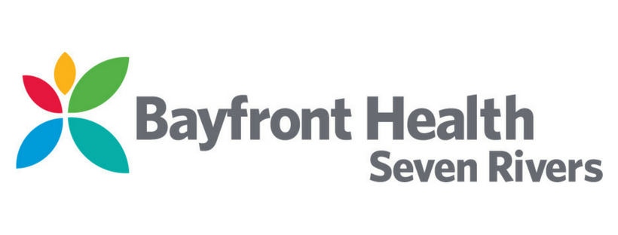
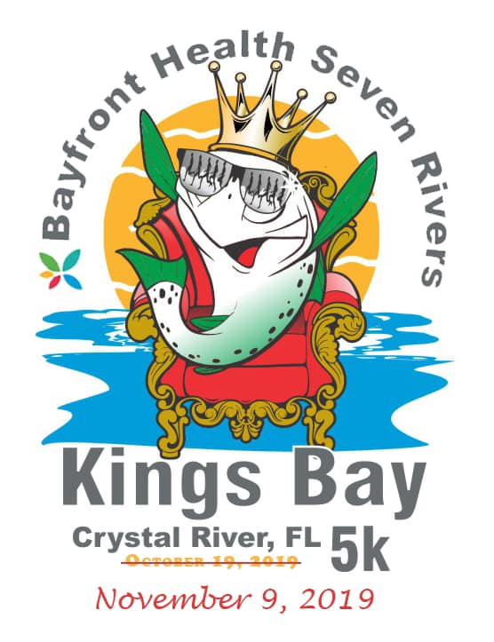
The Foundation will award mini-grants up to $500 per individual teacher or $1000 per team of teachers to focus on health and wellness projects that enhance curriculum and classroom instructional activities. Each teacher can only be included in one mini grant application.
Grants will be given based on unique, creative and innovative projects. Please review the allowable and non-allowable items on the last page of this application.

DEADLINE: Friday, December 20, 2019 at 4:00 pm
** ALL APPLICATIONS MUST BE TURNED INTO YOUR SCHOOL PRINCIPAL **

Please do not send this completed application by email or FAX. Send the hard copy with original signatures of the teachers and principal.

This year's program is being funded through the Citrus County Education Foundation and Bayfront Heath Seven Rivers through their Kings Bay 5K fundraising event.

Mini-Grant recipients agree to:

- Follow the polices & procedures of the Education Foundation in regard to these mini-grants.
- Attend a grant awards celebration for recipients and CCEF members on January 23rd, 2020 from 5:30 to 6:30pm at the Lecanto High School Cafeteria.
- Complete his/her project and purchase all items by March 20th, 2020
- Complete and return the Evaluation / Budget Report on or before May 1st, 2020
- Provide photographs of your project in action and allow CCEF members to come observe the project if requested.

Submissions will be reviewed by January 16th, 2020. Members from CCEF’s Review Committee may contact you for additional information on your project/submission prior to making final funding decisions. Winners will be notified by January 17th, 2020.

Please save pages one and two for your records and submit the remainder of this packet.

APPLICATION ANSWERS MUST BE TYPED.

If you have any questions or need any assistance, please contact Shaunda Burdette at
352.726.1931 x2240 or burdettes@citrus.k12.fl.us

Health & Wellness Mini Grant Application

Teacher(s) Submitting Application:

Name: ___________________________________________________

Name: ___________________________________________________

School: __________________________________________________

Project Name: __________________________________________________________

__________________________________________________________

---------------------------------------------------------------------------------------
Internal use:

Date Received: __________

Time Received: __________

Grant #: _________

General Information:

Name: ____________________________________________________________________

Name: ____________________________________________________________________

School: ____________________________________________________________________

Grade Level/Subject Area: _________________________________________________

Project Name: ______________________________________________________________

Amount requested: $_______________
(up to $500 if applying individually and $1000 if 2 or more)

If the total cost of your project exceeds the amount requested, please provide the total cost and describe how you plan to cover the additional costs:

Total Costs $______________________

Exceeded costs will be covered by/through: ________________________________

_____________________________________________________________________________

Number of students to benefit from this project: #_______________

Are you a 1st year teacher applying: (circle one) YES NO

Name of 1st year teacher applying: ________________________________________

Project Details:
For the following questions, please be as thorough as possible. You may attach additional pages, printouts, photos, and other items you feel will help in reviewing your project.
- Describe the project and its purpose:

2) Describe how this project proposes to focus on health and wellness in your classroom/school and note any other areas of focus:

3) Project Evaluation: Please select one or more of the evaluation tools and in the space below describe how you will use it to compare/ measure the effectiveness of this project. (Documentation of this will need to be included in the May final evaluation of your project.)
- Pre and Post Tests
- Evaluation of student portfolios
- Rubric
- Test scores (FSA scores will not be available by May when you have to turn in a final report)
- Report card grades comparison
- Surveys
- Questionnaires
- Discussion/Interviews
- Other

4) List the materials and the cost of each item you need to complete the project (Please be sure you are researching to find the best available price for the items requested):
Item you wish to purchase with mini grant funds | Project Use | Vendor | Estimated cost
 |  | Total Requested
Policies and Procedures
- Applications must be filled out in their entirety and turned into your school principal by 4:00 PM on December 20th.
- Social media must be used to promote your grant and the Citrus County Education Foundation, and your Corporate Grant sponsor must be tagged. Facebook - @citruseducation Twitter - CCEduFoundation Instagram - @CC Education Foundation
- A cost strip will be assigned by the finance department to the school site bookkeeper. * Grant purchased items must remain in the school at which they were purchased. Example: Teachers, who transfer from one school site to another, must leave the grant purchased items at the school in which the grant was originated.
- No individual checks or reimbursements will be given. Mini grants will require purchasing items by school purchase orders, school checks or school credit cards through the school bookkeepers.
- All recipients will adhere to the timeline set-up by the Foundation for the completion of final grant evaluations.
- Final evaluations must be completed in their entirety and include: copies of the individual invoices, bills, etc. from all purchases made for this project; and data evaluation results.

NOTE: Failure to meet submission deadlines and policies will result in elimination from future grants.

I have read and understand the policies and procedures of the Citrus County Education Foundation’s Health & Wellness Mini-Grant and should I (we) be awarded a grant, I (we) agree to adhere to these policies.
Are any technology items included in this grant to purchase?
(circle one) YES NO
If YES, Appendix (A) MUST also be reviewed and signed.
Teacher Signatures:

Signed: _________________________________________
Signed: _________________________________________
Principal’s Signature: ___________________________ Date: ______________
** All documentation required must be complete to receive consideration for this grant
Approved grant recipients will be notified by January 17th.
Appendix A

Considerations for technology purchases related to the
Foundation for Success Mini Grants

Each year there is an increase in technology items requested in the mini grant budgets. Below are some district guidelines. Please refer to the guidelines when budgeting for or ordering technology items. Our goal is not to hinder creativity or thinking outside of the box, but rather to maintain a semblance of standards and uniformity for the hardware and software systems in place in our school district.

- Any iPad, regardless of model, should be purchased directly from Apple. Quotes may be obtained from our Apple Inside Sales rep: Adam Pirttima, apirttima@apple.com, (512) 674-2834. The reason iPads need to be purchased from Apple is to enable us to incorporate them into our mobile device management system, which is connected to Apple. They populate device information into our system upon purchase.

- The following items are prohibited for purchase and will not be approved: ink jet printers, android tablets, multifunction printers (printer, scanner, fax), network switches, wireless access points or any other device that may connect to our computer network. The reason for this is standardization of equipment in our schools.

- Items like smart boards, video projectors, document cameras, and computers should align with current district standards and infrastructure. In most cases the district ends up supporting these devices and we need to minimize the diversity of brands and models that we have in place to provide adequate support.

- Any grant application should include the full cost of implementation. For example, if a new project or initiative requires an additional network drop in a classroom, the cost of that network drop should be included in the grant. Applicants may contact the Technology Resource Center at 352-746-3437 for an estimate of these costs if needed.

- Careful consideration should be given to not duplicate existing software systems that we have in place.

Teacher(s) Signature: _________________________________________
Signature: _________________________________________
Signature: _________________________________________

