Growing Head Start Success
with Farm to Early Care and Education

Aligning Head Start Program Performance Standards and the Early Learning Outcomes Framework with Farm to Early Care and Education Opportunities

Outreach Toolkit
August 2017

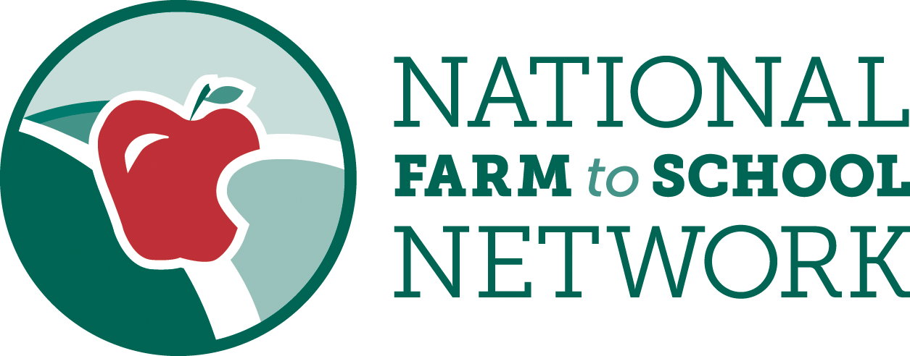

farmtoschool.org/ECE
Introduction
Head Start offers vital, high quality early care and education (ECE) opportunities to low-income families across the country. Farm to ECE offers benefits that support the goals and priorities of the early care and education community, with a particularly strong alignment with Head Start priority areas, including an emphasis on experiential learning opportunities, parent and community engagement, and life-long health and wellness for children, families and caregivers.

The National Farm to School Network has created Growing Head Start Success with Farm to Early Care and Education to promote understanding amongst Head Start stakeholders (including state level directors and collaboration office staff, directors, teaching staff, health coordinators, trainers and advocates) of how farm to ECE can support achievement of Head Start Program Performance Standards and actively contributes to learning and development benchmarks as outlined in the Head Start Early Learning Outcomes Framework. This resource aims to highlight how farm to ECE elements, implemented individually or in combination, may address multiple domains and standards, and provide significant benefits for children, families and communities.

Get involved
To reach the many stakeholders across the country who can benefit from this resource, we need your help. Use the social media copy, newsletter and blog content provided in this toolkit to share this new resource and the great benefits of farm to ECE. Here are several ideas of how you can help spread the word:
- Share the resource on your social media channels and website. Be sure to use the hashtags: #farmtoECE and #HeadStart
- Announce the resource in your next e-newsletter
- Post a story about the resource and the benefits of farm to ECE on your blog
- Use the resource to start a conversation about farm to ECE with Head Start leaders and ECE and food systems partners in your community
- Tell us about farm to ECE activities at your Head Start and in your community using our Story Form: farmtoschool.org/about/tell-us-your-story

Social Media
Social media is a great place to highlight this valuable new resource with your audience. Use #farmtoECE and #HeadStart and tag the National Farm to School Network to let us know that you are spreading the word.
- Follow us on Twitter at @FarmtoSchool
- Follow us on Facebook by searching for “National Farm to School Network”
- Follow us on Instagram at @FarmtoSchool

Suggested Tweets:
NEW resource from @FarmtoSchool highlights how #farmtoECE activities support #HeadStart success. Explore: farmtoschool.org/HeadStart

Aligning #HeadStart and #farmtoECE made easy with @FarmtoSchool’s new “Growing Head Start Success” Toolkit: farmtoschool.org/HeadStart

Farm to ECE can easily fit into your #HeadStart Program’s curriculum! Learn more & explore resources at farmtoschool.org/HeadStart #ECE

#FarmtoECE promotes social + emotional development, approaches to learning, physical development + more. See how: farmtoschool.org/HeadStart

Suggested Facebook Posts:
Farm to early care and education strongly aligns with and supports Head Start priority areas. Learn how and find ways to start or expand farm to ECE in Head Start with new Growing Head Start with Farm to ECE resource. farmtoschool.org/HeadStart

Gardens, local foods & food and ag education support Head Start success! Learn how farm to ECE and Head Start align in National Farm to School Network’s new resource, Growing Head Start Success with Farm to ECE. farmtoschool.org/HeadStart

Sample Text for Newsletters, Blogs & Listservs
Short Version:

Farm to ECE & Head Start: A Natural Alignment
Farm to early care and education offers benefits that strongly parallel the goals and priorities of the early care and education community, with a particularly strong alignment with Head Start priority areas, including an emphasis on experiential learning opportunities, parent and community engagement and life-long health and wellness for children, families, and caregivers.

To make it even easier for Head Start stakeholders to implement farm to ECE, the National Farm to School Network has created Growing Head Start Success with Farm to Early Care and Education. This new, comprehensive resource aims to promote understanding amongst Head Start stakeholders of how farm to ECE supports achievement of Head Start Program Performance Standards and contributes to learning and development benchmarks as outlined in the Head Start Early Learning Outcomes Framework.

To dig into this new resource and find additional ways to get involved in farm to ECE, visit the National Farm to School Network’s Farm to ECE Landing Page. NFSN is available to provide additional training, customized support and tools for your organization on a consultation basis. To learn more, contact Lacy Stephens, Farm to Early Care and Education Associate, at lacy@farmtoschool.org.

Long Version:

Farm to ECE & Head Start: A Natural Alignment
Farm to early care and education offers benefits that strongly parallel the goals and priorities of the early care and education community, with a particularly strong alignment with Head Start priority areas, including an emphasis on experiential learning opportunities, parent and community engagement and life-long health and wellness for children, families and caregivers.

To make it even easier for Head Start stakeholders to implement farm to ECE, the National Farm to School Network has created Growing Head Start Success with Farm to Early Care and Education. This new, comprehensive resource aims to promote understanding amongst Head Start stakeholders of how farm to ECE supports achievement of Head Start Program Performance Standards and contributes to learning and development benchmarks as outlined in the Head Start Early Learning Outcomes Framework. Growing Head Start Success is designed with clear, easy to read tables that directly align Program Performance Standards and the Early Learning Outcomes Framework with specific farm to ECE activities from each of the three core elements of local procurement, gardening and food, agriculture and nutrition education. The resource also offers three profiles of Head Start programs leading the way in addressing performance and learning standards with farm to ECE and their tips for integrating farm to ECE in Head Start.

By promoting this resource widely, we hope that even more Head Start programs choose farm to ECE to meet program and learning standards while providing children, families and communities with the myriad benefits that farm to ECE has to offer. To dig into this new resource and find additional ways to get involved in farm to ECE, visit the National Farm to School Network’s Farm to ECE Landing Page. NFSN is available to provide additional training, customized support and tools for your organization on a consultation basis. To learn more, contact Lacy Stephens, Farm to Early Care and Education Associate, at lacy@farmtoschool.org.

