2020 KALEIDOSCOPE COMMUNITY SERVICES
FROM PASTOR GAR
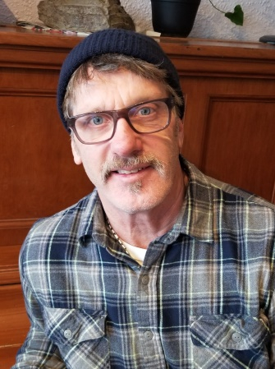
2020 has been a tumultuous year for all of us. We, like many of you, are grateful to the Lord for getting us through. While this year hasn’t been easy by any stretch of the imagination, we can look back with thanksgiving for the Lord’s provision, protection, direction, and resiliency throughout the year.
We have lost dear friends this year, we have had friends who have experienced severe illness, and some of our dearest friends have experienced the unfathomable grief of losing family members. We have also had friends who have lost businesses, jobs, and even their homes. We share the grief of these dear friends because when one part of the Body hurts, we all hurt with them- this is our way.
On the opposite end of grief and loss, we have experienced great relief and joy. Through it all we have been a part of the work of the Kingdom of God in amazing ways. Burdens have been lifted and bondages broken. New people have committed their lives to the direction of Jesus and His ways. People have found housing, found and maintained employment, reconciled with family members, received needed clothing, food, and other resources, and made progress in many areas of their lives. New volunteers and supporters have been called and deployed in meaningful work that has become life changing for them, and we’ve seen the ‘people of God’- the Church- come together like never before.
God is good-all the time- even through confusing and painful circumstances. We can trust Him in every circumstance we face- we have experienced that ourselves this last year- and we believe this with all our hearts and we stake our lives on this promise.
We would like to thank all of our supporters whom God has used to provide for our ministry this last year. Many have donated time and money to our ministry, and prayed for us throughout the year. All of you have become our partners in ministry and share in all of the fruit that we’ve experienced this last year. Thank you!
KALEIDOSCOPE GIVES
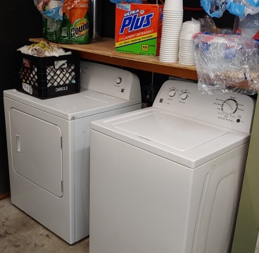
On September 1st, 2020 KCS handed the baton of management of the 2nd Street Commons over to our longtime ministry partner ‘2nd Chance Discipleship Ministries’. We are excited about this move because 2nd Chance will bring new vision, resources, and volunteers to the Commons through their partnership with their Nazarene Connect Churches.
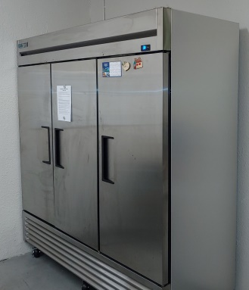
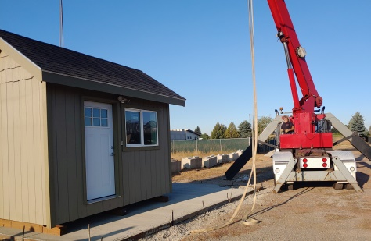
In October of 2020, the KCS board of directors unanimously agreed to gift all the contents of the 2nd Street Commons to 2nd Chance Ministries. This included all of our kitchen equipment, freezers, washer and dryer, inventory of resources, and furnishings (On KCS books for about $ 20,000.00). Initially the board was considering selling all of these items but as time went on the Lord made it clear that we were to bless 2nd Chance with everything so they wouldn’t incur any debt to acquire what they need for ministry. It was an easy choice for the board because everything that was there was donated or purchased with grant funds for ministry at the Commons.
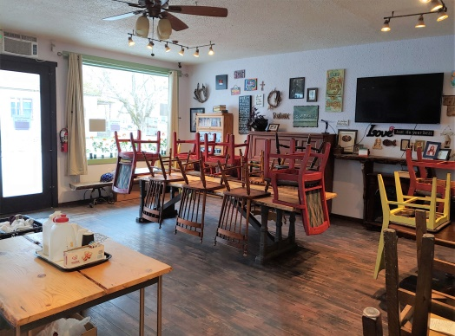

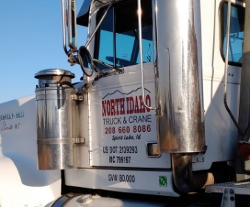
Along with the contents of the Commons, KCS also donated our ‘Pathfinder Tiny House’ to 2nd Chance Ministries. 2nd Chance hopes to use this cabin to provide temporary crisis housing for individuals or small families as they wait for housing. We are so thankful to Paul Loibl and ‘North Idaho Truck and Crane’ for helping us with the moving project!
In 2020 KCS spent over $ 4,500.00 in direct benevolence to meet crisis needs through the 2nd St. Commons, and an additional $ 6,900.00 for support supplies for the 2nd St. Commons. KCS will continue to partner with 2nd Chance Ministries through the 2nd Street Commons by being a resource for emergency needs (car repairs, bus tickets, transportation, etc.) and by being an employment option (through our work services training program) for homeless individuals who are ready to make a change.
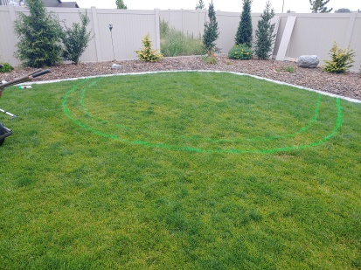
WORK SERVICES TRAINING PROGRAM
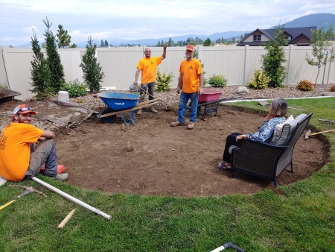
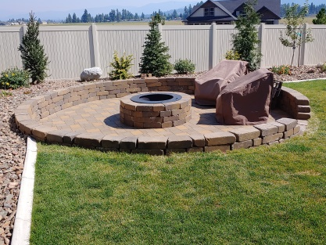
We started the work season last March in the beginning stages of covid-19 lock-downs. Being deemed ‘necessary workers’, we were able to proceed with our jobs. Throughout the year we remained about 30 days out for new jobs, and we ran out of weather in November, still about a month out. Currently we have six jobs to start out with in the spring of 2021.
We did all kinds of jobs this year- logging and brush clearing, seedling planting, full landscapes and refurbishments, sprinkler systems, wood and vinyl fencing, patios and fire pits in pavers and flagstones, moving jobs and interior remodeling work. Throughout the year we remained very diversified and our guys were able to learn a tremendous amount.
Our team also realized much growth in the ‘soft skill’ area which included job-site ethics, working through inter-personal conflicts, working through personal problems outside of work, rolling through last minute changes in jobsite work-scope and schedule changes, and navigating the ever-present daily problems that arise working on jobsites. We witnessed steady improvement among crew members throughout the year. One main reason for this I believe was our daily practice of spending time in God’s word and prayer together before we did anything.
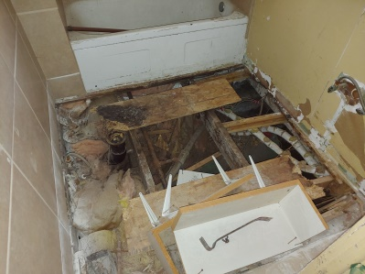
Here are some highlight outcomes from 2020:
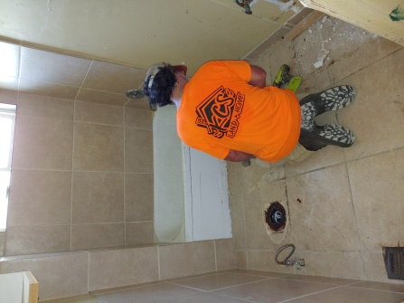
- Income Generated: $ 122,664
- Billable Hours: 3,625
- Training Hours: 492
- Donated Hours: 142
- Other Hours: 241
- Payroll Generated to employees: $ 67,862
- Job Materials purchased locally: $ 20,051
- Tools, Rental Equip & Equip Purchased locally: $ 27,140
- Other Contractors & Local Purchases: $2,058
- Housing Assistance to employees: $ 5,438
(first, last, deposits)
- Employee Motel Assistance: $ 3,354
- Transportation Costs for employees: $ 3,695
- Other Costs benefitting employees: $ 4,073 (work clothing, food, eye and dental care, teaching materials, printing, misc. repairs)
- Case Management/Mentoring Hours: 170
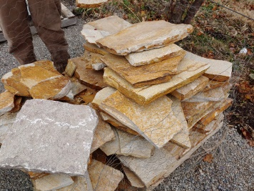
- Employees Hired: 9
- Employees Retained: 6
- Two leases signed over to ex-employees; two new houses rented (Employees are now making rent payments)
- Three Employees eye exams and new glasses
- Five Employees outfitted with work clothes and boots
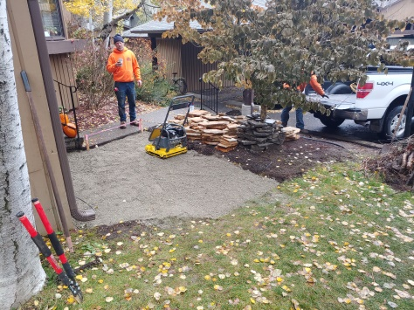
- Continued to staff a part-time grant writer
- Secured $ 700 CDA Rotary Endowment for Work Service Program
- Secured $ 850 CDA Sunrise Rotary Endowment for mower purchase
- Secured $ 10,000.00 Laura Moore Cunningham Foundation Grant for Skidsteer purchase
- Raised $2,130 through Facebook Fundraising for work clothing
- All 27 customers were happy when jobs were completed
- Economic Situation of all 9 hires was improved
- Child support payments made by employees (since hire):
$ 2,307
- Significant life transformation reported and observed in 6 employees
- 6 Families and non-profit agencies served with free services
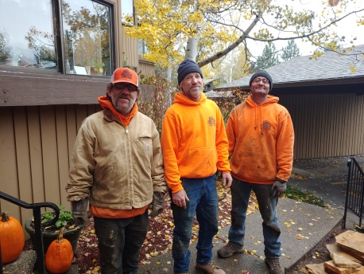
- 6 Formerly unemployed homeless people are now stabilized, employed, housed, getting healthy, paying bills, serving others, and enjoying hope for their future
- All four 2020 year-end crew members hired to full-time work for the coming winter through a local land services company
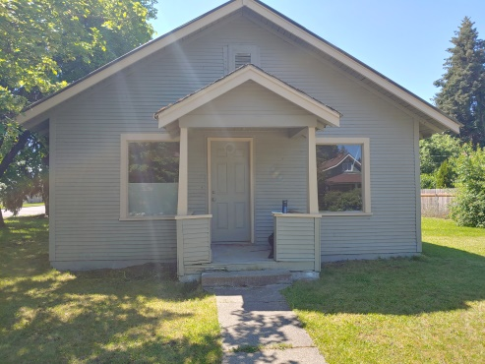
A NEW HOME
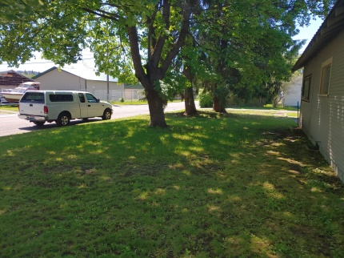
Over the last seven years KCS has used different housing models to house dozens of people. We have housed people in a variety of RV trailers and motorhomes, rooms in houses of empathetic friends, and rooms in various transitional housing programs. Over the last two years KCS has rented our own houses and allowed our work services program participants to sublet from us (with landlord approval). While expensive on the front end, renting our own homes has seemed to work the best with the longest lasting results. In 2020, KCS was able to transfer the leases of two houses to program participants.
Just this fall KCS rented another house for program participants. It cost KCS $ 3,750.00 to get into the house up front for first, last, and damage deposit. The residents of the house will pay monthly rent and gradually make up the damage deposit over time. KCS volunteers will meet with the tenants of the house weekly for house meetings and an option Bible study (which the tenants are eager to do). At the end of the lease period, the tenants will have the option to lease the house in their own names.
This is a great model but it takes stable partnerships to make it happen. First of all you need a landlord who is willing to take a risk housing formerly homeless persons. Next it takes an organization that has screened the individuals, has the cash to put up front, then the personal to regularly oversee the house and the relationships in the house. Finally it takes residents who are committed to taking the opportunity to turn their lives around.

A HEART FELT THANK YOU
We at Kaleidoscope Community Services want to thank you for your support and prayers. It means the world to us to know we have your support- we really couldn’t do what we do without all of you lifting us up. We thank God for each and every one of you!
Feel free to reach out to us if you have any questions- we would be delighted to talk to you! As you all know, we are a donation run ministry. As with all 501 C3 nonprofits, we are always excited to talk about what we do more in depth with you or your friends whom you might think are interested in investing in our work and ministry among the poor, homeless, and most vulnerable in our community.
Gar Mickelson
Executive Director, Kaleidoscope Community Services www.kaleidoscopecs.org
208.699.2250 gar.mickelson@kaleidoscopecs.org

