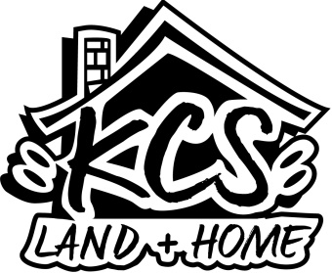

KCS WORK SERVICES PROGRAM OUTCOMES 2020

WORK SERVICES TRAINING PROGRAM
We started the work season last March in the beginning stages of covid-19 lock-downs. Being deemed ‘necessary workers’, we were able to proceed with our jobs. Throughout the year we remained about 30 days out for new jobs, and we ran out of weather in November, still about a month out. Currently we have six jobs to start out with in the spring of 2021.
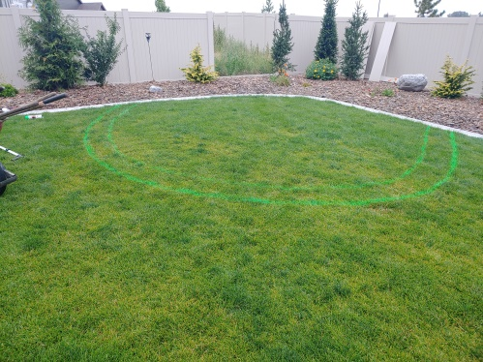
We did all kinds of jobs this year- logging and brush clearing, seedling planting, full landscapes and refurbishments, sprinkler systems, wood and vinyl fencing, patios and fire pits in pavers and flagstones, moving jobs and interior remodeling work. Throughout the year we remained verify diversified and our guys were able to learn a tremendous amount.
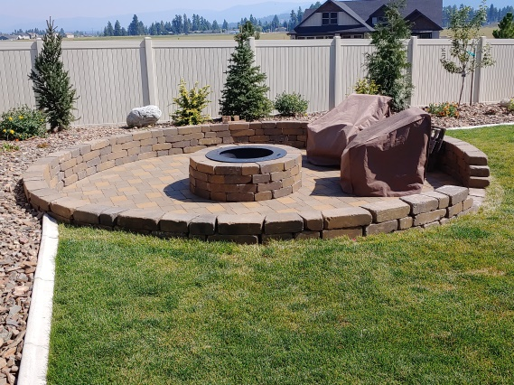
Our team also realized much growth in the ‘soft skill’ area which included job-site ethics, working through inter-personal conflicts, working through personal problems outside of work, rolling through last minute changes in jobsite work-scope and schedule changes, and navigating the ever-present daily problems that arise working on jobsites. We witnessed steady improvement among crew members throughout the year. One main reason for this I believe was our daily practice of spending time in God’s word and prayer together before we did anything.
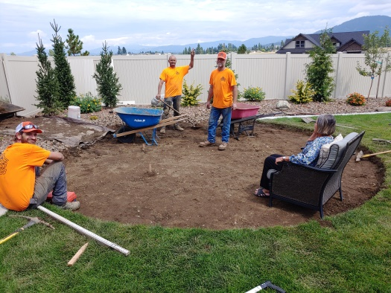

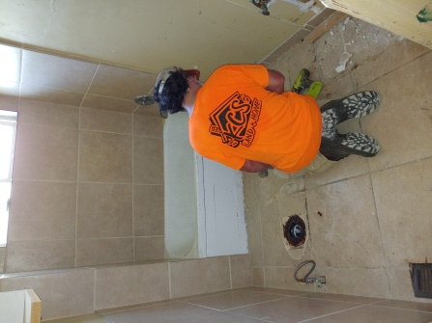
Here are some highlight outcomes from 2020:
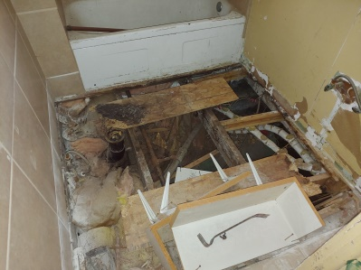
- Income Generated: $ 122,664
- Billable Hours: 3,625
- Training Hours: 492
- Donated Hours: 142
- Other Hours: 241
- Payroll Generated to employees: $ 67,862
- Job Materials purchased locally: $ 20,051
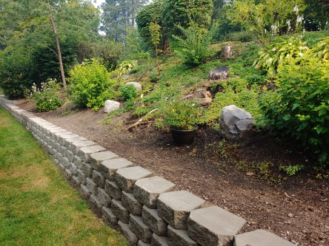
- Tools, Rental Equip & Equip Purchased locally: $ 27,140
- Other Contractors & Local Purchases: $2,058
- Housing Assistance to employees: $ 5,438
(first, last, deposits)
- Employee Motel Assistance: 3,354
- Transportation Costs for employees: $ 3,695
- Other Costs benefitting employees: $ 4,073 (work clothing, food, eye and dental care, teaching materials, printing, misc. repairs)
- Case Management/Mentoring Hours: 170
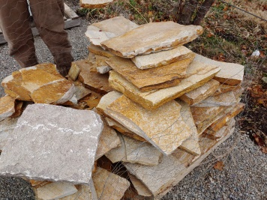
- Employees Hired: 9
- Employees Retained: 6
- Two leases signed over to ex-employees; two new houses rented (Employees are now making rent payments)
- Three Employees eye exams and new glasses
- Five Employees outfitted with work clothes and boots
- Continued to staff a Part-time grant writer
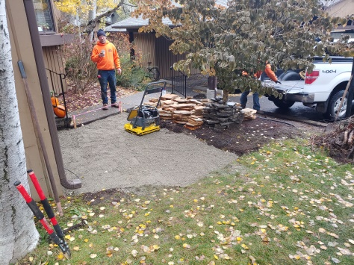
- Secured $ 700 CDA Rotary Endowment for Work Service Program
- Secured $ 850 CDA Sunrise Rotary Endowment for mower purchase
- Secured $ 10,000.00 Laura Moore Cunningham Foundation Grant for Skidsteer purchase
- Raised $2,130 through Facebook Fundraising for work clothing
- All 27 customers were happy when jobs were completed
- Economic Situation of all 9 hires was improved
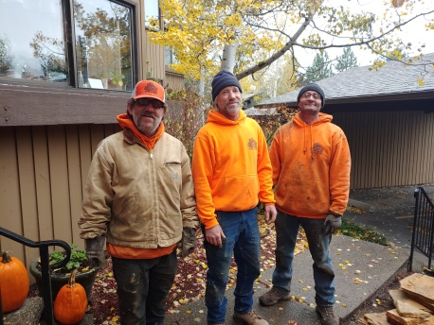
- Child support payments made by employees (since hire):
$ 2,307
- Significant Life transformation reported and observed in 6 employees
- 6 Families and non-profit agencies served with free services

- 6 Formerly unemployed homeless people are now stabilized, employed, housed, getting healthy, paying bills, serving others, and enjoying hope for their future
- All four 2020 year-end crew members hired to full-time work for the coming winter through a local land services company

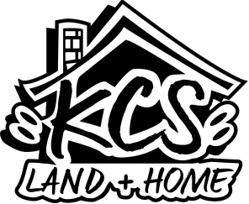
2020 was the 2nd Year for our work services program, which we call ‘KCS Land and Home’. We began the work year in January and February by planning and estimating for upcoming jobs, planning organizational improvements based on what we learned in 2019, and by applying for various grants. We began interviewing potential program participants in late February and early March and actually started working out on jobs in late March in the midst of the Covid-19 outbreak.

When we reflect back on the last number of months we are humbly amazed at what God has done and what He has brought us through. We give Him all the credit! Lives have been changed for the better, people who could not afford work services have been served, customers have been pleased and have recommended us to others, and we grew in skill, knowledge, and maturity. While this whole work season seems to have been one giant test of faith and endurance through uncertain times, today as we look back we feel wonderfully blessed and encouraged.

Financially, the bottom line is that ‘KCS Land and Home’ did very well this year and actually turned some profit, which was used to help with a portion of employee support costs. The program generated more income, had more billable hours (better efficiency), had more customers, spent more money in our local community, and did this this with less payroll and training hours. We are so excited about how this program grew and became more efficient in its operation. We are more excited about how God provided the resources to really help people to stabilize and change!

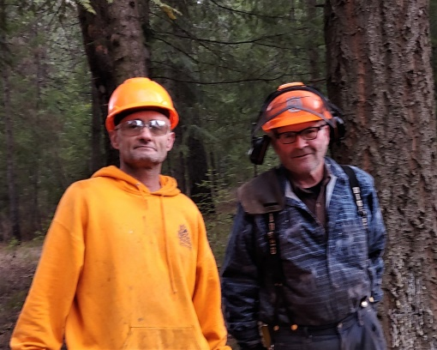
While the work program covered its entire job related operational costs and then some, there were other costs related to employee care and benevolence that were not covered by job income that had to be taken from the KCS nonprofit general fund. These expenditures included funds allocated to employee support which included costs related to housing, transportation, eye care, dental, clearing fines, licensing, and other forms of support. The program also did not support KCS administrative staff or other KCS benevolence initiatives.

To continue to run this program we need to have the support services. Without these services we really don’t have a program at all. We estimate that these employee support services, along with the staff necessary to provide them, will cost 60-80 Thousand dollars each year at current operational levels. If KCS decides to continue this program for a third year in 2021, these support funds will need to be raised through partner donors and grants.

We sincerely thank you for taking the time to read this update, and for your support without which we could not do what we do!
Pastor Gar Mickelson, Executive Director

KCS WORK SERVICES PROGRAM OUTCOMES 2019 and 2020 Combined

Through 09/05/2020:

- Income Generated: $ 181,336.00
- Billable Hours: 5041
- Training Hours: 841.5
- Donated Hours: 374.5
- Other Hours: 151
- Payroll Generated to employees: $ 102,312.00
- Job Materials purchased locally: $ 52,070.00
- Tools, Rental Equip & Equip Purchased locally: $ 27,846.00
- Other Contractors & Local Purchases: $1,679.00
- Housing Assistance to employees: $ 5,176.00 (first, last, deposits)
- Transportation Costs for employees: $ 1,484.00
- Other Costs benefitting employees: $ 10,099.00 (work clothing, food, eye and dental care, teaching materials, printing, misc. repairs)
- Case Management/Mentoring Hours: 386
- Employees Hired: 22
- Employees Retained: 16
- Continued to rent Two Houses (Employees are now making rent payments)
- Six Employees eye exams and new glasses
- Ten Employees outfitted with work clothes and boots
- Continued to staff a Part-time grant writer
- Secured $ 700.00 CDA Rotary Endowment for Work Service Program
- Secured $ 850.00 CDA Sunrise Rotary Endowment for mower purchase
- Secured $ 10,000.00 Laura Moore Cunningham Foundation Grant for Skidsteer purchase
- Secured $ 9,000.00 United Way Grant for work truck
- Secured $ 1,500.00 Idaho Dental Foundation Grant for employee dental assistance
- Secured $ 4,500.00 private donation for enclosed work trailer
- Raised $2,130.00 through Facebook Fundraising for work clothing
- All 46 customers were happy when jobs were completed
- Economic Situation of all 22 hires was improved
- Child support payments made by employees (since hire): $ 5,362.00
- Significant Life transformation reported and observed in 16 employees
- 21 Families and non-profit agencies served with free services
- 16 Formerly unemployed homeless people are now stabilized, employed, housed, getting healthy, paying bills, serving others, and enjoying hope for their future

