The Wheel Of Wellness – By Barbara Cox

10 Areas of Your Life for True Health, Wealth, Happiness and Success.

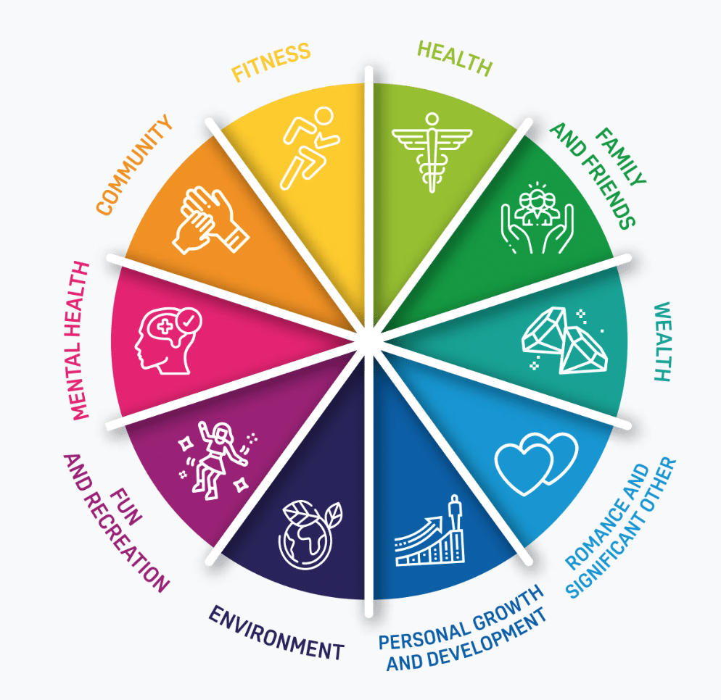

In order to have lasting changes and balance in life, we must look at a holistic way of living that reflects our body, mind, spirit, people, place and planet. Research is showing us how our health and happiness can be boosted by doing certain things on a day-to-day basis. The Wheel of Wellbeing is designed to structure your focus on certain areas of your life so you can make simple improvements that have a knock on effect for the whole wheel.

Let’s take a look at each section and how they are all inter-connected.

Health
Good nutrition is an important part of leading a healthy lifestyle. Combined with physical activity, your diet can help you to reach and maintain a healthy weight, reduce your risk of chronic diseases (like heart disease and cancer), and promote your overall health.

Family & Friends
Most people need a certain level of social interaction to stay healthy although the amount is different for everyone. Spending time with friends and family can reduce your chances of becoming depressed and lonely. Spending time with people is also likely to make you more confident and it keeps your support network healthy and thriving.

Wealth
Being wealthy is important. We need the peace of mind. We need to provide for our family. We need to have enough so we can share. For us to give, we need extra. For us to have extra, we must provide more than our needs. Having more than our needs is having wealth. Having wealth allows us to live the life we deserve, a victorious life that each one of us should be enjoying.

Romance/Significant Other
Having a romantic partner gives a person a sense of reassurance, self-esteem, and love for themselves.
Love enhances the lives of both partners in the relationship. When two people are in love, their emotions are at an ultimate high. Romantic relationships enrich life with friendship, courtship and love.

Personal Growth & Development
Personal development refers to those activities that improve a person's talents, potential, employability, consciousness and ability to realise dreams and create wealth. In short, it's what you do to improve yourself and your prospects in life.
Being confident in these basic academic skills is necessary for finding and keeping jobs that provide a steady income and opportunities for advancement. Skills such as critical thinking, decision-making, and conflict resolution are essential for success in any walk of life.
Raising skills is one of the keys to higher living standards and well-being. Investing in knowledge creation raises self esteem and confidence.

Environment
Environment plays an important role in the healthy living of human beings. It matters because this planet is the only home that humans have, and it provides air, food, and other needs. Humanity's entire life support system depends on the well-being of all the environmental factors.
We can also look at specific environments like your work place, school, home and circle of friends.

Fun & Recreation
We have been bombarded with the idea that working hard is the only way to success. But FUN plays an important role in achieving your goals! The importance of having fun is quite obvious, but people often forget or take their other responsibilities to have precedence over “indulging” in fun.

Positive Mental Health
A positive mental health is characterised by a person’s ability to fulfil a number of key functions and activities, including the ability to learn, the ability to feel, express and manage a range of positive and negative emotions, the ability to form and maintain good relationships with others and also the the ability to cope with and manage change and uncertainty.
Being mentally or emotionally healthy is much more than being free of depression, anxiety or other psychological issues. Rather than the absence of mental illness, mental and emotional health refers to the presence of positive characteristics and at Refresh, this is positive mental health.

Community
As human beings, we need a sense of belonging, and that sense of belonging is what connects us to the many relationships we develop.
A community allows us to support one another, interact, share experiences and our modern life struggles. Having this open bond with others is what builds valuable relationships, and gives us a deeper sense of belonging.
Communities are also rich in resources. Your strengths may be someone else's weaknesses and vice versa.

Fitness
There are plenty of reasons why being physically active is good for you, such as having a healthier heart and strong joints and bones. It can also have a positive impact on your mental health.

Even small amounts of exercise can boost your mental alertness, give you more energy and put you in a good mood. It can also reduce stress and anxiety as well as increase your self-esteem.

Maintaining a balanced life is becoming increasingly more important for your personal health and wellness in a fast-paced, modern world.

Hence, the wheel of wellness can create a more balanced lifestyle.

