Certificate of Completion

Presented to

Lorem Ipsum

signifying completion of training on the

Bringing the Farm to School:
Agricultural Producers’ Toolkit

Presented on MONTH DAY, YEAR

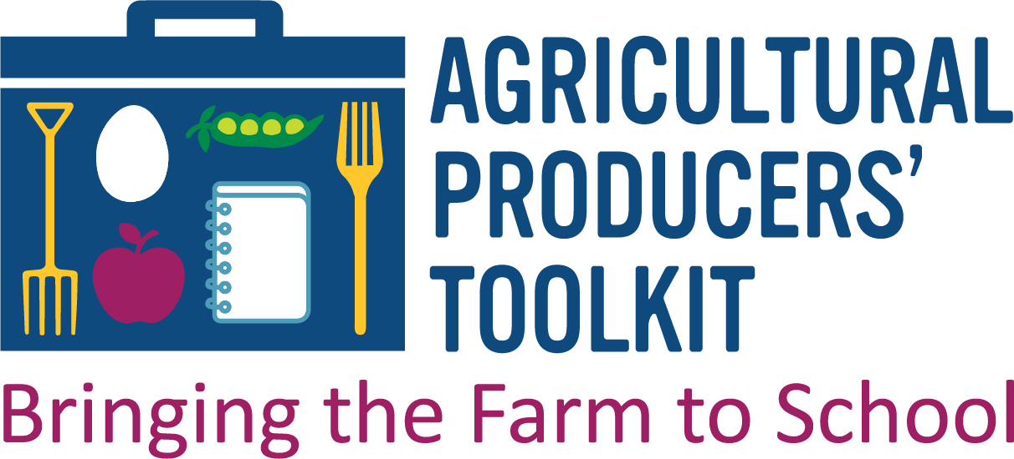

TRAINER

