Social Media Suggestions & Tips
Use these suggested posts on any social media that your organization is active to help get the word out about your Bringing the Farm to School: Local Producer Training. Adding specific training information – such as dates, registration link, and name of your organization – to these posts will make for more effective outreach and promotion.

Twitter
Register Now! [ORG NAME] is hosting the Bringing the Farm to School: Local Producer Training on [DATE] at [LOCATION] to help producers learn about selling their product to schools. Learn more and register by [DATE]: [REGISTRATION LINK]

Want to learn about expanding your ag business to reach school markets? [ORG NAME] is hosting the Bringing the Farm to School: Local Producer Training on [DATE] and [LOCATION]. Learn more and register at [REGISTRATION LINK]

Could sales of local food to schools be a nice addition to your farm’s business plan? Find out at the Bringing the Farm to School: Local Producer Training on [DATE] and [LOCATION]. Learn more and register at [REGISTRATION LINK]

Schools across the country buy $10 Billion each year in food for school meals. Could this market be right for you? Find out at the Bringing the Farm to School: Local Producer Training on [DATE] and [LOCATION]. Learn more and register at [REGISTRATION LINK]

Heard about the farm to school concept, but not really sure how to “dig in”? The Bringing the Farm to School: Local Producer Training on [DATE] at [LOCATION] can help you learn about selling your products to schools. Learn more and register at [REGISTRATION LINK]
Facebook
Training Opportunity: Learn about expanding your ag business to reach school markets. [ORG NAME] is hosting the Bringing the Farm to School: Local Producer Training on [DATE] and [LOCATION]. Hear from local experts about accessing school markets, growing products for schools, and more. Learn more and register at [REGISTRATION LINK].

Curious about expanding your business to reach school markets? Join us on [DATE] at [LOCATION] for a Bringing the Farm to School: Local Producer Training to gain new knowledge and resources to help you connect to the school market. Learn more and register at [REGISTRATION LINK].

Instagram
Calling all farmers & agricultural producers! Are you interested in learning about expanding your business to reach schools? [ORG NAME] is hosting a Bringing the Farm to School: Local Producer Training on [DATE] at [LOCATION] where you can learn from local experts about accessing school markets, growing products for schools, and more. Learn more and register by [PROVIDE MORE INFORMATION].

LinkedIn
Schools across the US purchase more than $800 million in local food products for school meals every year – and that number is growing. Learn about expanding your ag business to reach schools at [ORG NAME]’s Bringing the Farm to School: Local Producer Training on [DATE] at [LOCATION]. Hear from local experts about accessing school markets, growing products for schools, and more. Register at [REGISTRATION LINK].

Generating Buzz With A #Hashtag
Hashtags help identify and connect your social media posts to specific topics and conversations and can help expand your outreach efforts. Some frequently used hashtags to use for your Bringing the Farm to School: Local Producer Training could be #farmtoschool, #schoolfood, #agriculture, #farming and #localfood. Your organization or state may also have frequently used hashtags for farmer-related content (e.g. #PAPreferred, ) that you might use. Any word or phrase can be used as a hashtag, so you could also create a unique hashtag for your training and encourage participants to use it in real-time to share what they’re learning. Hashtags are most effective on Twitter and Instagram.

Reach More People with Tagging (@)
Tagging individuals and organizations connected with your training is a surefire way to assure that they see your post. Be sure to tag (@________) anyone that can help get the word out. If those involved are willing, tag specific individuals, e.g. “@John is leading the #farmtoschool training”. Remember, tagging organizations is a great way to signal that you’d like them to share your post. Tagging is relevant across all social media, especially Facebook.

Social Media Graphics
Use images or graphics along with your social media posts to increase interest and engagement. Best practice for all social media types it to use an image with your post. Below are several ready-to-use graphics, but creating your own graphics with images specific to your location or region (e.g. a rancher) may help attract more attention. Note that every social media channel uses a different dimension for images. Right click on these images to save.

Twitter
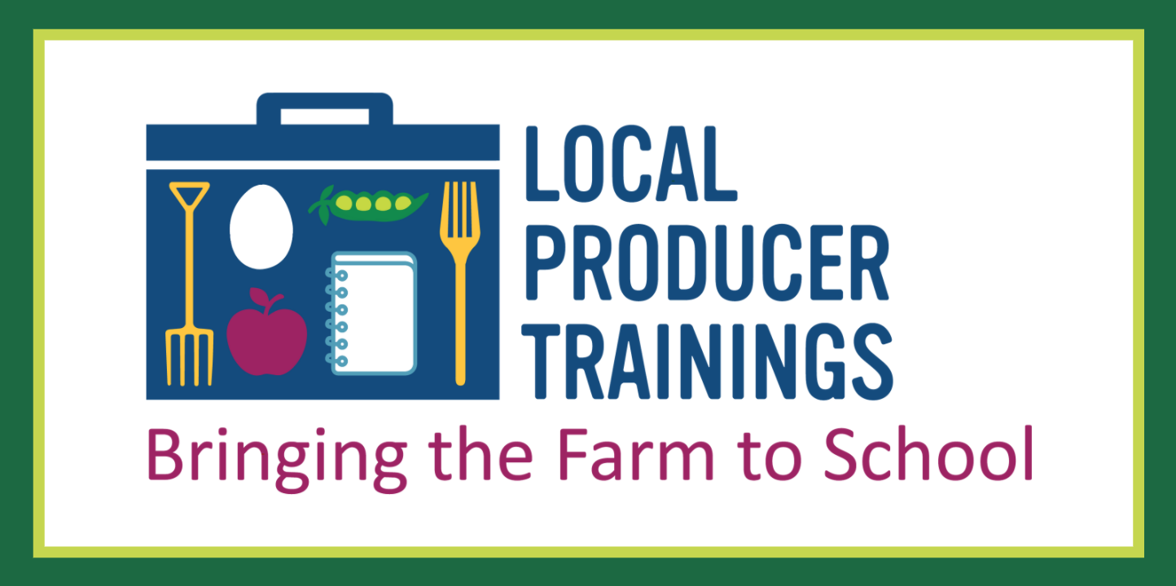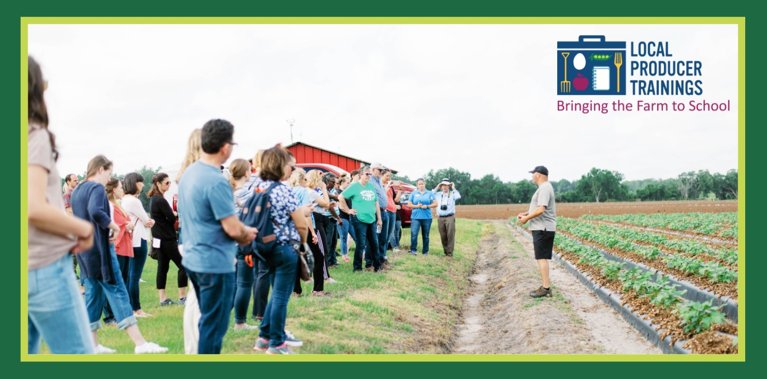

Facebook
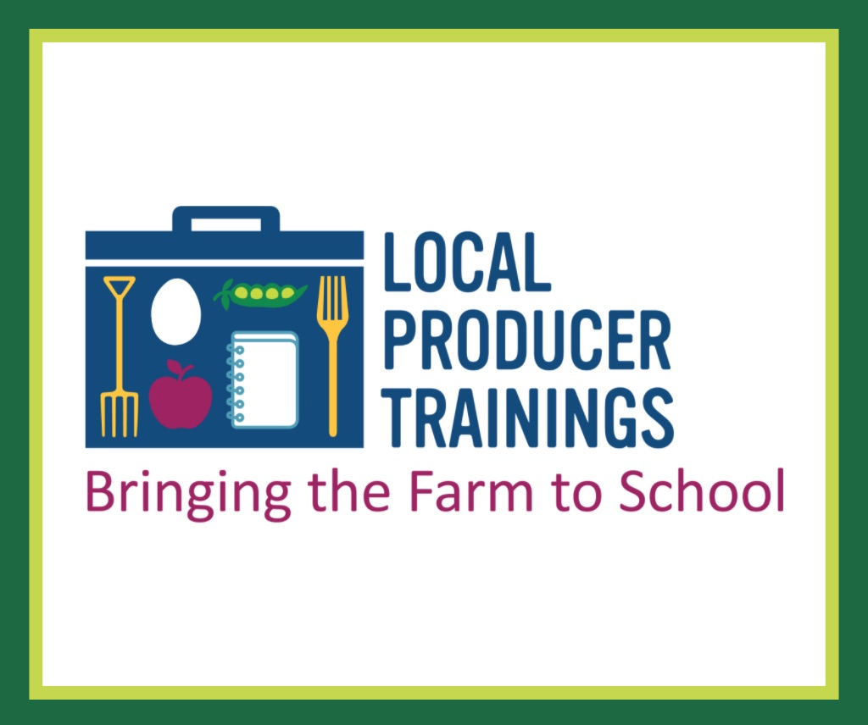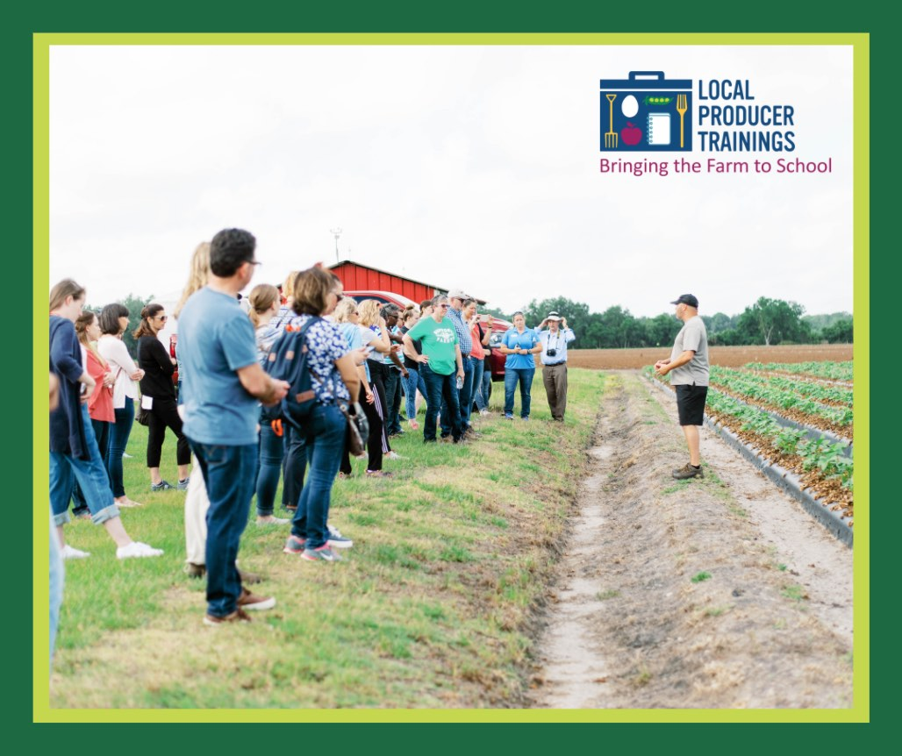

Instagram
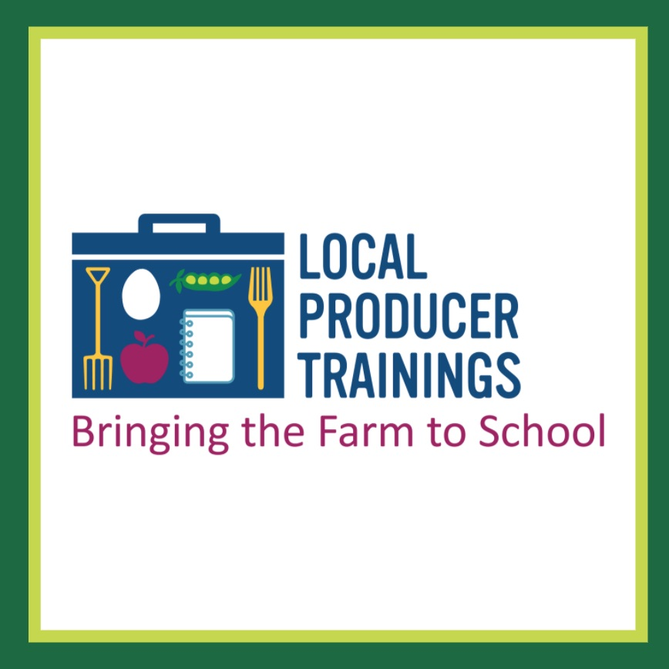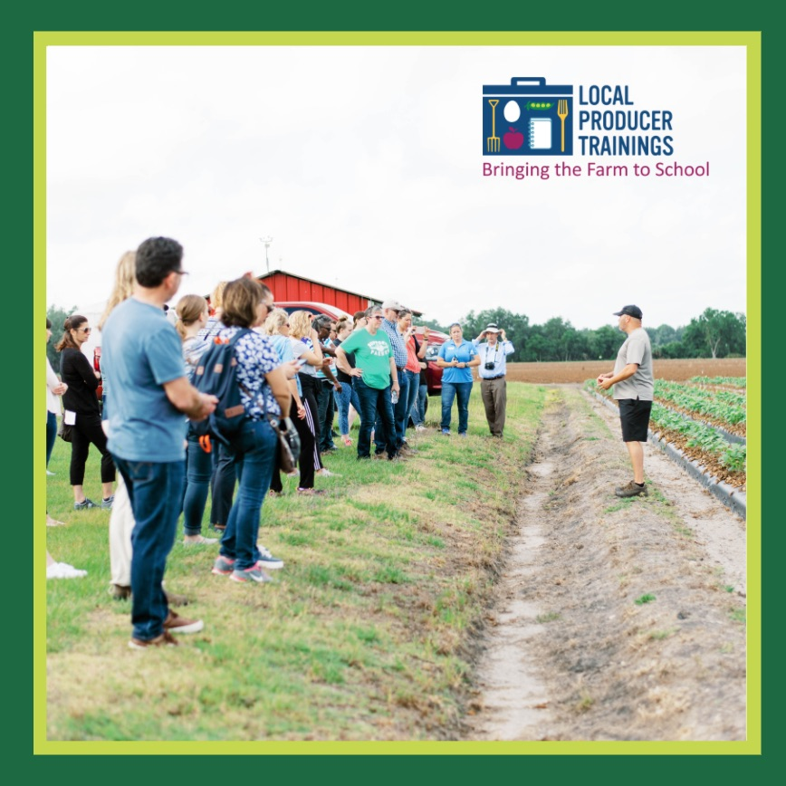

LinkedIn
