November 19, 2020
Dear Valued Member,
The Governor has determined that Western New York is part of a COVID-19 cluster zone and has put our area into Orange status.
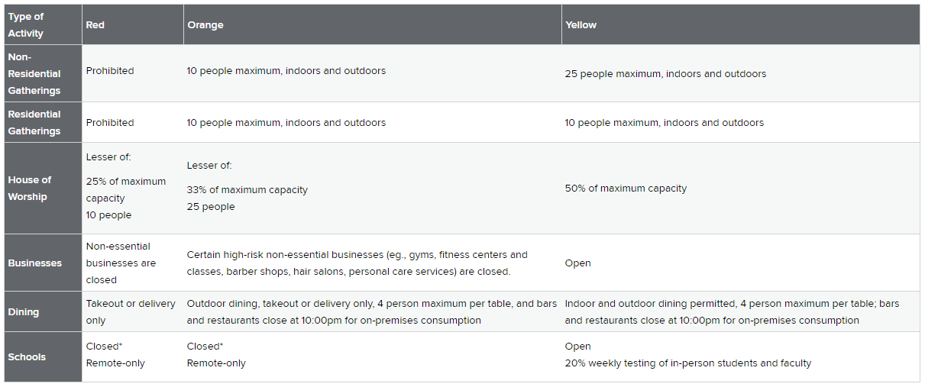

At 9:00pm Thursday November 19, 2020, all Catalyst Fitness locations will close until further notice. We are confident that the closure will contribute to slowing the spread of the virus so we may all return to normal activities more quickly.
All membership billing will stop on December 1, 2020. Your membership will be credited for the time that the gym is closed. The credit will be applied when we are allowed to re-open and billing resumes automatically. We appreciate your patience and loyalty during this incredibly challenging period in our country’s history.
We know that fitness in an integral part of your daily routine. It helps to keep you focused and grounded, and in uncertain times helps you to de-stress. We hope that you take this time to get outside and continue to work towards your fitness goals. We will be posting updates to our social media accounts with suggestions for workouts. Follow our trainers and Group Exercise staff members for great workouts as we navigate this together.
We wish you and your families the best of health, and our hearts go out to all those who have been affected by the COVID-19 Coronavirus. Please do your part to stop the spread and continue to follow the guidelines set by our Local, State and Federal governments in order to help this pandemic come to a safe and quick resolution.
The moment our numbers in Erie County decline and our cluster zone changes to yellow or no color at all, we will be ready to welcome you back to the club. Keep an eye on our social media posts and website www.catalystfitnessbuffalo.com for up to date information.

