Curriculum Guide

“The truly great dancers are the ones that dance with their hearts.”
- Serena Silvertail

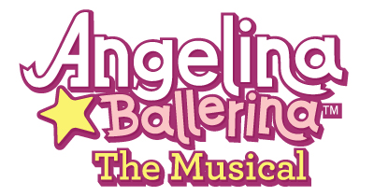

Thank you for attending our show! This curriculum guide for Vital Theatre Company’s production of Angelina Ballerina the Musical is designed to extend our work into your classroom community.

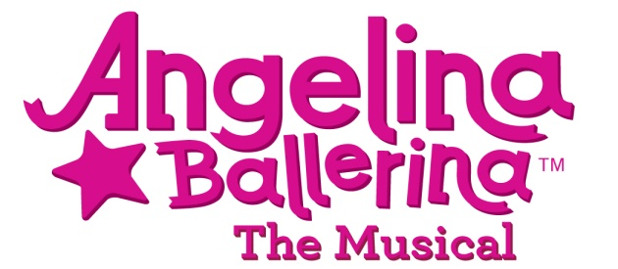

Produced by Vital Theatre Company
410 West 42nd Street
New York, NY 10036
www.vitaltheatre.org
Book & Lyrics by: Susan DiLallo
Music by: Ben Morss
Based on the book: ANGELINA BALLERINA
By Katharine Holabird

Cast of Characters
Angelina Ballerina
Dad (Angelina’s Father)
Serena Silvertail (Prima Ballerina)
Miss Mimi (Dance Teacher)
Alice (Angelina’s Best Friend)
Gracie (Modern Dancer)
Viki (Tap Dancer)
AZ (Break Dancer)

Scenes
The time is present day
Locations: Angelina’s bedroom, kitchen, and Camembert Academy

Scene 1 - At home preparing for school
Scene 2 - It’s after school and Angelina is telling her father the big news.
Scene 3 - It’s a new day and Angelina wakes up late!
Scene 4 - Angelina arrives at school late and receives disappointing news.
Scene 5 - Angelina gets home disappointed and has a talk with her father.
Scene 6 - Angelina tries to find the next best dance, after ballet.
Scene 7 - While in her bedroom, Angelina has a useful daydream.
Scene 8 - Alice comes over to help her find another dance.
Scene 9 - The big recital
Scene 10 - Just get up and dance!

Synopsis of Angelina Ballerina the Musical

Angelina wakes up and exclaims, “Oh, goodie - It’s a school day!” She begins to sing.

SONG #1: Camembert

THERE ARE SCHOOLS
WHERE YOU CAN STUDY SCIENCES
LEARN TO PAINT OR
FIX UP HOME APPLIANCES
SCHOOLS FOR ALMOST ANYTHING, I KNOW.
BUT IF YOU WANT TO DANCE LIKE SERENA
BE THE NUMBER ONE BALLERINA
THERE IS ONLY ONE PLACE YOU SHOULD GO. . .

IT’S CAMEMBERT,
CAMEMBERT
EVERY MOUSE IN MOUSELAND WOULD AGREE –
CAMEMBERT
THAT IS WHERE EVERY DANCING MOUSE WANTS TO BE.

Angelina runs into the kitchen and begins eating rapidly, unable to wait to get to school. Her dad says, “Whoa, Angelina. Slow down. It’s not good to gulp your breakfast.”

“I’m just so excited. It’s almost time for Camembert,” Angelina responds.

She arrives at school and greets her friends, Viki, Gracie, and AZ. She hears from her teacher Miss Mimi that the most famous dancer in all of Mouseland, Serena Silvertail, is coming to her school and will see them perform.

Sign-ups will happen early Friday morning. So, Angelina makes a memo: “Get…to…school…early.”

The night before sign-ups, Angelina stays up late – too late.

She wakes up the next morning realizing she’ll be late for sign-ups. When she finally makes it to school and the sign-up sheets, Angelina sees Miss Mimi taking down the sheet for the ballet performance, because all the ballet spots are taken.

Angelina is devastated. Miss Mimi tries to comfort her by encouraging her to take up tap or break dancing. Angelina sighs and replies, “But Miss Mimi – I’m not Angelina Tapper or Angelina Hip Hopper. I’m Angelina Ballerina!”

Days go by and Angelina tries to figure out what she can do for the performance that would be just as good as ballet. After a surprise visit from Serena Silvertail in a daydream, Angelina arises with a new-found determination for the day ahead.
Theatre Vocabulary

Composer writes the musical “score,” all the musical notes that create the songs that you hear – including the orchestration.

Lyricist writes the words to the song. Often the composer is the lyricist. Sometimes, the book writer is the lyricist.

Book Writer writes the talking scenes in the show which tell the story. Their words must fit between the songs and make the songs fit together.

Director is responsible for creating the world of the play. He or she interprets the play and helps everyone on the creative team agree on the choices made in collaboration with the designers and actors.

Music Director is responsible for teaching the music and helping the singers interpret the composer’s work. The way that the ensemble sounds is the responsibility of the musical director.

Choreographer helps the director stage the play. The choreographer creates and teaches the dances and movement that help to tell the story.

Author writes a book or other literary work. The author of Angelina Ballerina is Katharine Holabird.

Designer conceives or forms, or invents in the mind a plan or pattern. Angelina Ballerina the Musical has a lighting designer, set designer, costume designer, and sound designer.

Dialogue is the lines spoken by characters in drama or fiction.

Illustrator is a person who creates drawings or pictures intended for education or adornment. Helen Craig is the illustrator of Angelina Ballerina.

Drama is a composition presenting a story in dialogue, usually acted out on the stage.

Play is a dramatic performance taking place on a stage.

Musical is a play or motion picture in which the story line is interspersed with songs and dances.

Actor is a person who acts in stage plays, musicals, motion pictures, television show, etc.

Role is the part or character played by an actor or actress.

Stage is the platform on which the actors perform in a theatre.

Props are items or objects used by actors in a play.

Learning Benchmark: Exploring careers and lifelong learning: Students are introduced to the variety of careers in theater, onstage or behind the scenes.
For the Word Wall – Dance Styles [mentioned in Angelina Ballerina the Musical]

There are hundreds of different dance types in the world. In Angelina Ballerina the Musical a variety of old and modern dances are mention. These dance definitions will give you a brief overview of dances that you might want to watch being performed or to perform yourself.

Ballet is one of the oldest dance types and serves as the basis for many other styles of dance. Ballet is based on techniques developed over hundreds of years starting in Italy and further developed in France, England and Russia as a concert dance form. Angelina Ballerina specializes in ballet.

Disco is the name of a modern dance that goes with a style of music developed in the 1970s. It is characterized by moving to the beat of the music in your own way – with elaborate movement of hands and arms along with sleek twists and turns.

Flamenco is an expressive dance form developed in Spain mixing stomping footwork with intricate hand, arm and body movements. The Spanish art of Flamenco mixes song, dance and guitar music.

Hip-Hop is another modern dance style that originated from a fad in the United States. The dance includes various moves such as breaking, popping, and locking that are all personally interpreted.

Irish Step dance is a performance dance known for its rapid leg movements and stationary body and arms. [It was popularized by the famous “Riverdance” show.]

Jitterbug/Lindy are two names for dance popularized in the United States in the early 1900s. Jitterbug and Lindy are associated with various types of swing dances performed by couples on the dance floor sometimes jumping around acrobatically as if they were jittery.

Limbo is a dance that originated in the West Indies in the 1950s. Dancers keep bending over backward and passing under a pole that is lowered slightly each time [ until only one person is left who did not touch the pole with any part of their body or touch the floor with a hand].

Minuet is a very old slow, graceful social dance of French origin for two people to music of the same name. The couple take small steps while dancing. [It has been written that the minuet was George Washington’s favorite dance.]

Modern Dance is a dance style developed in the early 1900s that rejects many of the strict rules of classical ballet and focuses of the expression of feelings. It emphasizes creativity in dancing.

Polka is a happy folk dance for couples developed in central Europe. Polka is also the name for the type of music for polka dancing. Folk dances are made up by groups of people instead of by a choreographer.

Salsa is a popular social dance form throughout the world which originated in the Caribbean islands. [The partners move together mainly with their hips and legs.]

Samba is a lively dance of Brazilian origin danced to Samba music which includes a definitive drum beat. [It is heavily influenced by African slaves and Portuguese settlers in Brazil.]

Tango is a couples ballroom dance as well as music of Latin-American origin. It consists of two long sliding steps followed by three short steps and stylized body positions.

Tap is an exciting form of dancing in which dancers wear special shoes with metal plates attached to the ball and heel of the dancer’s shoes. [Tap dancers use their feet like drums to create rhythmic patterns and beats.]

Texas Two Step or simply the “two-step” is a country/western dance with partners. The dancers move around the floor counter -clockwise. [Traditionally the two-step includes three steps: a quick step, a quick step, then a slow step.]

Learning Benchmark: Making Connections Through Theater: Students connect learning from other arts and disciplines, such as math, science, language arts, social studies, technology, music, visual arts and dance, to extend their understanding of theatre.

Acting Activities

Getting to Know You Game

Have everyone stand in a circle.
The workshop leader starts by saying his or her name and following it with an action, for example, “Sara!” with action of waving hands. Then the leader asks the whole group to repeat the name and action. Continue around the circle, one at a time, until everyone has had a turn and everyone in the group has repeated each name and action.

Walk/Freeze Game

This game is used to get students up and moving.

Level 1: Have students walk around the space, making sure that there is space between them. Have them fill in all blank spaces and really be aware of filling the entire room. Caution them not to bump into each other and to be aware of moving around each other in space. When the leader calls “freeze,” the students should freeze on the spot. They should unfreeze when they hear a clap and not until then. Once they learn to freeze on the spot, add that when the leader calls “freeze,” the students should strike a funny pose.

Level 2: The leader will call out different ways of walking. The leader will say, “walk as if…” and give a specific person, place and/or thing.

Examples:
- Gracie doing her modern dance about flowers
- Angelina disappointed that she can’t dance ballet for Serena Silvertail
- Serena Silvertail coming out of the poster
- AZ break dancing

Improvisation Activity

The leader gives the students their chance to be actors and act out moments from the show Angelina Ballerina the Musical. Angelina feels different at certain times of the play. The leader asks the students to act out the following moments in the show in small groups. After they finish, the leader asks the students what their character was thinking or feeling.

Possible scenarios:
- Angelina wakes up late and hurries to get ready for school.
- Students meet at Camembert for their first day of class.
- Students find out that Serena Silvertail, Prima Ballerina, is coming to their school.
- Angelina realizes she won’t be able to dance ballet for Serena.
- Angelina thinks about what dance she could perform.
- Angelina dances with Serena at the end of the show.

Learning Benchmark: Acting: Students participate in group activities, including creative play, storytelling, pantomime and improvisation.
Classroom Activities

Activity 1 - Dance Party

Have a selection of dance music with different genres of dance music represented in Angelina Ballerina the Musical. Have the class stand in a circle and one by one let students, or pairs of students, volunteer to display a dance of their choice.

Activity 2 - Angelina Ballerina Collage

Suggested materials: markers, crayons, finger paint, construction paper, tissue paper, a collection of newspapers and magazines, cotton balls, cardboard and glue or paste

Using any or all of the suggested materials, create a visual collage that relates to or represents scenes, characters, places, or dances from Angelina Ballerina the Musical. The students should be as creative as possible; encourage the students to think outside the box.

Activity 3 – Cheese Names

You might have noticed that many of the names in Angelina Ballerina the Musical are based on cheese. Camembert Academy, Michael Brie-Ishnakov and Margot Fontina are all based on cheeses called Camembert, Brie, and Fontina.

List five other kinds of cheese? Have students make up a few more fun names that include cheeses in them.

Activity 4 – Angelina Ballerina Acrostic Poem

Acrostics are poems in which the first letters of all the lines combine to make a word. For example:

A – Angelina loves ballet!
N – Needs to learn another dance
G – Getting to school late was so not fun.
E – Everyone was excited to see Serena Silvertail.
Can you finish the acrostic poem using all the letters of the name Angelina Ballerina?
L –

I –

N –

A –

B –

A –

L –

L –

E-

R-

I-

N-

A-

Activity 5 – Learn the Five Ballet Positions

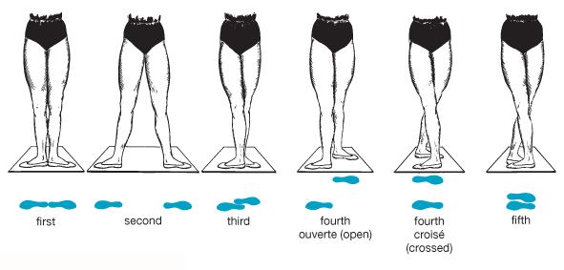

When you begin learning ballet, you start by learning the five basic ballet positions, because every move in ballet begins and ends in one of these positions.

First Position: The balls of the feet are turned out. The heels touch each other and the feet face outward in close to a straight line.

Second Position: Similar to first position with the feet turned out, second position has the heels separated by about the length of one foot. The feet are spread apart.

Third Position: One foot is in front of the other with the front foot touching the middle or arch of the back foot.

Fourth Position: One foot is in front of the other but one step apart.

Fifth Position: With one foot in front of the other, the toe of one foot reaches the heel of the other foot. The feet are pointing in opposite directions.

[There are also five positions to the arms that go along with the positions of the feet. ]

Activity 6 – Design a Set for Angelina Ballerina the Musical

What would you design an Angelina Ballerina the Musical set to look like? Think of places and things in the show and draw them on your stage. On another sheet of paper draw an outline of the stage and create your set.

Angelina Ballerina the Musical is performed on a proscenium stage. A proscenium stage has, as its primary feature, a large frame or arch around the stage with the audience on one side of the stage.

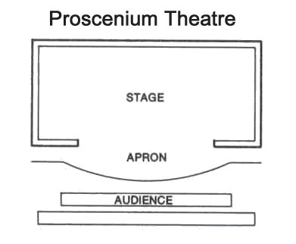

A theatre space whose primary feature is a large frame or arch with the audience on one side

Learning Benchmark: Theater Making: Designing and Technical Theater: Students explore various design roles in theater and how design choices influence the mood of the production.

Activity 7 – Paper Bag Puppets of Angelina and her friends

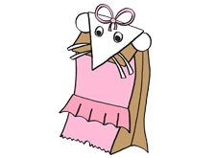

Supplies
- Paper bag - lunch size will work well
- Construction paper – any colors
- Craft glue
- Safety scissors
- Markers or crayons
- Pipe cleaners or yarn
Instructions
- Take a paper bag (bottom side up). Make sure the palm of you hand fits into the side with the bottom fold.
- Have a grown-up help you cut out a triangle (point facing down) for her face and half circles for her ears from the white construction paper.
- Glue on all the pieces to create a face on the bottom of your paper bag. Decorate the inside of ears with a crayon or construction paper. Add whiskers and eyes.
- Use fabric (or crayons) to create their outfits. Look at what each friend looks like and the colors they might use.
- Make your final touches and you are ready to start your very own puppet show
Extension Activities for Language Arts Integration

Write a Review - Write a one page review on the musical itself. You can focus on any topic from dance, characters, storyline or anything else. How did the music and movement help to tell the story? What was your favorite song? Why?

Learning Benchmark: Developing Theater Literacy: Responding to Theater Performance: Students articulate responses to theatre performance.

Critique the Production - Production values add to a play. Sets, lighting, costumes and props all help theatre artists tell the story. What production elements did you see in Angelina Ballerina the Musical? Were any missing? Were there times you had to use your imagination? If so, when?

Learning Benchmark: Theater Making: Designing and Technical Theater: Students explore various design roles in theater and how design choices influence the mood of the production.

Character Exploration - Which character would you like to know more about? Write a song for that character. Answer your own questions in the song. Use your imagination.

Class Collaboration - Break into small groups so that the whole class works together to write a new song or a poem about the show. Each student contributes his or her own line.

Script Revision - Were there parts of the story you didn’t like? Why not? Rewrite the story so it would work better for you. How would the play change if you were the writer?

Learning Benchmarks: Acting: Students participate in group activities, including creative play, storytelling, pantomime and improvisation;

Playwriting/Play Making: Students imagine, analyze and understand play making processes by listening, retelling and creating stories and dramas.

Extension Activity for Visual Arts Integration

Draw a picture of your favorite character. Write on the back of your drawing why you like that character.

Draw a picture of your favorite part of the story? Write why you like that part on the back of your work.

Learning Benchmark: Making Connections Through Theater: Connect learning from other arts and disciplines, such as math, science, language arts, social studies, technology, music, visual arts and dance, to extend their understanding of theatre.

Vital Theatre Company curriculum guides align with the National Learning Standards for the Arts for the United States as well as the New York City Department of Education Blueprint for Theatre. Please look at the end of each activity to the information in pink to reference relevant learning benchmarks.

We want to hear from you!
Write to us and send us your reviews.

VITAL THEATRE COMPANY
410 West 42nd Street
NEW YORK, NY 10024
212-579-0528
www.vitaltheatre.org

