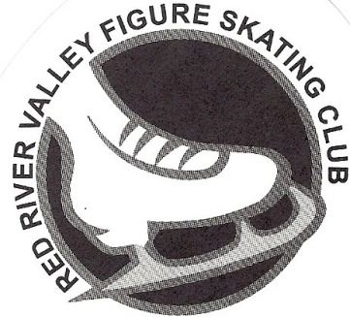 February 9, 2023, Test Results
Red River Valley FSC
Dance
Dutch Waltz: Cora Erickson, Ella Willey, Veronica Neir
Canasta Tango: Veronica Neir, Cora Erickson, Ella Willey, Angela Tollefson
Rhythm Blues: Natalie Cook, Cora Anderson
Swing Dance: Aernestine Daeuber, Caroline Pederson, Alessandra Neir, Hailey Sorenson, Ella Lammers, Lela Hultgren, Lilia Mason, Rachel Pavlat
Cha Cha: Caroline Pederson, Ryan Dahl, Angelina Foster
Fiesta Tango: Lilia Mason, Alessandra Neir, Aernestine Daeuber, Ellla Lammers, Violet Drechsel, Rachel Pavlat
Hickory Hoedown: Elizabeth Reburn
Ten Fox: Haylee Wohlwend, Clara Stumpf
Willow Waltz: Anna Winzer, Raegan Miller, Clara Stumpf
14 Step: Hannah Rooks, Ella Noyes, Oleksandra Tarnavchyk
European Waltz: Oleksandra Tarnavchyk, Sophia Lin, Ashley Christopher, Allie Aalund
Foxtrot: Allie Aalund
Silver Tango: Rena Baba
Blues: Cayla Walker
Kilian: Mabel Wanzek
Paso Doble: Cayla Walker
Westminster Waltz: Maren Rygg
Silver Samba: Sophia Quam
Cha Cha Congelado: Lauren Lamp
Finnstep: Isabella Skoblik
Senior Solo Free Dance: Makenna Bessler, Sophia Quam
Moves in the Field
Pre-Preliminary: Natalie Cook, Norah Carlson, Cora Anderson, Veronica Neir, Caroline Pederson, Hailey Sorenson
Preliminary: Aernestine Daeuber, Rachel Pavlat
Pre-Juvenile: Ella Noyes
Juvenile: Kenley Weum, Hannah Rooks, Clara Stumpf
Adult Pre-Bronze: Audra Hagen-Grunhovd
Free Skate
Pre-Preliminary—Rachel Pavlat, Natalie Scholz
Preliminary—Rena Baba, Sophia Lin, Avery Nelson, Emily Greiff, Allie Aalund
Pre-Juvenile—Mabel Wanzek
Intermediate—Maren Rygg
Senior—Sydney Aberle

Congratulations to these skaters who earned a gold medal at this session: Maren Rygg , Makenna Bessler, Sophia Quam, all in Dance and Sydney Aberle in Free Skate. Isabella Skoblik finished her International Dances at this session.

