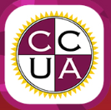

Safeguarding
At
Christ Church Upper Armley
Primary School

Information leaflet for parents, carers and visitors.

What is safeguarding?
Children should be free from harm or danger; it is everyone’s responsibility to ensure that they are. Safeguarding means protecting children for harm and acting on concerns for a child’s safety and wellbeing. Harm is ill treatment or child abuse. This includes physical, sexual, emotional abuse and neglect. Here are some examples:

Physical abuse
Physical abuse is deliberately hurting a child causing injuries such as bruises, broken bones, burns or cuts. It isn’t accidental - children who are physically abused suffer violence such as being hit, kicked, poisoned, burned, slapped or having objects thrown at them. It can be when someone deliberately induces illness in a child.

Emotional abuse
Emotional abuse is the ongoing emotional maltreatment or emotional neglect of a child. It may involve making a child feel constantly worthless or unloved, frightened or in danger. Children who are emotionally abused are usually suffering another type of abuse or neglect at the same time – but this isn’t always the case.

Sexual abuse
A child is sexually abused when they are forced or persuaded to take part in sexual activities. This doesn't have to be physical contact and it can happen online. Sometimes the child won't understand that what's happening to them is abuse. They may not even understand that it's wrong. In most cases sexual abuse is carried out by a person who is known to the child even a member of their own family.

Neglect
Neglect is the ongoing failure to meet a child's basic needs and is the most common form of child abuse. A child may be left hungry or dirty, without adequate clothing, shelter, supervision, medical or health care. A child may be put in danger or not protected from physical or emotional harm. They may not get the love, care and attention they need from their parents.

What do you need to know?
Christ Church Upper Armley Primary has procedures in place to safeguard children and a policy that all staff, volunteers and regular visitors must work to. A copy can be found on the school website. There are four members of staff whose job it is to be responsible for all aspects of safeguarding in our school (see overleaf). We also have a named governor for safeguarding.

What will happen if we have concerns for your child?
If school has a concern that your child is, or may be, suffering harm within or outside the school we will act according to our statutory duty to protect your child from any harm or danger. All schools have a duty to refer cases if they have a safeguarding concern.
What does this mean? What concerns may we have for your child?
- If someone at our school sees an unusual or unexplained injury or mark
- If your child has said something worrying us
- If their behaviour is out of the ordinary
- Or if there is any other reason we feel your child may be suffering harm outside of school, we have a legal duty to make a referral.
We will discuss the concern with you and also let you know if a referral has been made, unless to do so would put your child more at risk by informing you. It is always better for your child if we can work together.

Christ Church Primary’s Designated
Safeguarding Lead:
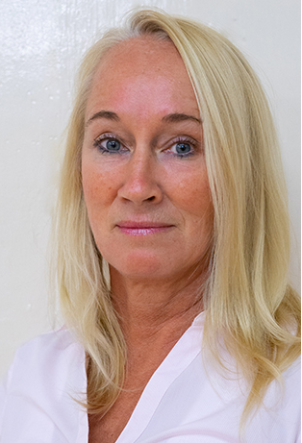 Mrs Murfin

Deputy safeguarding Lead:
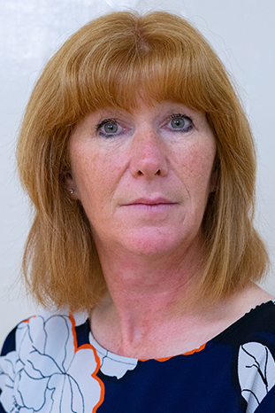 Mrs Myers
Prevent Lead:
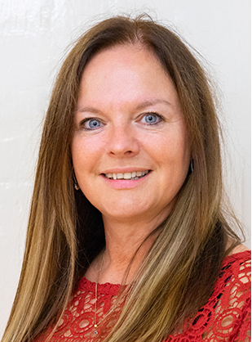 Mrs Green
Learning Mentor
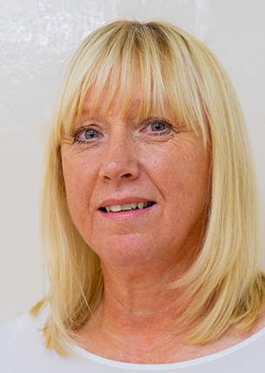 Mrs Caldwell

Named governor for safeguarding:
Peter Laurence.

For more information about safeguarding please visit Abbey Multi Academy Trust website: https://www.abbeymat.co.uk/our-academies/christ-church-upper-armley

If you have a concern for a child’s safety or wellbeing, you can contact CSWS Duty and Advice / Front Door Safeguarding Hub
0113 2223301

